Manganese Oxide Promoter Effects in the Copper-Catalyzed Hydrogenation of Ethyl Acetate
Rolf Beerthuis,^{a, #} Nienke L. Visser,^{a, #} Jessi E. S. van der Hoeven,^{a,b} Peter Ngene,ª Jon M. S. Deeley,^{c} Glenn J. Sunley,^{c} Krijn P. de Jong,ª Petra E. de Jongh^{a,*}
ª Inorganic Chemistry and Catalysis, Debye Institute for Nanomaterials Science, Utrecht University, Universiteitsweg 99, 3584 CG Utrecht, Netherlands. #Authors contributed equally. *Corresponding author: P.E.deJongh@uu.nl
^{b} Soft Condensed Matter, Debye Institute for Nanomaterials Science, Utrecht University, Princetonplein 5, 3584 CC, Utrecht, the Netherlands
^{c} Applied Chemistry and Physics Centre of Expertise, BP Group Research, Hull Research and Technology Centre, c/o BP Chemicals, Saltend, Hull, United Kingdom

Table of Contents
Section S1: Experimental methods 2
Section S2: Catalyst characterization 7
Supplementary references 24

Section S1: Experimental methods
Catalyst preparation
The carbon support was dried in a round-bottom flask for 90 min at 170 °C, while stirring under dynamic vacuum, and subsequently stored in an Ar-filled glovebox (Mbraun LABmaster, <0.1 ppm H₂O, <0.1 ppm O₂) until further use. Aqueous precursor solutions of Cu(NO₃)₂ and/or Mn(NO₃)₂ were prepared by dissolving the copper nitrate (Cu(NO₃)₂•3H₂O, Acros Organics, ≥99 %) and/or manganese nitrate (Mn(NO₃)₂•4H₂O, Sigma Aldrich, ≥97.0 %) precursor salts in de-ionized water. The solutions were acidified using 0.10 M nitric acid (HNO_{3 (aq)}, Merck, 65 %) to ensure a pH ≤1. The concentrations of Cu(NO₃)₂ and Mn(NO₃)₂ in the precursor solution were adjusted to control the Cu and Mn loadings in the final catalyst. In a typical synthesis procedure, ~2 g of dried carbon powder was impregnated to incipient wetness, in a round-bottom flask under static vacuum. The volume of the impregnation solution was approximately 95 % of the total pore volume by N₂ physisorption analysis. The solution was added dropwise by syringe through a rubber septum, under vigorous stirring.

The impregnated sample was stirred for 24 h to homogenize the Cu and Mn content. Next, the impregnated sample was dried during 24 h at room temperature, while stirring and under dynamic vacuum. The dried catalyst precursor was transferred to an Ar-filled glovebox, and subsequently loaded into a plug-flow reactor, without exposure to air. The dried sample was heated to 230 °C (0.5 °C min⁻¹) with 1 h isothermal hold at 230 °C, under a flow of N₂ (0.1 mL min⁻¹ mg⁻¹), which completely removed the nitrate residues (Figure S1). After letting the sample cool down to room temperature, it was purged for 3 h with a flow of 10 vol% O₂/N₂ (0.1 mL min⁻¹ mg⁻¹). Subsequently, the sample was purged for 30 min with N₂ to remove any residual O₂ and heated to 170 °C (2 °C min⁻¹), with 2 h isothermal hold at 170 °C, under a flow of 10 vol% H₂/N₂ (0.1 mL min⁻¹ mg⁻¹) and finally heated to 400 °C (2 °C min⁻¹), with 1 h isothermal hold at 400 °C. After letting the catalyst cool down to room temperature, it was transferred to an Ar-filled glovebox, without exposure to air, to allow for XRD characterization of the reduced catalysts. Finally, the catalyst was collected after passivation by overnight exposure to air at room temperature.

X-ray absorption spectroscopy.
The passivated sample was pelleted and placed inside a stainless-steel in situ cell, equipped with Kapton foil windows. The sample was surrounded by a tubular furnace for temperature control. The measurement cell was connected to a gas manifold to control the gas flow and composition. All data were acquired under continuous gas flow of either pure He or 4 vol% H₂/He (~1 mL min⁻¹ mg_{cat}), at ambient pressure. The sample was initially purged with He at room temperature for 15 min, before acquiring XAS data to analyze the passivated sample. Next, the gas flow was exchanged for 4 vol% H₂/He and purged for 15 min at room temperature. Subsequently, the temperature was increased to 250 °C (5 °C min⁻¹), with 1 h isothermal hold at 250 °C, and a final XAS spectrum of the reduced catalysts was recorded. The average Cu oxidation state was calculated by linear combination fitting of the XANES between 8,790–9,010 eV. The Cu–Cu coordination number (CN_{Cu–Cu}) was calculated by fitting the first shell Cu–Cu scattering from the EXAFS spectra after in situ reduction. The average Mn oxidation states were calculated using the method developed by Johnson et al., which uses a linear correlation between Mn oxidation state values and the energy of the pre-edge feature.^{[1]}

The collected EXAFS spectra were background corrected and analyzed using the Athena software package. The Cu coordination number (CN_{Cu–Cu}), the difference of the Debye−Waller factor with respect to the reference (Δσ²), the correction of the threshold energy (ΔE₀) and the Cu−Cu distance (R) were treated as free parameters during the fitting. The amplitude reduction factor (S₀²) of 0.855 for Cu was obtained by fitting the EXAFS data of the Cu foil reference, with CN_{Cu–Cu} defined as 12.0 for bulk Cu. The structural parameters were determined by multiple k-weight fitting within a distance fit range between 1.4-3.0 Å. The quality of the fit was evaluated by visual comparison of the magnitude and imaginary part of the Fourier transform, which indicated good agreement between experimental and fitted data for samples (Figure S7). An overview of the EXAFS fitting parameters is given in Table S1.

Table S1. EXAFS fitting parameters for several representative MnO_{x}-Cu/C catalysts, after reduction at 250 °C under 4 vol% H₂/He flow.
Sample | CN_{Cu–Cu} | Δσ²  (*10⁻³) | E₀  (eV) | R  (Å)
Cu foil (ref.) | 12.0 | 8.44 | 4.16 | 2.54
0_MnO_{x}-Cu/C | 11.3 | 9.60 | 3.56 | 2.54
4.8_MnO_{x}-Cu/C | 10.4 | 10.20 | 3.17 | 2.53
11_MnO_{x}-Cu/C | 10.8 | 9.80 | 3.35 | 2.53
20_MnO_{x}-Cu/C | 10.2 | 10.46 | 3.18 | 2.53

Scanning transmission electron microscopy
The catalysts sample was dispersed as a dry catalyst powder, onto a Ni sample grid coated with holey carbon (Agar 300 mesh Ni). The images were acquired in high-angle annular dark-field (HAADF) mode, on an FEI Talos F200X operated at 200 kV. Energy-dispersive X-ray spectroscopy (EDX) mapping was performed to analyse the distribution and amount of the Mn, Cu and C content in the catalyst before and after catalysis. The Mn and Cu distribution was analysed by acquiring high resolution EDX maps at high magnification (910,000–1,300,000 times) using a probe current of around 700 pA and total map acquisition time of 800–1,000 s to obtain sufficient EDX signals for Cu and Mn. To determine the average metal composition, EDX maps were acquired at a much lower magnification (40,000–60,000 times) and concentrations quantified using the Cliff-Lorimer method. The high resolution EDX intensity maps were used to characterize the distribution of Mn and Cu in the samples. To this end, the EDX intensity maps were analysed as line scans in the direction perpendicular to the Cu-Mn interface.

Powder X-ray diffractometry
The reduced catalyst was loaded into an airtight XRD specimen holder (A100B33, Bruker AXS) inside an Ar-filled glovebox (Mbraun LABmaster, <0.1 ppm H₂O, <0.1 ppm O₂). Diffractograms were continuously acquired with 0.1 °2θ increment between 5 to 95 °2θ, in approximately 2 to 3 h. The diffractograms were normalized to the peak intensity of the graphitic (002) diffraction peak at 30.9 °2θ and carbon baseline subtracted. A bi-modal Cu crystallite size distribution was observed for some MnO_{x}-Cu/C catalysts. The presence of larger Cu crystallites (>20 nm) was attributed to slight over-impregnation during catalysts synthesis. Since no bulk particles were observed by TEM analysis, any particles >20 nm were neglected in the Cu size analysis.

Catalytic performance.
The catalysts were pelletized (2 cm diameter) using a hydraulic press at 1.5 ton weight, equivalent to 460 bar pressure, ground and sieved to obtain a granulate size of 75–150 μm. The catalysts were diluted with SiC granulates (212–425 μm), to maintain the volume of the diluted catalyst bed constant (~3.0 mL) and prevent heat transfer limitations. The SiC diluent was pre-treated by washing with HNO₃(aq) (68%; 10 mL g_{SiC}⁻¹) and calcined at 800 °C, to remove organic and metal impurities. The pre-mixed diluted catalyst was loaded by step-wise adding small fractions into a stainless-steel tubular reactor (2.6 mm inner diameter), to ensure homogenous catalyst distribution throughout the reactor tube. The diluted catalyst was loaded on top of SiC granules (0.5 mL), which were pre-loaded onto a stainless-steel frit. A hollow glass wool filament (~10 cm) was placed in the head space above the catalyst bed, up to the entrance of the reactor, to ensure continuous evaporation of the EtOAc reactant.

At the start of the catalysis, the catalysts were purged for 1 h with pure He (2 mL min⁻¹ per reactor) and subsequently re-reduced in situ by heating to either 200 °C (for the Mn-free 0.0_MnO_{x}_Cu/C catalyst) or to 250 °C (2 °C min⁻¹), with 2 h isothermal hold at the final temperature, under a flow of 20 vol% H₂/He (2 mL min⁻¹ per reactor). Afterwards, the temperature was lowered to 140 °C and the reactor was purged for 2 h with 9 vol% H₂/He (6.2 mL min⁻¹ per reactor). Next, the EtOAc feed was introduced (0.6 mL min⁻¹ per reactor). The concentration of water in the EtOAc feed was determined by Karl Fischer titration, using standard method ASTM D 1364. The standard reaction gas mixture consisted of H₂:He:EtOAc in a 10:1:1 molar ratio (6.8 mL min⁻¹ per reactor). Next, the pressure was gradually increased during 75 min to 30 bar(g). Finally, the reactor temperature was increased to either 180 °C or 200 °C (2 °C min⁻¹), to start the catalytic experiment. Between isothermal stages at 180–210 °C, the temperature was increased with 1 °C min⁻¹. After the reaction, the temperature was lowered to 90 °C and the catalysts were passivated by exposure to air at this temperature.

The effluent gas composition was analysed by on-line gas chromatography at 19 min intervals (GC, Agilent 7890B). He and H₂ were separated on a MolSieve 5A column (2.4 meter x 1/8 inch inner diameter) and quantified analyzed using a thermal conductivity detector. Hydrocarbons and oxygenates were separated on a HP-Innowax column (6 m x 0.32 mm ID) and GS-GasPro column (GS-Gaspro 30 m x 0.32 mm ID), and quantified by two separate flame ionization detectors. The analyte concentrations were calculated from the peak areas, using He as the internal standard.

The Cu weight-normalized time yield (CTY, mol_{EtOAc} g_{Cu}⁻¹ h⁻¹) was used to calculate the turn-over frequency (TOF, mol_{EtOAc} mol_{surface Cu} s⁻¹) using the formula: CTY*M_{Cu}/D_{Cu}, in which M_{Cu} stands for the molecular weight of Cu and D_{Cu} the fraction of surface Cu atoms. The value of D_{cu} is calculated from the Cu d_{s}, assuming fully accessible and spherical particles using the formula 6*(V_{Cu} A_{Cu}⁻¹)/d_{s}. Herein, A_{Cu} is the molar area occupied by surface Cu atoms (4.10*10²² nm²) and V_{Cu} is the molar volume occupied by bulk Cu atoms (7.09*10²¹ nm³). D_{Cu} is thus calculated as 1.04/d_{s}, with d_{s} in nm.^{[2]} Herein, we relied on TEM to calculate the surface-averaged particle size and determine the Cu surface area. TEM is considered a reliable technique to determine the Cu particle size and estimate the Cu surface area.^{[3]} Other characterization techniques, such as N₂O and H₂ chemisorption, were found to also probe metal oxide defect sites,^{[4]} thus rendering them unsuitable for the MnO_{x}-promoted catalysts. The initial TOF at 180 °C was determined after around 30 h on stream, and calculated from the Cu d_{s} of the fresh Cu/C catalyst. The final TOF at 180 °C was calculated after 150 h on steam, and calculated from the Cu d_{s} of the used catalyst. To be concise, the reaction times are referred to as 30 and 150 h on stream, yet precise reaction times may vary ±2.5 h depending on GC sampling time.

It is known from our own experiments and studies in literature that the reaction order in EtOAc is around zero, when applying a 10-fold excess of H₂ over EtOAc.^{[5-8]} A zero order dependency of the EtOAc concentration on the conversion was therefore used in our analysis of the E_{a}.

The relative standard deviation in TOF (σ_{TOF}) was determined by testing 12 reactors with the same loading of a commercial co-precipitated CuZnMgO_{x}/Al₂O₃ catalyst (Alfa Aesar). Herein, σ_{TOF} was defined as the typical distance of a data point (χ) from the mean value (µ) and calculated by the formula $σ_{TOF}= \sqrt{\left(\frac{1}{N-1}\right)\sum_{i=1}^{N}{{\left(χ_{i}- μ\right)}^{2}}}$ and found to be approximately 8%. To corroborate that the reaction was not mass transfer limited, we performed measurements with Cu/C catalysts of different granulate size ranges, i.e. 75–150 μm, 150–425 μm and 425–630 μm. No significant differences in conversions were observed, indicating that the reaction was not hindered by internal or external mass transfer limitations. Two measurements using the bare carbon support and SiC diluent showed no conversion at 210 °C.

Section S2: Catalyst characterization and catalytic results
Cu and Mn nitrate precursor decomposition. Thermogravimetric analysis coupled to mass spectrometry, was performed to investigate the decomposition temperature of the Cu(NO₃)₂ and Mn(NO₃)₂ metal salt precursors, after deposition via incipient wetness impregnation onto the carbon support and subsequent drying (Figure S1). During the measurement, the impregnated catalyst precursors were first purged under a flow of Ar, at 50 °C and subsequently heated to 600 °C (5 °C min⁻¹) under Ar flow. The NO signal (M/Z = 30) was measured to follow the decomposition of the nitrate precursor salts, which produces a mixture of different nitrogen oxide (NO_{x}) gasses, with NO as the main decomposition product. Water (M/Z = 18) was desorbed from the impregnated sample around 100 °C. The NO signal showed that the decomposition of Cu(NO₃)₂ and Mn(NO₃)₂ precursors started around 100 °C and exhibited at least 2 distinct decomposition steps. The peak of the final decomposition step resided around 230 °C for both nitrate precursors. Additional measurements with 1 h of isothermal hold at 230 °C confirm that the nitrate residues were completely removed by heating to 230 °C under a flow of inert atmosphere.
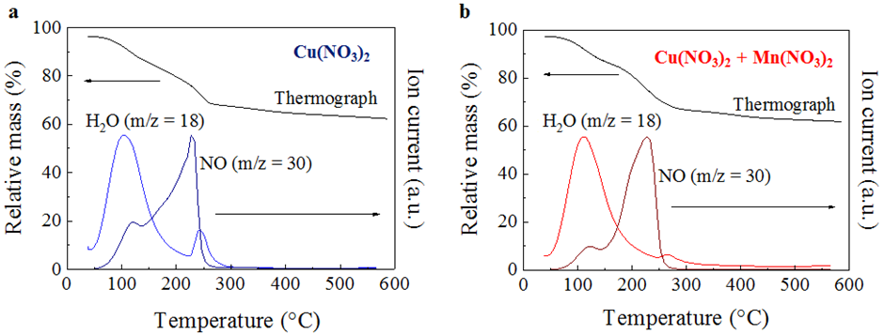

Figure S1. Thermogravimetric analysis coupled to mass spectrometry, was performed to investigate the decomposition temperature of metal salt precursors for a) Cu(NO₃)₂ and b) mixed Cu(NO₃)₂ and Mn(NO₃)₂, deposited on high surface area graphitic carbon as the catalyst support.
Transmission electron microscopy.
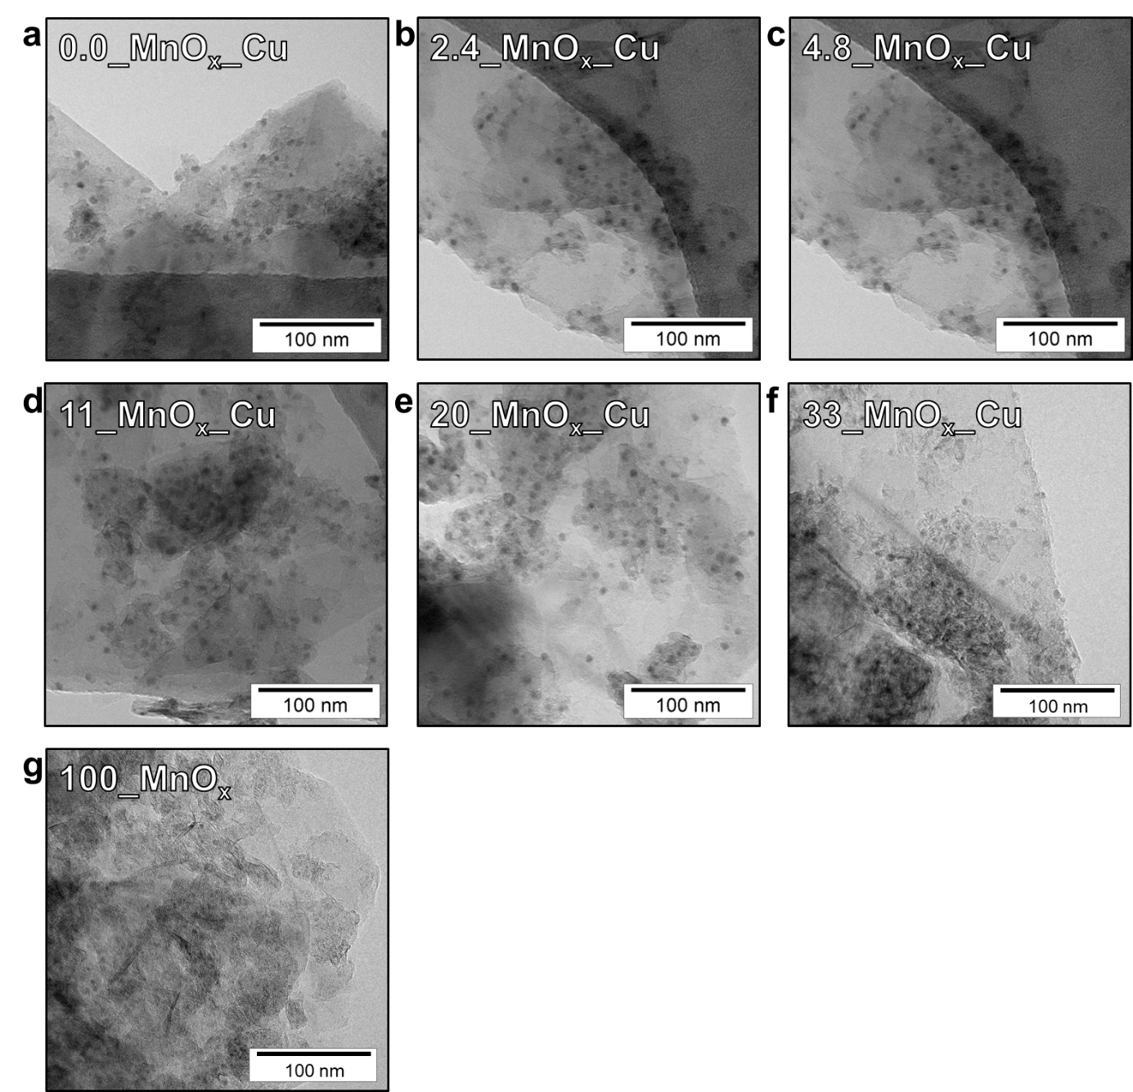
Figure S2. Transmission electron micrographs for a–f) the full set of MnO_{x}-Cu/C catalysts synthesized with variation of the Mn loading between 0–33 mol% Mn/(Cu+Mn), with a Cu loading around 8 wt% and using high surface area graphitic carbon as the catalyst support; g) one Cu-free MnO_{x}/C sample. Well-defined and approximately spherical Cu, MnO_{x}-Cu and MnO_{x} nanoparticles were visible for all carbon-supported catalysts.

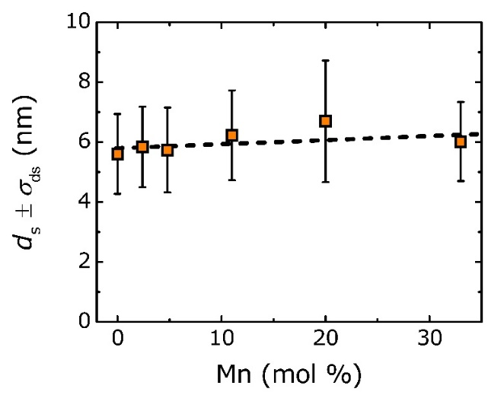
Figure S3. Surface-averaged MnO_{x}-Cu particle size (d_{s}) and standard deviation in the particle size distribution (σ_{ds}) as a function of Mn loading. The MnO_{x}-Cu/C catalysts were synthesized with variation of the Mn loading between 0–33 mol% Mn/(Cu+Mn), with a Cu loading around 8 wt% and using high surface area graphitic carbon as the catalyst support.

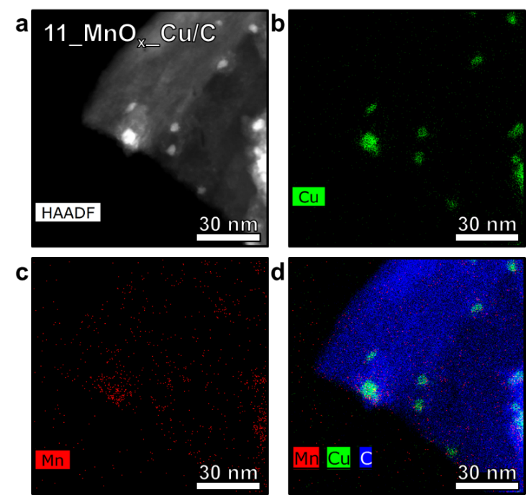
Figure S4. STEM-HAADF-EDX elemental mapping for the 11_MnO_{x}-Cu/C catalyst; a) STEM-HAADF image and corresponding EDX maps showing the distribution of b) Copper; c) Manganese; d) Overlay of copper (green), manganese (red) and carbon (blue).
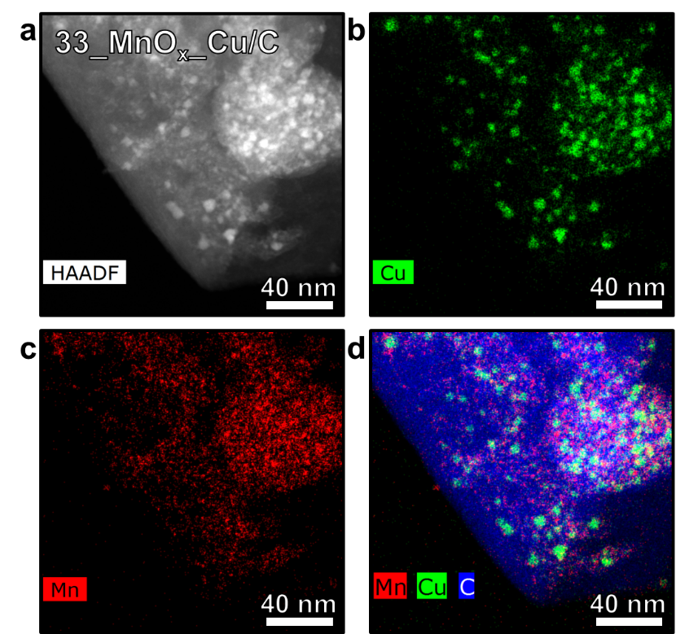
Figure S5. STEM-HAADF-EDX elemental mapping the 33_MnO_{x}-Cu/C catalyst; a) STEM-HAADF image and corresponding EDX maps showing the distribution of b) Copper; c) Manganese; d) Overlay of copper (green), manganese (red) and carbon (blue).

Mn monolayer estimation. The theoretical amount of Mn monolayer relative to the amount of Cu atoms on the nanoparticle surface is estimated in Table S2. The amount of surface Cu atoms was determined from the Cu dispersion (D_{Cu}) calculated as D_{Cu} = 1.04/d_{s}, in which the surface-averaged MnO_{x}-Cu particle size (d_{s}) was assumed to be 6 nm for all MnO_{x}-Cu/C catalysts. Moreover, the Cu particles were considered to be fully accessible and spherical in shape. In our estimation, the oxygen content in MnO_{x} was neglected for simplicity.

Table S2. Theoretical Mn monolayer amount, based on Cu surface/Mn atom ratio.
Catalyst | Cu loading | Amount of  Cu atoms | Amount of Cu surface atoms | Mn loading | Amount of Mn atoms | Mn/Surface Cu  ratio
 | (wt%) | (10²⁰ atoms/g_{cat}) | (10²⁰ atoms/g_{cat}) | (wt%) | (10²⁰ atoms/g_{cat}) | (atom/atom)
0_MnO_{x}-Cu/C | 8.7 | 8.2 | 1.4 | 0.0 | 0.0 | -
2.4_MnO_{x}-Cu/C | 8.7 | 8.2 | 1.4 | 0.2 | 0.2 | 0.2
4.8_MnO_{x}-Cu/C | 8.4 | 8.0 | 1.4 | 0.4 | 0.4 | 0.3
11_MnO_{x}-Cu/C | 8.5 | 8.1 | 1.4 | 0.9 | 1.0 | 0.7
20_MnO_{x}-Cu/C | 8.4 | 8.0 | 1.4 | 1.8 | 2.0 | 1.4
33_MnO_{x}-Cu/C | 7.9 | 7.5 | 1.3 | 3.4 | 3.7 | 2.9

Effect of Mn loading on apparent activation energy.
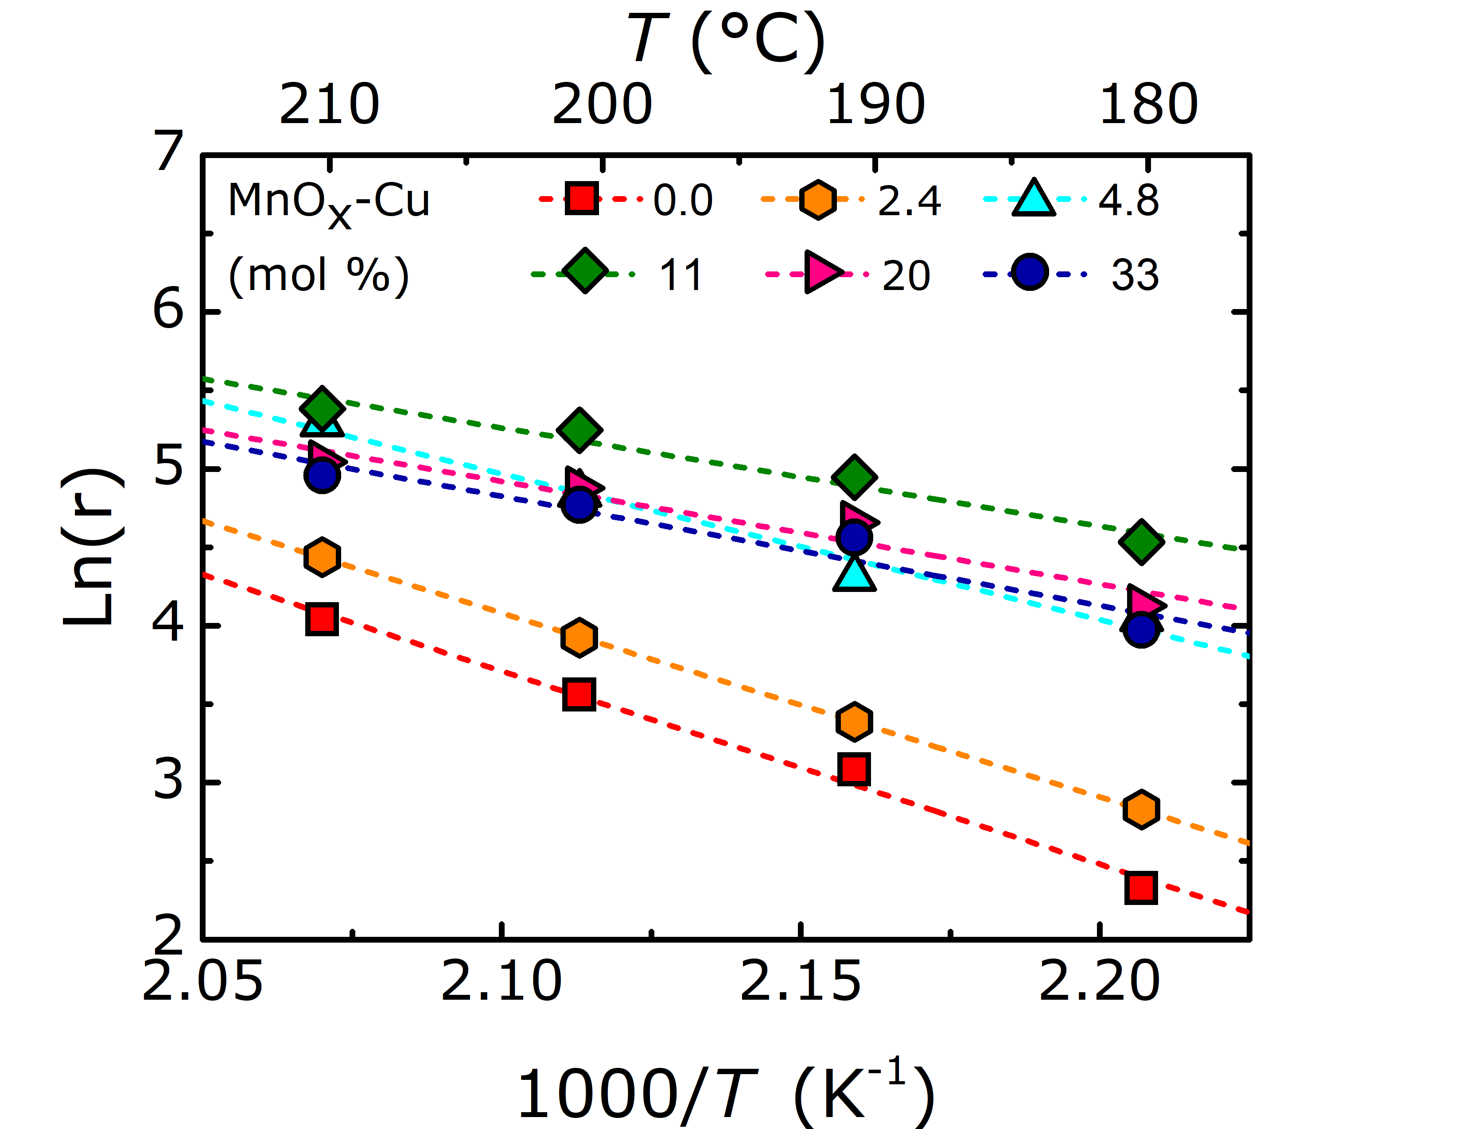
Figure S6. Arrhenius plots for MnO_{x}-Cu/C catalysts with varying Mn loadings between 0–33 mol% Mn/(Cu+Mn), prepared using high surface area graphitic carbon as support. Herein, the reaction rate r is expressed as the CTY in mmol_{EtOH} g_{Cu}⁻¹ h⁻¹. Reaction conditions: H₂:He:EtOAc = 10:1:1 vol%, 50 ppm water in EtOAc feed, 180–210 °C, 30 bar, 30 – 150 h on stream, and GHSV between 6,200–7,200 h⁻¹. The reaction rates were calculated here from the final conversions at each temperature stage between 30 and 150 h on stream (thus using the final isothermal stage at 180 °C).

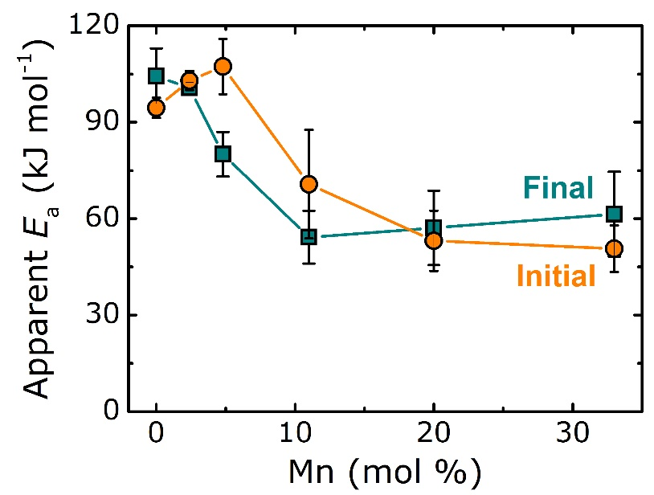
Figure S7. Apparent activation energy (E_{a}) as a function of Mn loading, calculated either from the final conversions of isothermal temperature stages (180–210 °C) between either 0 and 120 h on stream to use the initial isothermal stage at 180 °C (orange circles) or between 30 and 150 h on stream to use the final isothermal stage at 180 °C (cyan squares).

In Figure S7, a comparison is made between the E_{a} values calculated using either the conversions at the initial or the final isothermal stage at 180 °C. The largest differences were observed for the catalysts containing 4.8 and 11 mol% Mn, due to the fact that these two catalysts were most affected by (de-)activation over time on stream (Figure 2a). The 11_MnO_{x}-Cu/C catalyst initially activated over time during the temperature increase to 200 °C, which was followed by deactivation. Remarkably in the case of the 4.8_MnO_{x}-Cu/C catalyst, a continuous increase in conversion over time was observed. Irrespective of these differences, the addition of MnO_{x} as promoter lowered the apparent activation energy in both cases, confirming a valid trend.

Effect of water concentration in the EtOAc feed.
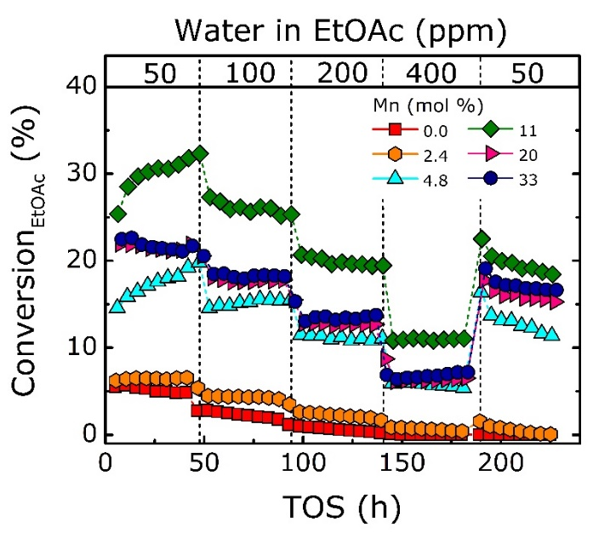
Figure S8. Isothermal EtOAc conversion as a function of water concentration (ppm) in the EtOAc feed and time on stream (TOS; h). Reaction conditions: H₂:He:EtOAc = 10:1:1 vol%,50–400 ppm water in EtOAc feed, 200 °C, 30 bar and GHSV between 6,200–7,200 h⁻¹.

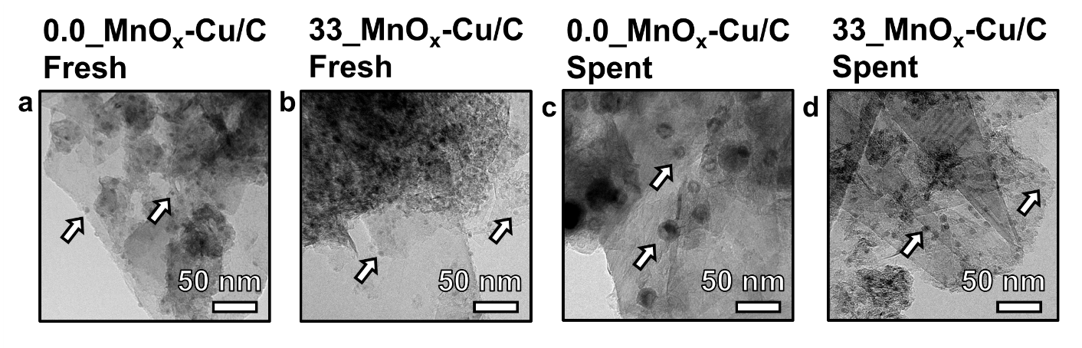
Figure S9. Transmission electron micrographs with arrows indicating several representative nanoparticles for a) fresh catalyst 0.0_MnO_{x}-Cu/C, b) fresh catalyst 33_MnO_{x}-Cu/C, c) used catalyst 0.0_MnO_{x}-Cu/C and d) used catalyst 33_MnO_{x}-Cu/C. The used catalysts were analyzed after around 240 h on stream with water contents of 50 to 400 ppm (Figure S7).

Product selectivity. The predominant reaction product for all experiments was ethanol, with minor side-production of ethane, acetaldehyde and acetic acid. The product selectivities (S_{Product}) were determined as S_{Ethane} = 0.5*(Yield_{Ethane}/Conversion_{EtOAc}) and S_{EtOH} = (Yield_{EtOH}/Conversion_{EtOAc}). S_{EtOH} was >99 % for all catalysts. Figure S8 shows S_{Ethane} as a function of the reaction temperature, for the full series of MnO_{x}-Cu/C catalyst, prepared using high surface area graphitic carbon as the catalyst support. S_{Ethane} slightly increased with reaction temperature, yet was unaffected by the EtOAc conversion level. Moreover, the presence of MnO_{x} decreased S_{Ethane}, thus enhancing the value for S_{EtOH}.

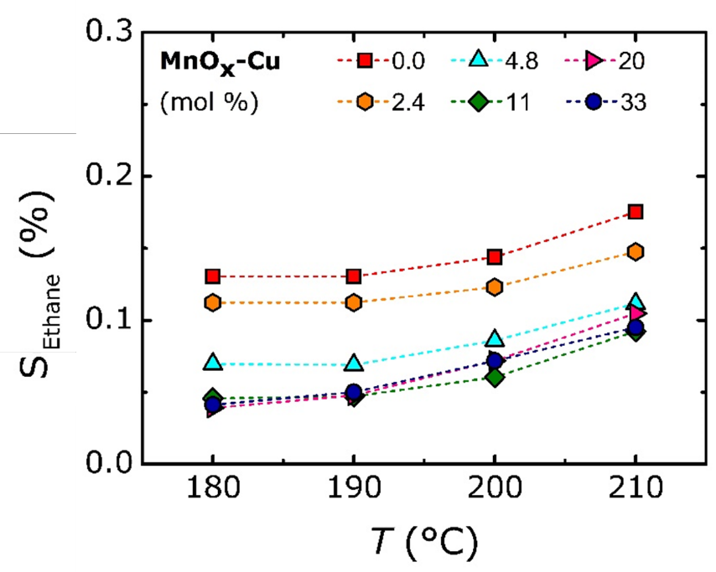
Figure S10. Ethane product selectivity (S_{Ethane}) as a function of temperature for the MnO_{x}-Cu/C catalysts synthesized with variation of the Mn loading between 0–33 mol% Mn/(Cu+Mn). Reaction conditions: H₂:He:EtOAc = 10:1:1 vol%, 50 ppm water in EtOAc feed, 180–210 °C, 30 bar and GHSV between 6,200–7,000 h⁻¹.

H₂ temperature-programmed reduction analysis.

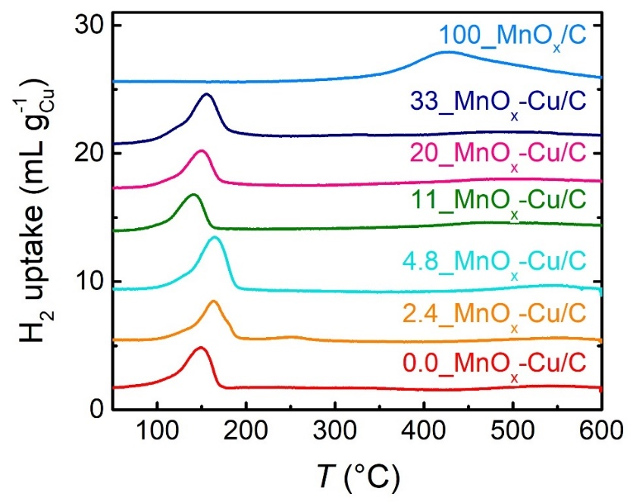
Figure S11. Temperature-programmed H₂ reduction profiles for the MnO_{x}-Cu/C catalysts, during heating to 600 °C (2°C min⁻¹), under 5 vol% H₂/Ar flow. Profiles stacked with individual offset for visual clarity.

In situ X-ray absorption spectroscopy. XAS analysis on the passivated MnO_{x}-Cu/C catalysts showed that the Cu K-edge absorption energies of the passivated catalysts were located between the Cu⁺ and Cu²⁺ references (Figure S6a). The Mn K-edge absorption energies for all passivated MnO_{x}-Cu/C catalysts were located between the Mn²⁺ and Mn³⁺ references, with a distinct shift towards higher energies for increasing Mn loadings (Figure S6b). At the same time, the Mn³⁺ white line feature around 6560 eV increased, with the largest increase for 11 mol% Mn.
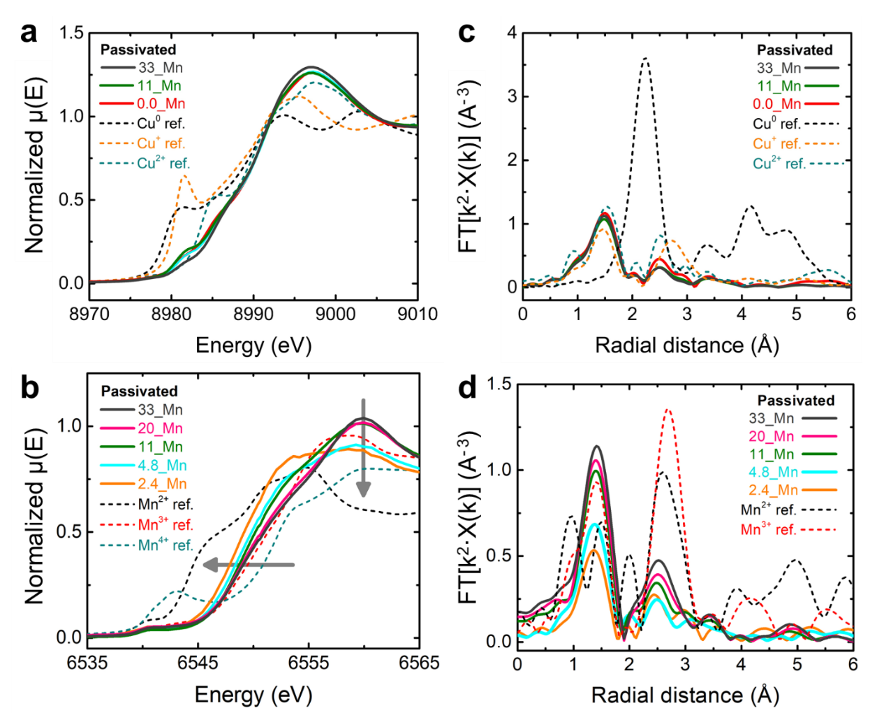
Figure S12. X-ray absorption near edge spectroscopy for several representative passivated MnO_{x}-Cu/C catalysts, measured under He flow at room temperature, with a) near Cu K-edge normalized XANES; b) near Mn K-edge normalized XANES; c) k²-weighted EXAFS in R-space for Cu; d) k²-weighted EXAFS in R-space for Mn. The gray arrows illustrate the edge shift towards lower energy and decrease in white line feature for decreasing Mn loadings.
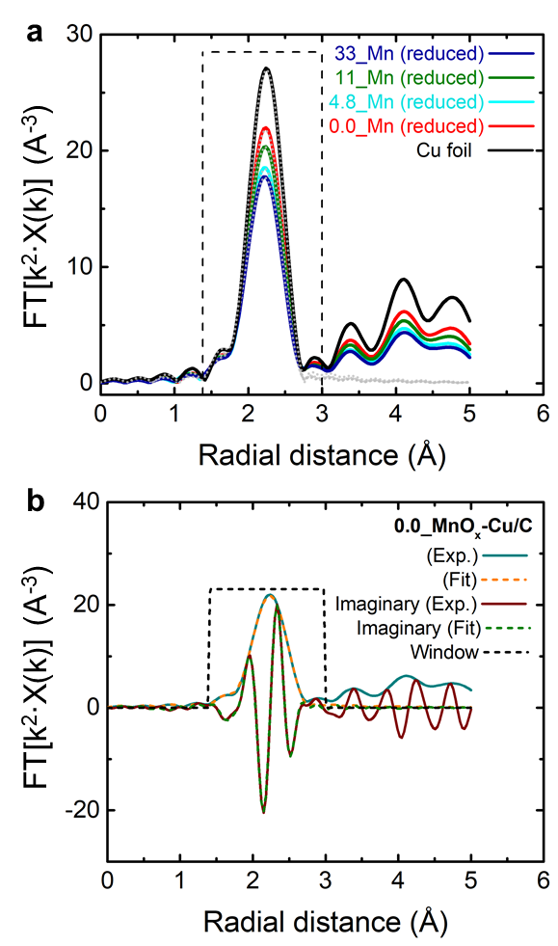
Figure S13. EXAFS fitting for several reduced MnO_{x}-Cu/C catalysts, after reduction for 1 h at 250 °C under flow of 4 vol% H₂/He. a) k²-weighted Cu EXAFS in R-space for representative MnO_{x}-Cu/C catalysts, showing experimentally measured spectra (coloured solid curves) and overlaying fitted spectra (grey dotted lines), with b) Example of EXAFS fitting for 0.0_MnO_{x}-Cu/C catalyst with experimental (Exp.) and fitted (Fit) spectra, for both the magnitude and imaginary parts of the EXAFS.

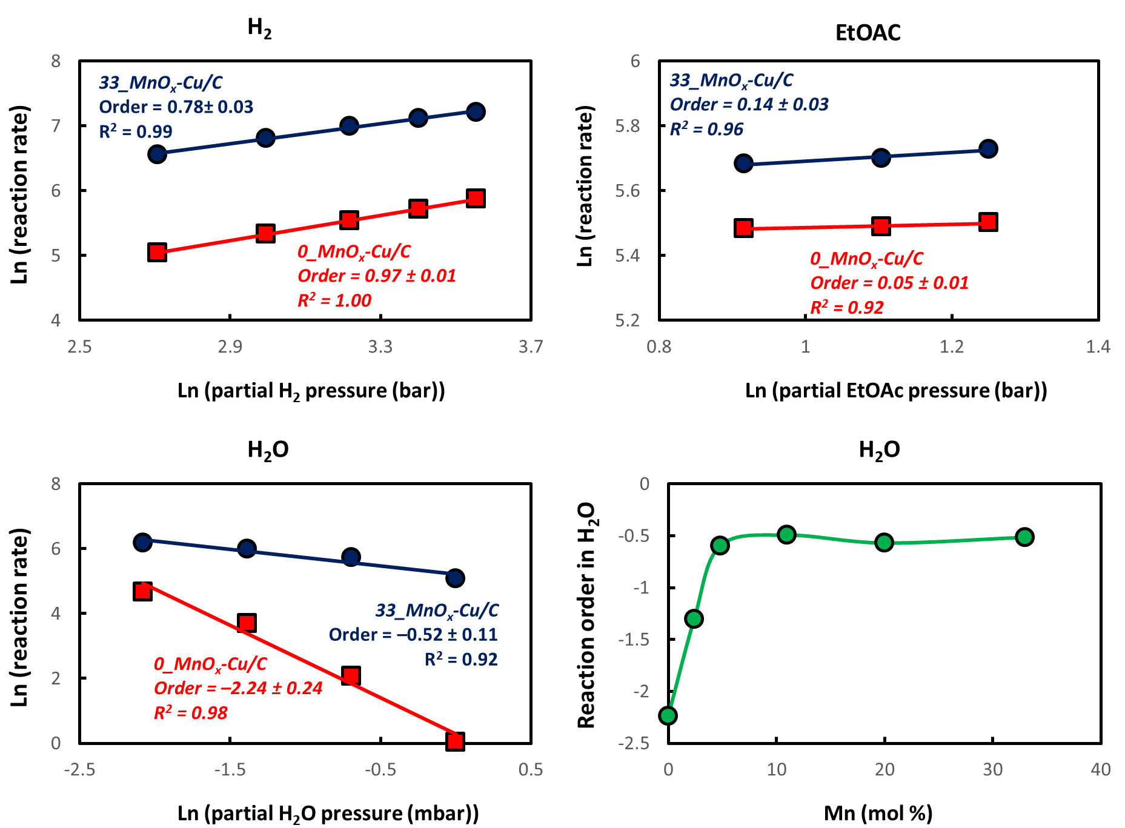
Figure S14: Reaction kinetics, showing the reaction rates (Log(${μmol}_{EtOAc}^{converted} h^{-1}g_{Cu}^{-1}$)) as a function of the partial H₂, EtOAc or H₂O pressures. The orders were calculated from the slope of the linear fits. Variation of the partial pressures was done for one reactant at a time, and data was acquired after >5 h at each stage. Reaction conditions: H₂ variation H₂:He:EtOAc:N₂ = 6–14 : 1 : 1 : 0–4 vol%, 50 ppm water in EtOAc feed, 200 °C, 40 bar; EtOAc variation H₂:He:EtOAc:N₂ = 10 : 1 : 1–1.4 : 3.6–4.0 vol%, 50 ppm water in EtOAc feed, 200 °C, 40 bar. H₂O variation H₂:He:EtOAc:N₂ = 10 : 1 : 1 : 4 vol%, 50–400 ppm water in the liquid EtOAc feed = 0.125–1 mbar H₂O in the gas phase, 200 °C, 30 bar. For the variation of H₂ and EtOAc, these experiments were performed at 40 bar pressure instead of 30 bar (as for all other experiments) to compensate for the changes in gas composition, while keeping the volumetric flow rate constant by decreasing/increasing the flow rate of N₂ as a diluent.

Table S3. H₂ uptake and average Cu and Mn oxidation states for MnO_{x}-Cu/C catalysts.
Mnª  (mol%) | H₂  uptake^{b}  (H₂/Cu) | CN^{c}  Cu–Cu  (red) | Average oxidation state^{d}
 |  |  | Cu  (pas) | Cu  (red) | Mn  (pas) | Mn  (red)
0.0 | 0.7 | 11.3 | 1.5 | 0.0 | - | -
2.4 | 1.2 | n.d. | n.d | n.d. | 2.3 | 2.2
4.8 | 1.2 | 10.4 | 1.5 | 0.0 | 2.7 | 2.3
11 | 1.2 | 10.8 | 1.3 | 0.0 | 2.8 | 2.4
20 | 1.1 | n.d. | n.d | n.d. | 2.9 | 2.5
33 | 1.3 | 10.2 | 1.6 | 0.0 | 2.9 | 2.5

a) Nominal Mn loading expressed as mol% Mn/(Cu+Mn); b) H₂ consumption between 100–250 °C during heating (2°C min⁻¹) under 5 vol% H₂/Ar flow; c) Cu–Cu coordination number (CN) after in situ reduction for 1 h at 250 °C, under 4 vol% H₂/He flow ; d) Average Cu and Mn oxidation states for the MnO_{x}-Cu/C catalysts after synthesis (passivated, pas) and after in situ reduction (red), as determined by XANES analysis.

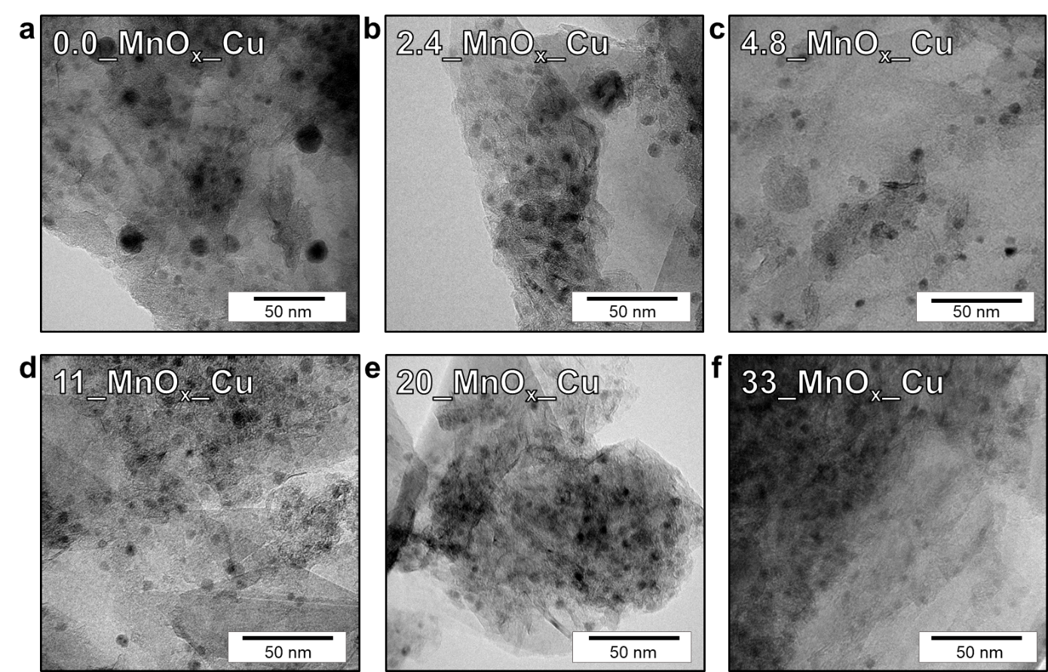
Figure S15. Transmission electron micrographs of the used MnO_{x}-Cu catalysts synthesized with varying Mn loading between 0–33 mol% Mn/(Cu+Mn), after 150h on stream. Reaction conditions: H₂:He:EtOAc = 10:1:1 vol%, 180–210 °C, 30 bar and GHSV between 6,200–7,000 h⁻¹.
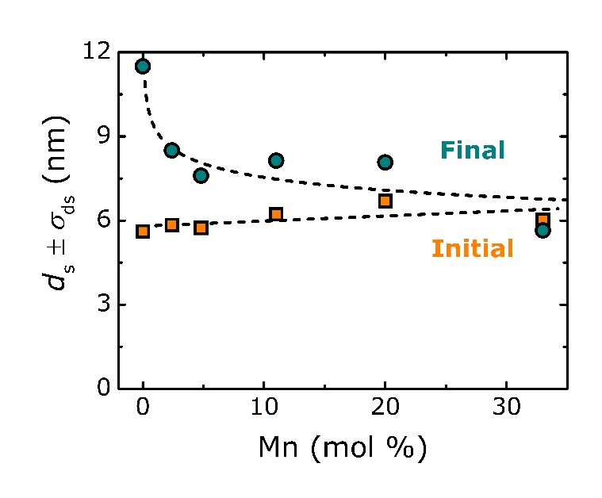
Figure S16. TEM particle size analysis for the series of MnO_{x}-Cu/C catalysts before and after catalysis for 150 h between 180 and 210 °C, showing the surface-averaged particle size (d_{n}) for the initial catalysts (orange squares) and final used catalysts (cyan circles).

Isothermal catalyst stability. The catalyst (de-)activation behavior was studied under isothermal reaction conditions, i.e. during 225 h at 200 °C (Figure S13). The GHSV for each MnO_{x}-Cu/C catalyst was adjusted to achieve around 15±5% EtOAc conversion after 50 h on stream. Next, we evaluate the relative changes in conversion between 50–225 h on stream. The conversion for the 0.0_MnO_{x}-Cu/C catalyst increased 6%, while the 2.4_MnO_{x}-Cu/C catalyst gained 33% conversion. Remarkably, the 4.8_MnO_{x}-Cu/C catalyst gained 67% conversion and continued to strongly activate even after 225 h. The MnO_{x}-Cu/C catalysts with ≥11 mol% Mn lost 6–16% conversion. The Mn loading hence strongly affected the activation behavior, which was occurred slowest at low Mn loading. At high Mn loadings, the catalysts activated rapidly, followed by gradual deactivation over time.

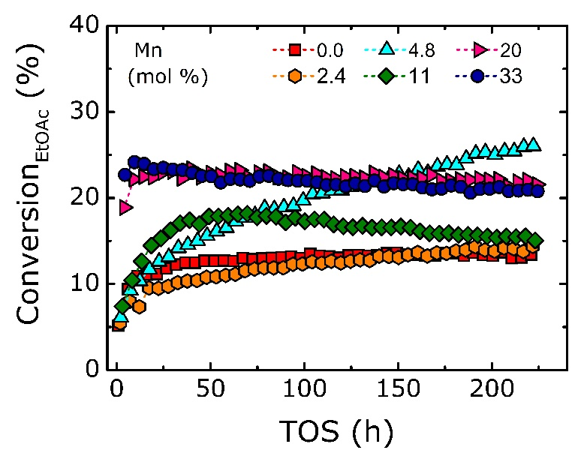
Figure S17. EtOAc conversion profiles under isothermal conditions, for the MnO_{x}-Cu/C catalysts with varying Mn loadings between 0–33 mol% Mn/(Cu+Mn), prepared using high surface area graphitic carbon as support. Reaction conditions: H₂:He:EtOAc = 10:1:1 vol%, 50 ppm water in EtOAc feed, 225 h at 200 °C, 30 bar and GHSV tuned between 2,000–17,000 h⁻¹ to achieve 15±5% EtOAc conversion after 50 h on stream.
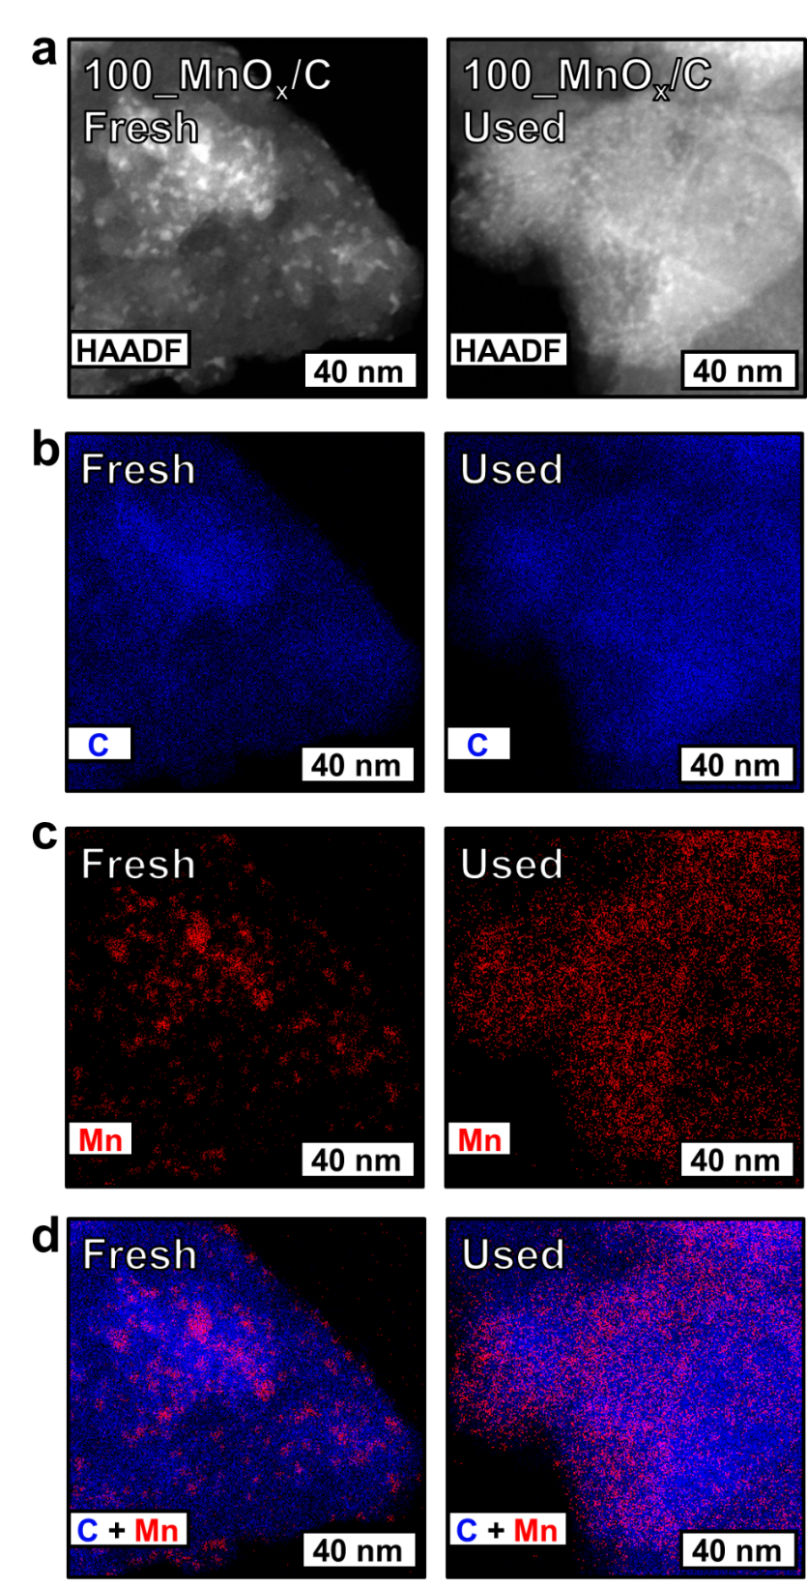
Figure S18. STEM-HAADF-EDX analysis for the fresh 100_MnO_{x}/C sample and after 150 h under reaction conditions at 180–210 °C; a) STEM-HAADF image and corresponding EDX maps showing the distribution of b) Carbon; c) Manganese; d) Overlay of carbon (blue) and manganese (red).

Supplementary references
[1] G.R. Johnson, S. Werner, A.T. Bell, An Investigation into the Effects of Mn Promotion on the Activity and Selectivity of Co/SiO2 for Fischer–Tropsch Synthesis: Evidence for Enhanced CO Adsorption and Dissociation, ACS Catalysis, 5 (2015) 5888-5903.
[2] G. Ertl, H. Knözinger, J. Weitkamp, Handbook of Heterogeneous Catalysis, Wiley, 2008.
[3] R. Beerthuis, J.W. de Rijk, J.M.S. Deeley, G.J. Sunley, K.P. de Jong, P.E. de Jongh, Particle size effects in copper-catalyzed hydrogenation of ethyl acetate, J. Catal., 388 (2020) 30-37.
[4] M.B. Fichtl, J. Schumann, I. Kasatkin, N. Jacobsen, M. Behrens, R. Schlögl, M. Muhler, O. Hinrichsen, Counting of Oxygen Defects versus Metal Surface Sites in Methanol Synthesis Catalysts by Different Probe Molecules, Angew. Chem. Int. Ed., 53 (2014) 7043-7047.
[5] J.W. Evans, M.S. Wainwright, N.W. Cant, D.L. Trimm, Structural and reactivity effects in the copper-catalyzed hydrogenolysis of aliphatic esters, J. Catal., 88 (1984) 203-213.
[6] J. Schittkowski, K. Tölle, S. Anke, S. Stürmer, M. Muhler, On the bifunctional nature of Cu/ZrO2 catalysts applied in the hydrogenation of ethyl acetate, J. Catal., 352 (2017) 120-129.
[7] A.K. Agarwal, N.W. Cant, M.S. Wainwright, D.L. Trimm, Catalytic hydrogenolysis of esters: a comparative study of the reactions of simple formates and acetates over copper on silica, J. Mol. Catal., 43 (1987) 79-92.
[8] P. Claus, M. Lucas, B. Lücke, T. Berndt, P. Birke, Selective hydrogenolysis of methyl and ethyl acetate in the gas phase on copper and supported Group VIII metal catalysts, Applied Catalysis A: General, 79 (1991) 1-18.

