Supplementary material

Cellulose microfibril networks in hydrolysed soy protein isolate solutions
Roland Gouzy^{a,b}*, Christos Tsekouª, Caroline Remijnª and Krassimir P. Velikov^{a,b,c}*

ª Unilever R&D Vlaardingen, Olivier van Noortlaan 120, 3133 AT Vlaardingen, The Netherlands.
^{b} Institute of Physics, University of Amsterdam, Science Park 904, 1098 XH Amsterdam, The Netherlands.
^{c} Soft Condensed Matter, Debye Institute for Nanomaterials Science, Utrecht University, Princetonplein 5, 3584 CC Utrecht, The Netherlands.

Figure S1. Cryo-SEM micrographs of the CMF-HSPI dispersions
Representative cryo-SEM images of CMF dispersions. The Cryo-SEM micrographs show the attractive nature of the CMFs: the CMFs are always appearing as bundles where the single fibrils are connected to neighboring fibrils. This bundling is mainly due to hydrogen bonding and van der Waals attractions between the CMFs.

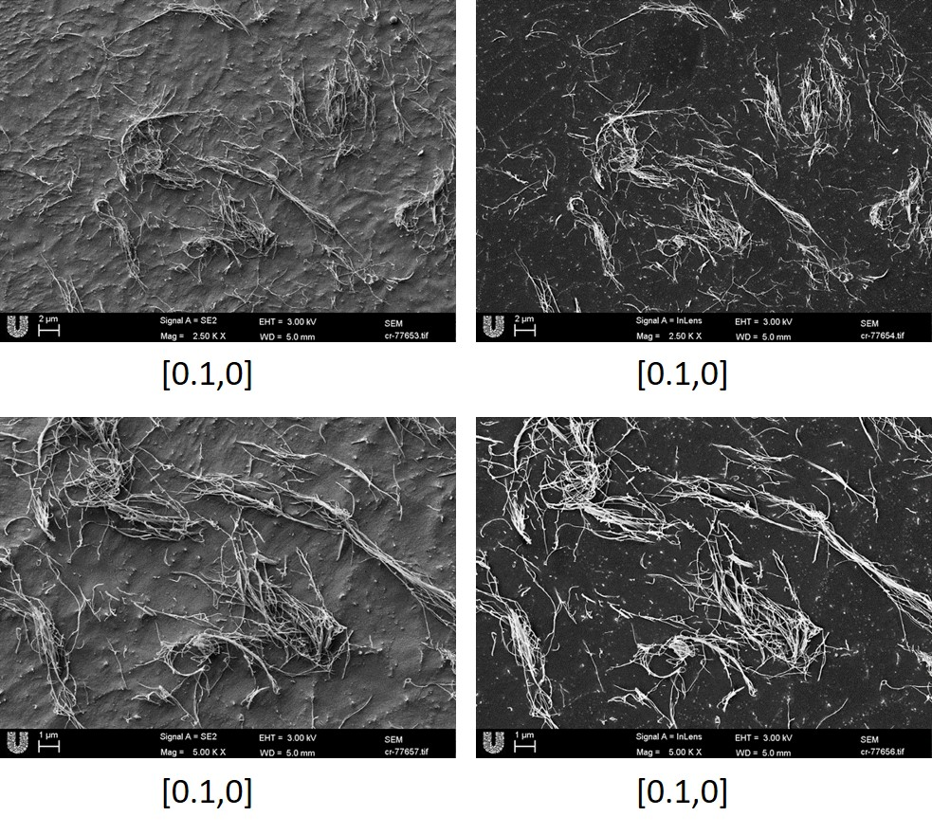

Figure S2. Cryo-SEM micrographs of the HSPI dispersions
Representative cryo-SEM images of HSPI dispersions. The formation of HSPI network were observed. We observed here the formation of a kind of continuous network, confirming the results obtained by rheology, where G’ and G’’ values increased by increasing the HSPI concentration.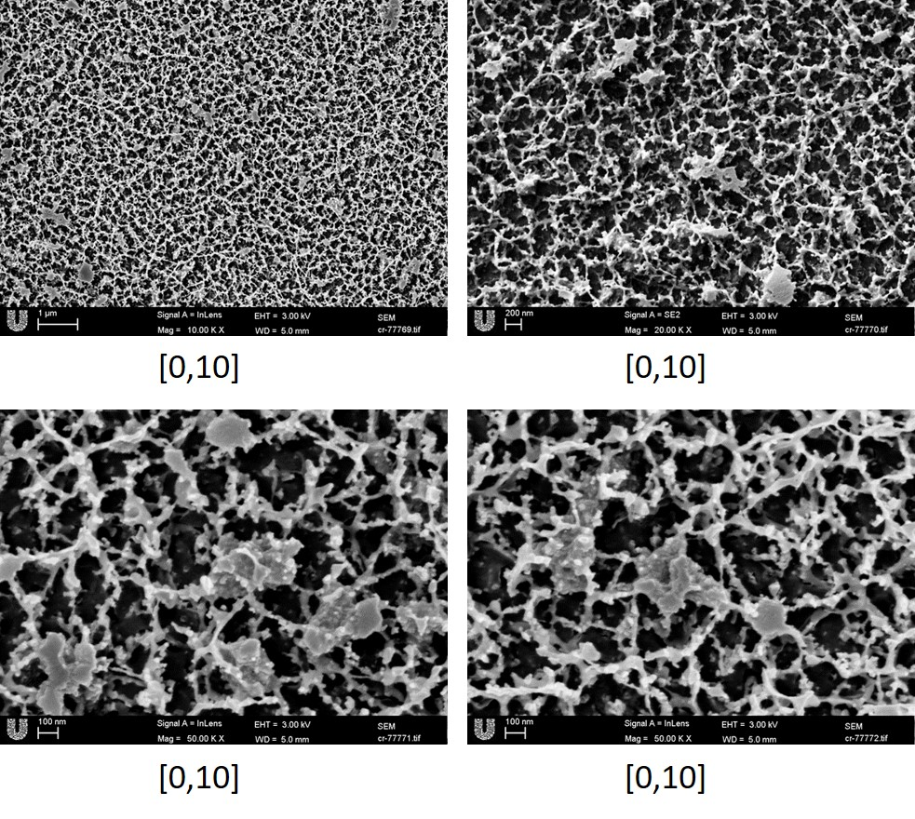

Figure S3. Cryo-SEM micrographs of the CMF-HSPI dispersions
Representative cryo-SEM images of CMF-HSPI dispersions at different HSPI and CMF concentrations. Concentrations of CMF (wt%) and HSPI (wt%) are given by [CMF, HSPI]. Here we observe a bundle of CMFs among the HSPI frozen solution. We observe as previously, globular particles at the surface of the CMFs which we are supposed to be HSPI particles.
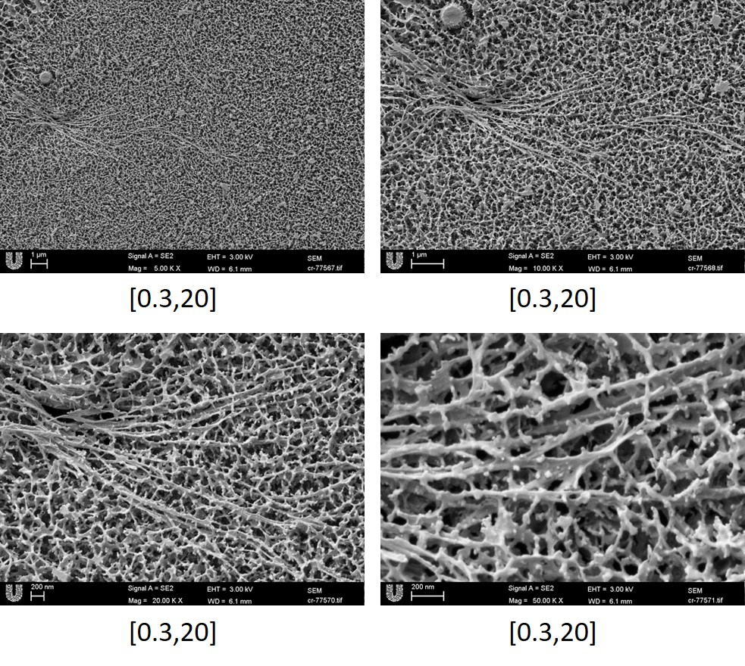

Figure S4. Cryo-SEM micrographs of the CMF-HSPI dispersions
Representative cryo-SEM images of CMF-HSPI dispersions at different HSPI and CMF concentrations. Concentrations of CMF (wt%) and HSPI (wt%) are given by [CMF, HSPI]. As well as the in figure S3, we observe here a bundle of aligned CMFs. Despite the smaller concentration of HSPI, we still observe a dense network
