Supplementary Material for the article:
Phase constitution and microstructure of the NbTiVZr refractory high-entropy alloy solidified upon different processing

Angelo F. Andreoli^{a*}, Rafael G. Mendes^{a, b}, Victor T. Witusiewicz^{c}, Olga Shuleshovaª, Marijn A. van Huis^{b}, Kornelius Nielsch^{d,e}, Ivan Kabanª*
ª IFW Dresden, Institute for Complex Materials, Helmholtzstr. 20, 01069, Dresden, Germany
^{b} Soft Condensed Matter, Debye Institute for Nanomaterials Science, Utrecht University, Princetonplein 5, 3584 CC Utrecht, The Netherlands
^{c} ACCESS e.V., Inzestraße 5, 52072, Aachen, Germany
^{d} IFW Dresden, Institute for Metallic Materials, Helmholtzstraße 20, 01069, Dresden, Germany
^{e} Institute of Materials Science, Technische Universität Dresden, 01062, Dresden, Germany

*Corresponding authors:
a.fernandes.andreoli@ifw-dresden.de (A.F. Andreoli)
i.kaban@ifw-dresden.de (I. Kaban).

Figure S1. 3D XRD plot showing formation of the bcc#1 phase during crystallization of the undercooled NbTiVZr melt; this corresponds to the data shown in Fig. 1.
Figure S2. 3D XRD plot showing formation of the two additional bcc phases during cooling of NbTiVZr sample from semisolid state; this corresponds to the data shown in Fig. 2.

Figure S3. Magnified SEM/EDX images of the NbTiVZr solidified from the semisolid state; this corresponds to the panels (c, d) in Fig. 5.

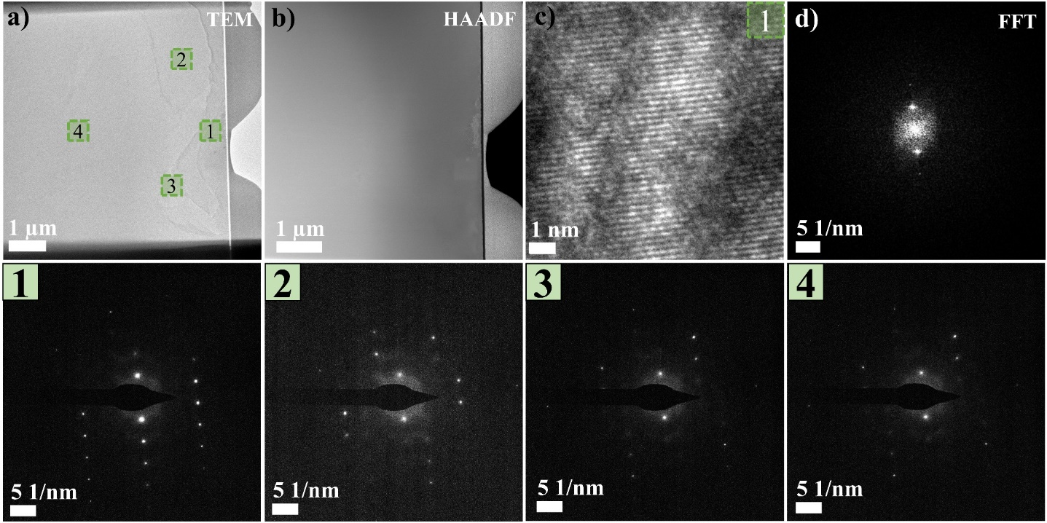
Figure S4. a) TEM image showing the cross-section of the matrix. The numbered green regions correspond to the points where the SAED patterns were collected and presented in the bottom numbered row; b) HAADF image of the same region presented in panel (a); c) high-resolution TEM image of region 1 and its fast Fourier transform (FFT) shown in panel (d).

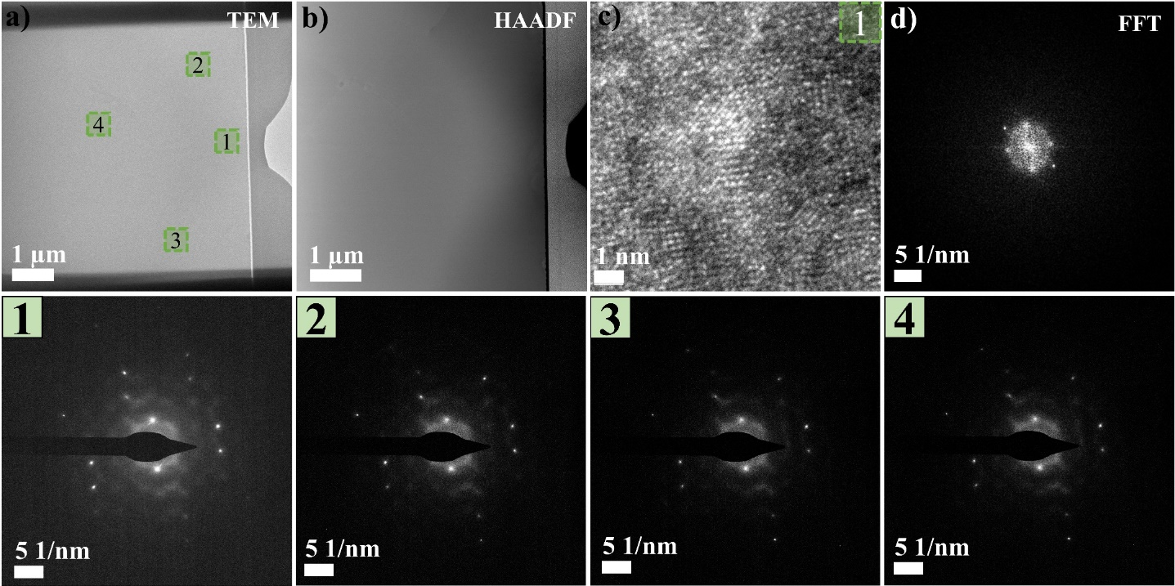
Figure S5. a) TEM image showing the cross-section of the matrix. The numbered green regions correspond to the points where the SAED patterns were collected and presented in the bottom numbered row; b) HAADF image of the same region presented in panel (a); c) high-resolution TEM image of region 1 and its fast Fourier transform (FFT) shown in panel (d).

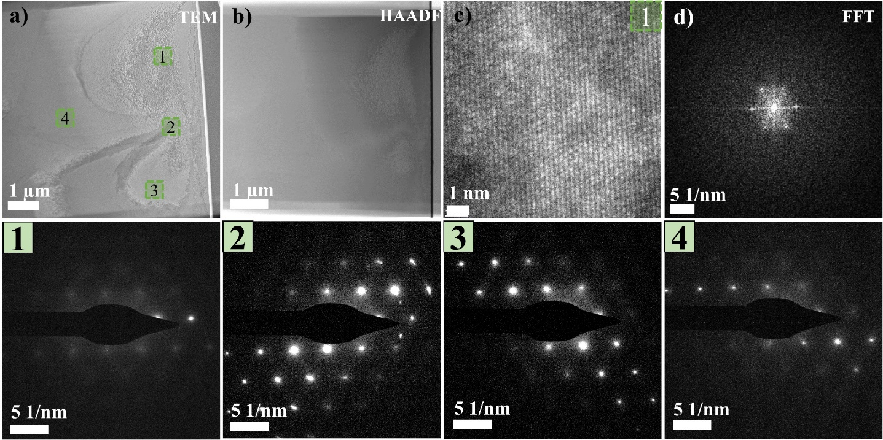
Figure S6. a) TEM image showing the cross-section of the matrix. The numbered green regions correspond to the points where the SAED patterns were collected and presented in the bottom numbered row; b) HAADF image of the same region presented in panel (a); c) high-resolution TEM image of region 1 and its fast Fourier transform (FFT) shown in panel (d).

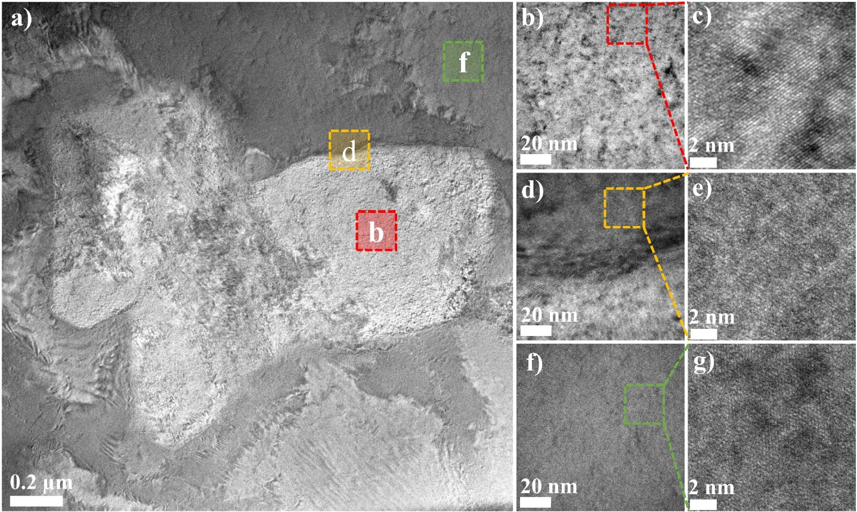
Figure S7. a) TEM image showing the three coexisting bcc phases; b) V-rich region; d) interface between V-rich and Zr-rich regions; f) matrix. Panels (c), (e), and (g) correspond to high-magnification TEM images of the V-rich, Zr-rich, and matrix regions, respectively.

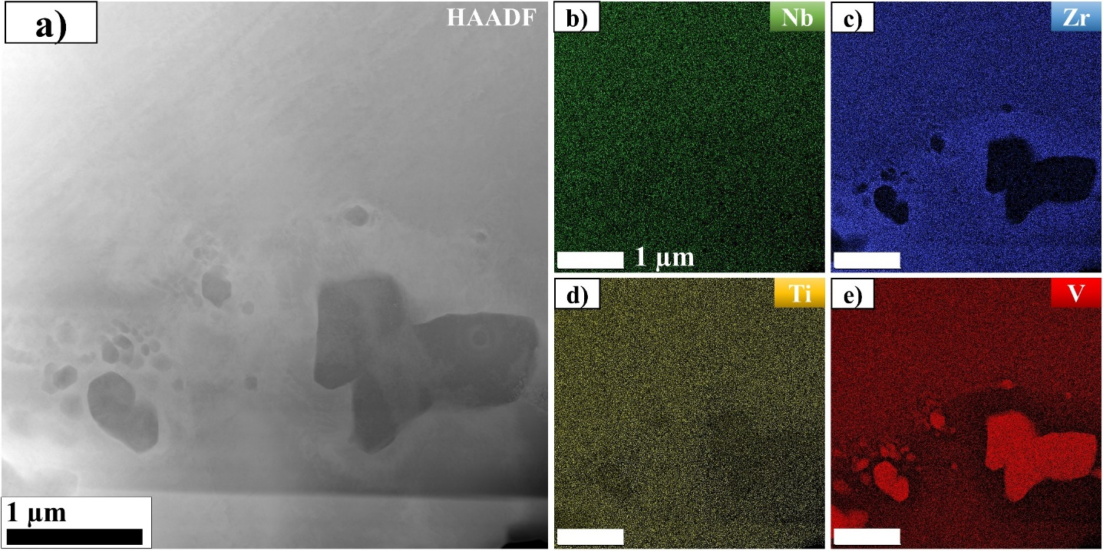
Figure S8. a) High-magnification HAADF image showing the V-rich regions in dark contrast; b, c, d, e) EDX element maps for Nb, Zr, Ti, and V, respectively.

