Supporting information
Recombination and localization: unfolding the pathways behind conductivity losses in Cs₂AgBiBr₆ thin films
Huygen J. Jöbsis¹, Valentina M. Caselli², Sven H. C. Askes³, Erik C. Garnett³, Tom J. Savenije², Freddy T. Rabouw^{1*}, Eline M. Hutter^{1*}
- Inorganic Chemistry and Catalysis, Department of Chemistry, Utrecht University, Princetonlaan 8, 3584 CB Utrecht, the Netherlands
- Department of Chemical Engineering, Delft University of Technology, van der Maasweg 9, 2629 HZ Delft, the Netherlands
- Center for Nanophotonics, AMOLF, 1098 XG Amsterdam, the Netherlands
Corresponding Authors
Freddy T. Rabouw, f.t.rabouw@uu.nl;
Eline M. Hutter, e.m.hutter@uu.nl

Experimental Information

Chemicals. 99.9% silver bromide (AgBr, Strem), 99.999% cesium bromide (CsBr, Sigma-Aldrich), 99.998% bismuth bromide (BiBr₃, Sigma-Aldrich), 99.9% anhydrous dimethyl sulfoxide (DMSO, Sigma-Aldrich).

CABB thin film synthesis. In a nitrogen filled glovebox 1.5 mmol CsBr, 0.75 mmol AgBr and 0.75 mmol BiBr₃ were dissolved in 1.5 mL DMSO by heating the mixture to 70 ℃ for 1 h until a clear yellow solution was obtained. 15 mm x 15 mm borosilicate glass optical substrates were cleaned by 5 min O₂ plasma cleaning. 80 μL perovskite solution was spin coated on the optical substrate by spinning at 4000 rpm for 40 seconds. The sample was allowed to rest for 15 minutes at room temperature before annealing at 250 ℃ for 5 minutes.

X-ray diffraction crystallography. X-ray diffraction (XRD) pattern was obtained with a Bruker-AXs D8 Phaser powder X-ray diffractometer in Bragg-Brentano geometry, using Cu Kα_{1,2} = 1.54184 Å, operated at 40 kV. The measurements used a step size of 0.01° and a scan speed of 1 s, with a 2 nm slit of the source.

Scanning electron microscopy. The image of the thin film surface was obtained using a scanning electron microscope (InTouchScope) operating at an accelerating voltage of 8 kV.

Steady state optical properties. The transmittance, absorptance and reflectance were determined using a Perkin-Elmer lambda UV-Vis-NIR_lambda950S with integrating sphere. The transmittance (fraction of photons transmitted, T) was determined by placing the CABB thin film at the entrance of the integration sphere. The sum of reflectance (fraction of photons reflected; R) and transmittance was determined by placing the thin film inside the sphere under an angle of 15° . Now the reflectivity and absorptivity (fraction of absorbed light, A) were calculated using

$$R=\left(R+T\right)-T$$
and
$$A=1-(R+T)$$

The photoluminescence spectrum has been recorded with a FLAME-S-VIS-NIR Ocean Optics spectrometer upon photoexcitation by CPS405 ThorLabs laser diode at 405 nm, in a home build set-up.
Determination of optical constants. The optical constants of the CABB layer were extracted using ellipsometry on a J. A. Woollam Variable Angle Spectrometric Ellipsometer (VASE) between 300 and 1700 nm with 2 nm wavelength spacing and at 5 different angles around the Brewster angle of ~65° (at 55°, 60°, 65°, 70°, and 75° angles). The layer thickness was measured using a KLA-Tencor alpha-step 500 surface profiler. The surface roughness (7.3 nm root mean square) was measured using Atomic Force Microscopy (AFM), performed on a Veeco Dimension 3100 AFM, and calculated using Gwyddion software. From these combined data, the optical constants of the CABB layer were extracted using CompleteEASE software by employing a generic oscillator model that included two Tauc-Lorentz oscillators to model the direct and indirect bandgaps, a Lorentz oscillator for the exciton peak at 2.8 eV, and a Gaussian oscillator for the peak at 3.2 eV.
Transient absorption and reflectance spectroscopy. The transient absorption measurements were carried out using an EOS multichannel pump probe transient absorption spectrometer (Ultrafast Systems LLC.). The second (532 nm) or third harmonic (355 nm) of a Nd:YAG laser (1064 nm, 650 ps FWHM pulse duration, 1 kHz) was used as the excitation source. Laser pulses with an energy of 4.5 uJ or 5.6 uJ were focused to a spot size of 3x10⁻⁴ cm⁻², corresponding to a fluence of 2.7x10¹⁶ (at 355 nm) or 5.0x10¹⁶ (at 532 nm) photons cm⁻² per pulse.
The probe pulse was generated using a LEUKOS super continuum light source (200-2400 nm, 200 mW, < 1ns) operating at 2 kHz. The white light is split into a probe and a reference beam, which is used to correct for fluctuations in the probe intensity. The reference and probe beam transmission spectra are both detected using fiber optics coupled multichannel spectrometer with a CMOS sensor (spectral resolution of 1.5 nm).
Time resolved microwave conductivity spectroscopy. Time resolved microwave conductivity measurements have been carried out upon photoexcitation at 355 nm. The excitation is performed by a Nd:YAG laser pulse of 3 ns, at 10 Hz repetition rate. The light intensity has been varied in the range 10¹¹ to 10¹⁴ photons/cm² per pulse. Monochromatic microwaves, in the range 8.2 to 12.2 GHz, are generated by a voltage-controlled oscillator, and the measurements are performed at the resonance frequency of approximately 8.5 GHz. The photoconductance signal (ΔG) is obtained from the normalized change in microwave power (P) due to interaction with free charge carriers, as:
$$\frac{∆P(t)}{P}= -K∆G(t)$$
where K is a pre-determined sensitivity factor.

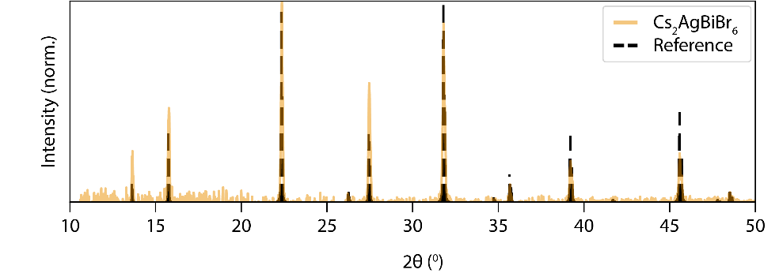
Figure S1 - Crystallographic data

X-Ray Diffraction patterns of the Cs₂AgBiBr₆ thin film. The reference diffractogram was reproduced from ref[1].

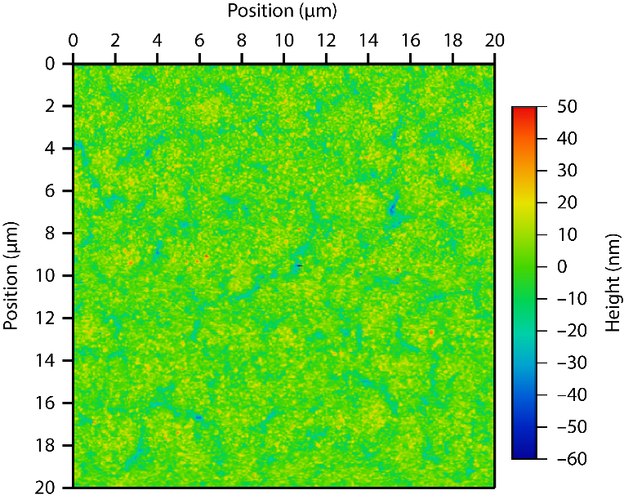
Figure S2 –Atomic Force Microscopy

Atomic force microscopy image of an area of 400 µm² of the CABB thin film, showing a homogeneous films coverage with a root-mean-square roughness of 7.3 nm.

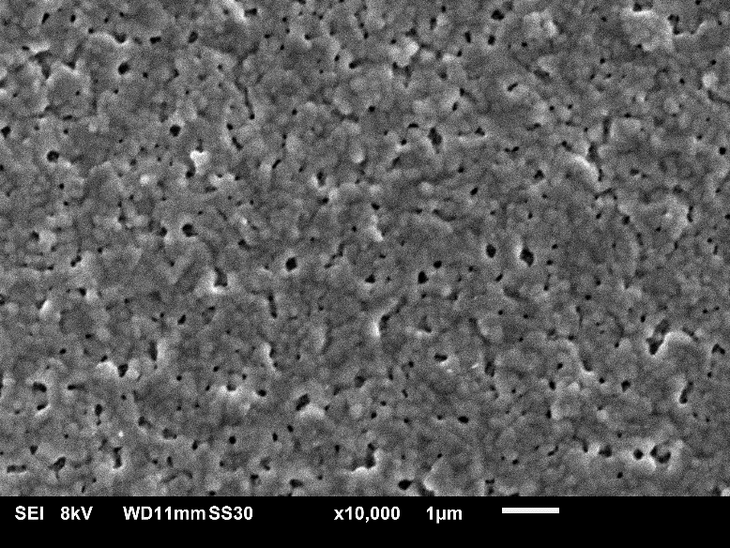
Figure S3 – Scanning electron microscopy
The image shows a 30 µm² surface magnified by a factor of 10,000.
Figure S4 – Ellipsometry spectroscopy
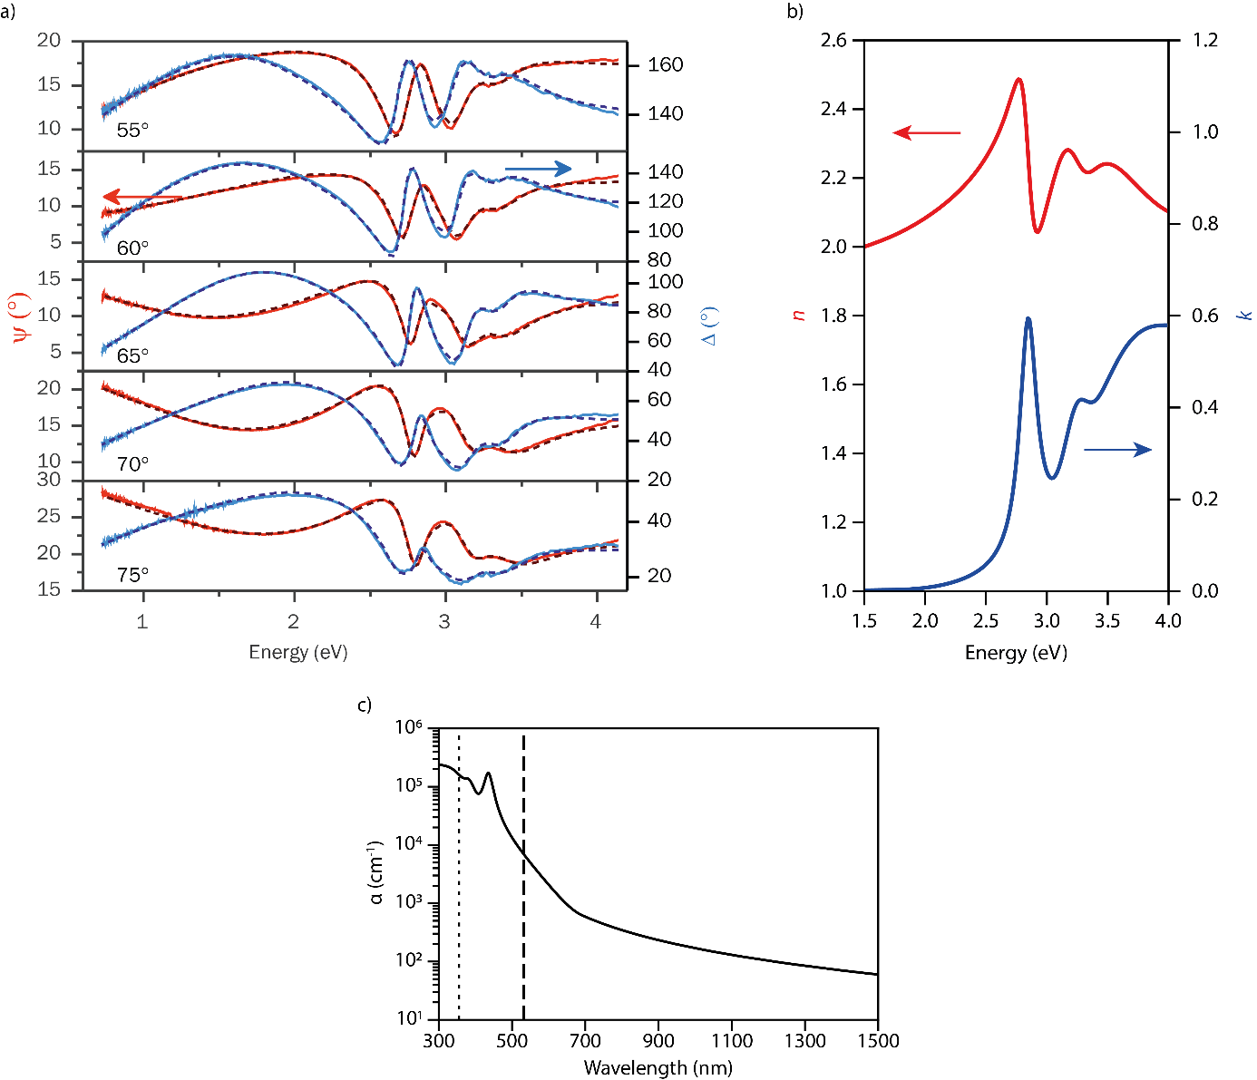

a) Complex reflection (amplitude (red, Ψ) and phase difference (blue, Δ) measured at 5 different angles around Brewster angle with 2 nm resolution. The optical constants of the CABB layer were extracted using CompleteEASE software by employing a generic oscillator model that included two Tauc-Lorentz oscillators to model the direct and indirect bandgaps, a Lorentz oscillator for the exciton peak at 2.8 eV, and a Gaussian oscillator for the peak at 3.2 eV (dashed black line). b) The refractive index (red, n) and extinction coefficient (blue, k) extracted from ellipsometry experiments. c) With the use of k the absorption coefficient (α) was calculated using
$α(λ)= \frac{4πk}{λ}$ (1)
The dashed and dotted lines represent the excitation wavelengths at 355 and 532 nm, respectively.

Figure S5 – Setup of transient absorption experiments in transmission and reflection mode
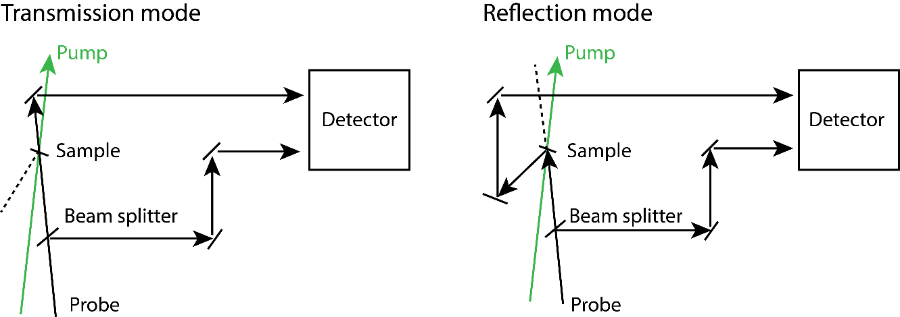

The probe pulse is split into two paths by a beam splitter. One part passes through the sample before entering a detection fiber, while the other is directed to a second fiber directly. The transmitted intensity is corrected for fluctuations in the probe intensity to obtain the differential transmittance ΔT/T of the sample:
$\frac{∆T}{T}=\ln\left(\frac{I^{*}}{I_{ref}^{*}}\frac{I_{ref}}{I}\right)$ (2)

where I is the intensity of light transmitted through the sample without pump pulse and $I_{ref}$ the corresponding intensity in the reference channel, while $I^{*}$ and $I_{ref}^{*}$ are the intensities after pumping the sample. Similarly, we calculate the differential reflectance ΔR/R from a transient reflection measurement using
$\frac{∆R}{R}=\ln\left(\frac{I^{*}}{I_{ref}^{*}}\frac{I_{ref}}{I}\right)$ (3)

where I and $I^{*}$ are the intensities of reflected light without and with pump pulse, respectively.

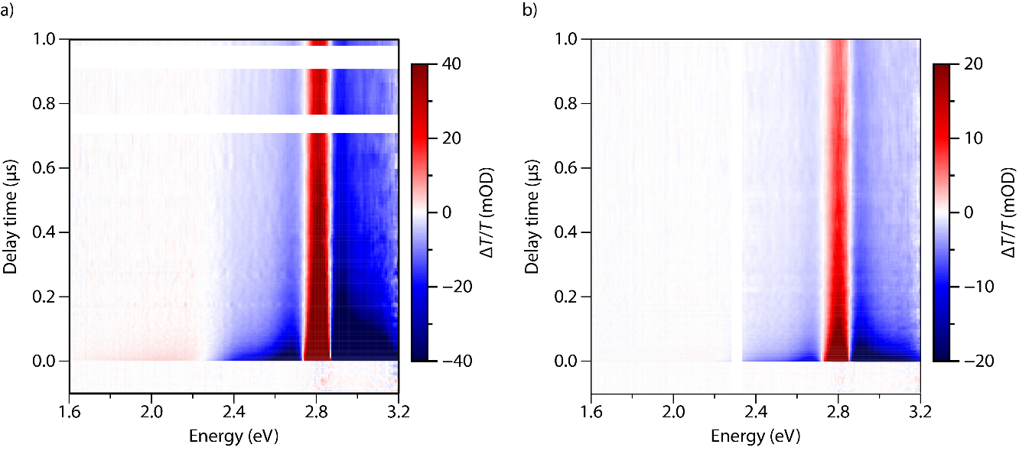
Figure S6 – Transient transmittance (ΔT/T)

a) TA spectra as a function of delay time and photon energy for excitation at 355 nm (estimated charge carrier density n = 2.09x10²⁰ cm⁻³ per pulse). b) TA spectra as a function of delay time and photon energy for excitation at 532 nm (estimated charge carrier density n = 2.02 x10²⁰ cm⁻³ per pulse). The gap in the data at 2.3 eV is due to excitation source.

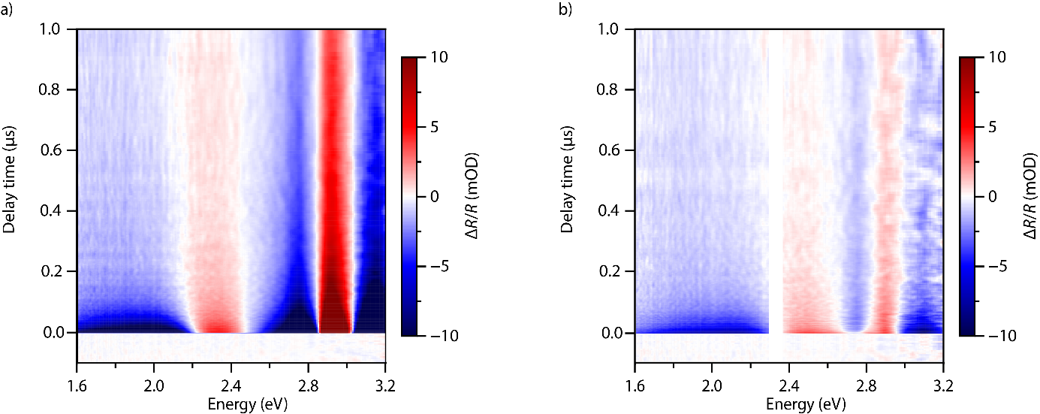
Figure S7 – Transient reflectance (ΔR/R)

a) TR spectra as a function of delay time and photon energy for excitation at 355 nm (n = 2.09x10²⁰ cm⁻³ per pulse). b) TR spectra as a function of delay time and photon energy for excitation at 532 nm (n = 2.02x10²⁰ cm⁻³ per pulse). The gap in the data at 2.3 eV is due to excitation source.

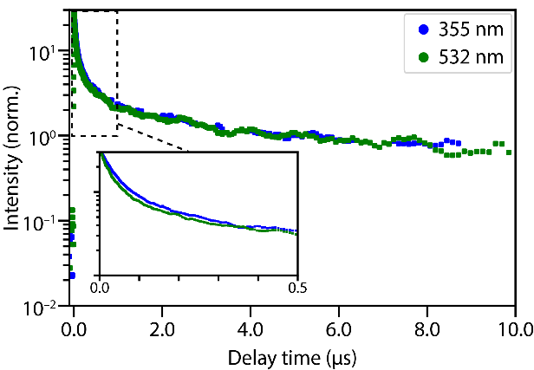
Figure S8 – TA trace of direct absorption transition

The bleach recovery dynamics of the direct absorption transition for excitation at 355 and 532 nm. The traces are normalized at 5 μs, showing similar decay dynamics. The inset shows a zoom in for the decay dyanmics on short timescales.

Figure S9 – TA and TRMC traces and charge-carrier mobilities for different excitaiton densities
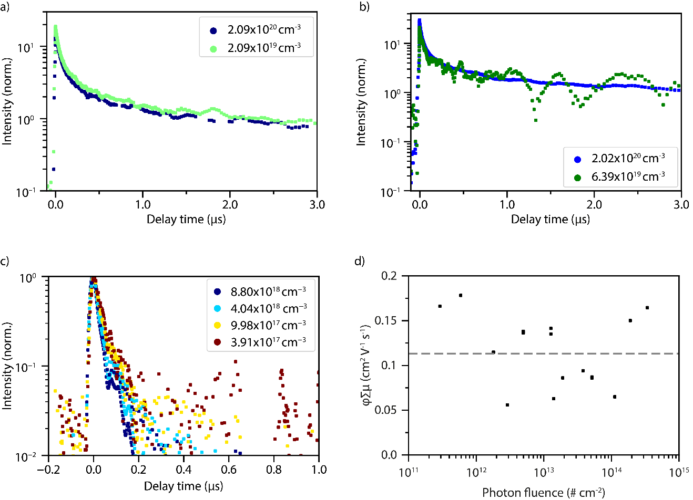
The bleach recovery dynamics at 2.8 eV for excitation at (a) 355 nm and (b) 532 nm for different excitation densities. The time traces are normalized at 2 µs, showing that the decay kinetics are nearly independent of excitation density. The excitation density is given as a number of excitation per cubic nanometer per pulse. Panel c shows the normalized TRMC signal for different excitation densities. The charge carrier mobility determined from TRMC experiments as a function of photon fluence (d), showing no dependence on the excitation density. The grey dashed line represents the average charge carrier mobility, $φ\sum{μ}=0.11 {cm}^{2} V^{-1} s^{-1}$.

Table S1 – Diffusion length

The diffusion length was estimated from the half lifetime (τ_{1/2}), i.e. the time after which the TRMC signal has dropped by a factor 2, and the mobility (see figure S8D), using ²

$L_{D}= \sqrt{μ\frac{k_{B}T}{e}τ_{1/2}}$ (4)

with µ the charge carrier mobility, k_{B} the Boltzmann’s constant, T the temperature, e the elementary charge.
Sample | Half lifetime (ns) | Mobility (cm²/(V s)) | L_{D} (nm)
Cs₂AgBiBr₆ | 35 | 0.11 | 101

References

¹ A.H. Slavney, T. Hu, A.M. Lindenberg, and H.I. Karunadasa, J. Am. Chem. Soc. 138, 2138 (2016).
² E.M. Hutter, M.C. Gélvez-Rueda, D. Bartesaghi, F.C. Grozema, and T.J. Savenije, ACS Omega 3, 11655 (2018).

