SUPPORTING INFORMATION

Elastic reinforcement and yielding of starch-filled lipid suspensions
Braulio A. Macias-Rodriguez^{a,b}, Krassimir P. Velikov^{a, b,}
ª Unilever Innovation Centre Wageningen, Bronland 14, 6708 WH Wageningen, the Netherlands
^{b} Institute of Physics, University of Amsterdam, Science Park 904, 1098 XH Amsterdam, The Netherlands
^{c} Soft Condensed Matter, Debye Institute for Nanomaterials Science, Utrecht University, Princetonplein 5, 3584 CC Utrecht, The Netherlands

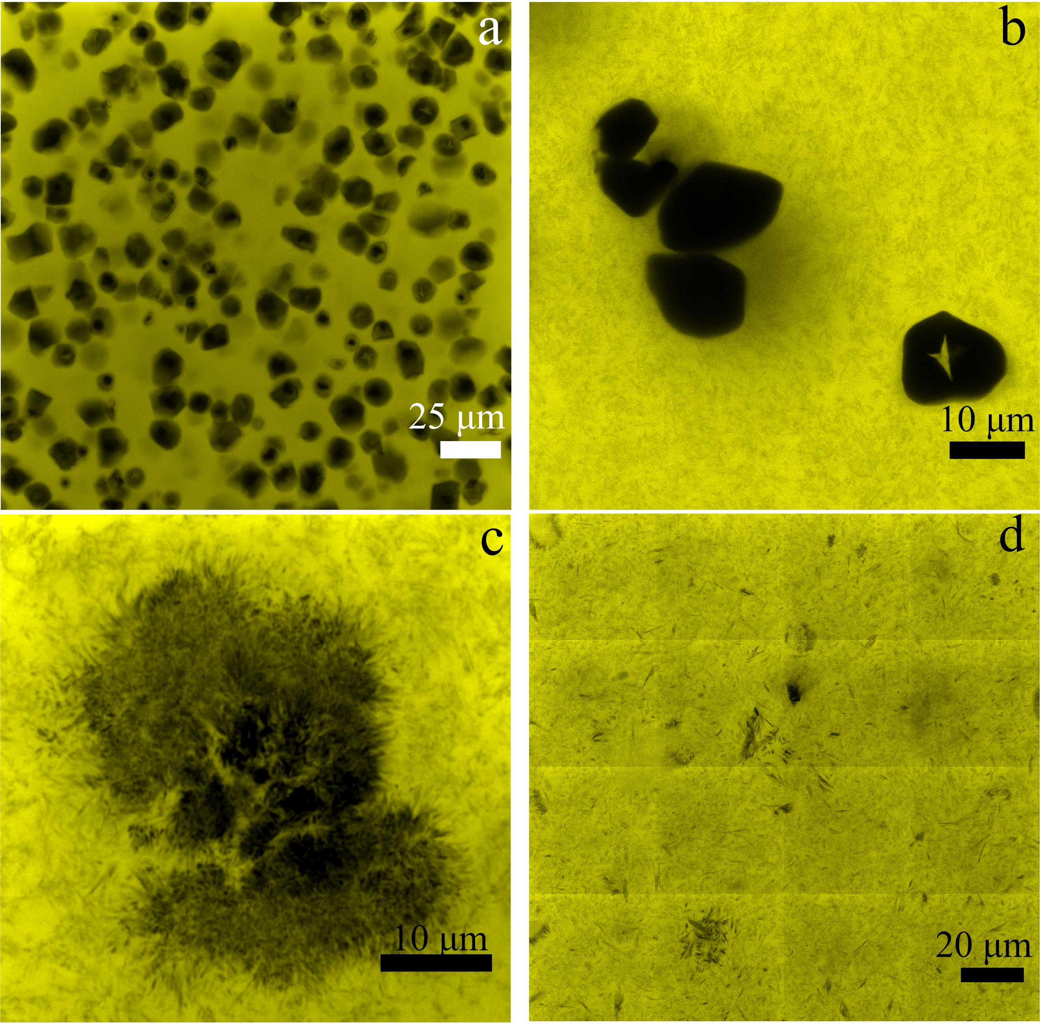
Figure S1. Confocal images of starch-filled lipid suspensions at ϕ_{starch} = 0.10 and ϕ_{lipid} = 0.10 at 40× magnification (a). Similar images at higher 63× (zoom: 2) magnification displaying starch granules (b) and the lipid colloidal gel (zoom: 3) (c), title scan (4 × 4) at similar magnification 63× of lipid colloidal gel ϕ_{lipid} = 0.10 occasionally displaying lipid clusters (d).

Figure S2. Representative SAXD (a) and WAXD (b) spectra of starch, lipid, and starch-lipid suspensions. Dotted lines indicate characteristic positions of peaks associated with the β polymorph.

Average crystal thickness (ACT) of representative samples was calculated by Scherrer equation ξ= $\frac{Kλ}{FWHM\cos{(θ)}}$ where K is the shape factor (0.9 for crystallites), $λ$is the wavelength (0.15418 nm) θ is the diffraction angle, and FWHM is the full width at half Maximum value (in radians) of the first small angle reflection corresponding to the (001) plane (Fig. S2a). Comparable ACT were obtained:
Sample | ACT ± SD (nm) | Polymorph
ϕ_{tripalmitin} = 0.10 | 40.8 ± 2.5 | β
ϕ_{tripalmitin} = 0.10 + ϕ_{starch} = 0.10 | 42.8 ± 4.1 | β
ϕ_{tripalmitin} = 0.10 + ϕ_{starch} = 0.20 | 42.4 ± 8.1 | β

Likewise, samples displayed strong lattice spacings at 4.6 Å and several other strong peaks at 3.7 Å and 3.9 Å, characteristic of beta polymorph.
Based on this and rheology investigations, we argue that starch particles do not substantially influence the nucleation and crystallization behavior of the lipid phase. Therefore, the mechanics of the lipid gel can be treated as remaining comparable when filled with starch particles.

Figure S3. Elastic modulus under varying loading conditions with plate geometries of diameter DIA = 10, 25 mm in a suspension ϕ_{lipid} = 0.1, ϕ_{starch} = 0.5 a), and effect of oscillations in suspensions ϕ_{lipid} = 0.1, ϕ_{starch} = 0.4 and ϕ_{lipid} = 0.1, ϕ_{starch} = 0.5 with plate geometries of diameter DIA = 25 mm.

b
Figure S4. Free-fitting of the dimensionless elastic modulus G' (ϕ) / G'₀ to the Krieger-Dougherty model (Eq. 2 in main text) for various “upper” limits set by G' (ϕ = 0.5) obtained at increasing normal force loading conditions 5N, 10N, and 20N with a plate-plate geometry DIA = 25mm (a). Free-fitting of the dimensionless elastic modulus G' (ϕ) / G'₀ with similar experimental data plotted in Fig. 5 in the main text (b).

