Supplementary information
Reactivity of Fe(III)-containing pyrophosphate salts with phenolics: complexation, oxidation, and surface interaction
Judith BIJLSMA^{1,‡}, Neshat MOSLEHI^{2,‡}, Krassimir P. VELIKOV^{3,4,5}, Willem K. KEGEL², Jean-Paul VINCKEN¹, and Wouter J.C. DE BRUIJN^{1,*}
† Judith Bijlsma and Neshat Moslehi contributed equally to this work
¹ Laboratory of Food Chemistry, Wageningen University & Research, Bornse Weilanden 9, P.O. Box 17, 6700 AA, Wageningen, The Netherlands
² Van ‘t Hoff Laboratory for Physical and Colloidal Chemistry, Debye Institute for Nanomaterials Science, Utrecht University, Padualaan 8, 3584 CH, Utrecht, The Netherlands
³ Unilever Innovation Centre B.V. Bronland 14, 6708 WH Wageningen, The Netherlands
⁴ Soft Condensed Matter, Debye Institute for Nanomaterials Science, Utrecht University, Princetonplein 5, 3584 CC Utrecht, The Netherlands
⁵ Institute of Physics, University of Amsterdam, Science Park 904, 1098 XH Amsterdam, the Netherlands
* Corresponding author: Email address wouter.debruijn@wur.nl

Contents |  | Page
Fig. S1 | TEM images of CaPP, FePP, and Ca-Fe(III) pyrophosphate salts | S3
Method S1 | Soluble iron concentration measurement by inductively coupled plasma-atomic emission spectroscopy (ICP-AES) | S4
Fig. S2 | Images of Eppendorfs of phenolics with CaPP, FePP, and Ca-Fe(III) pyrophosphate salts | S5
Method S2 | Elution profiles for reversed-phase chromatography | S6
Fig. S3 | Comparison of the dissolved iron measured by the ICP-AES and the ferrozine method | S7
Table S1 | Iron content (%), theoretical maximum concentration (mM), and measured iron concentration (mM) from Fe(III)-containing pyrophosphate salts | S8
Fig. S4 | Water-solubility of the phenolics at pH 3, 6, and 8 | S9
Table S2 | Stability constants of complexes of the different phenolics with Fe(III) | S10
Fig. S5 | Dissolution behavior of iron from FePP and Ca-Fe(III) pyrophosphate salts in presence of phenolics at pH 1-10 | S11
Fig. S6 | Dissolution behavior ofׄ iron from FePP and Ca-Fe(III) pyrophosphate salts in presence of epicatechin at 23, 37, and 90 °C | S12
Fig. S7 | Relation between area under the curve in the visible spectrum versus the iron concentration | S13
Fig. S8 | Proposed oxidation product of epicatechin and bar graph indicating the peak area | S14
Fig. S9 | Proposed oxidation products of quercetin and bar graph indicating the peak areas | S15
Fig. S10 | XPS wide scan spectra of CaPP, FePP, and mixed Ca-Fe(III) pyrophosphate salts | S16
Fig. S11 | XPS wide scan spectra of CaPP, FePP, and mixed Ca-Fe(III) pyrophosphate salts after incubation with epicatechin | S17
Fig. S12 | Concentration of dissolved iron, calcium, and phosphorus quantified by ICP-AES for CaPP, FePP, and Ca-Fe(III) pyrophosphate salts in presence of epicatechin | S18
References |  | S19

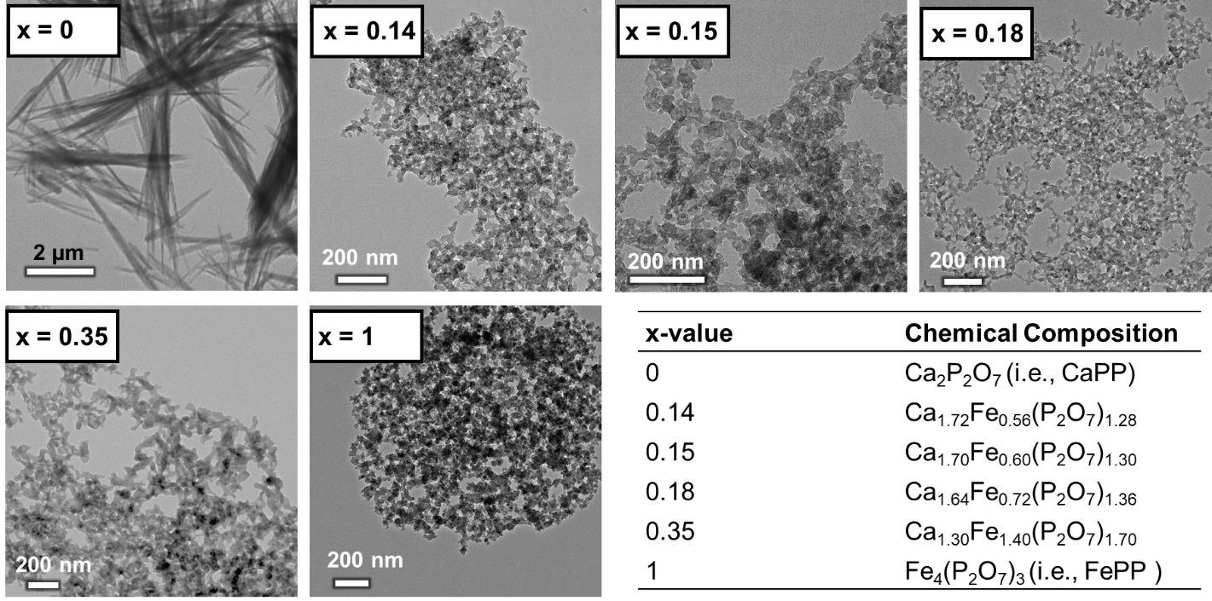
Fig. S1. TEM images of the CaPP (x = 0), FePP (x = 1), and mixed Ca-Fe(III) pyrophosphate salts with x = 0.14, 0.15, 0.18, and 0.35 prepared by coprecipitation. The x-values and chemical formula of the pure and mixed salts were obtained from the elemental composition determined by EDX.

Method S1: Dissolution of CaPP, FePP, and mixed Ca-Fe(III) pyrophosphate salts in the presence of phenolics by inductively coupled plasma – atomic emission spectroscopy (ICP-AES)
Inductively coupled plasma–atomic emission spectroscopy (ICP-AES) was used for independent verification of the iron quantification by the ferrozine assay. For ICP-AES measurements, CaPP, FePP, and the mixed Ca-Fe(III) pyrophosphate salts were redispersed in water by stirring (~250 rpm) with a magnetic stir bar (final amount of salt 10 mg/ml) followed by the addition of aqueous solutions (i.e., catechol, caffeic acid, and epicatechin) or dispersions (i.e., quercetin, apigenin, and curcumin) of the phenolics at a final concentration of 5 mM. pH was set to reach a target pH 3, 6, or 8 after 2 h of incubation at 23 °C while mixing at 1000 rpm. Samples were five times diluted in 0.14 M HNO₃, before injection in the ICP-AES system (Agilent 5110 VDV; Agilent Technologies, Tokyo, Japan). Independent duplicate samples were taken from the salt at each pH point by independent titrations. The concentration of iron, calcium, and phosphorus was determined using scandium as an internal standard. The limit of detection values of iron, calcium, and phosphorus were respectively 0.05, 0.05, and 0.20 mg/l, the limit of quantification values were 0.15, 0.15, and 0.61 mg/l respectively.

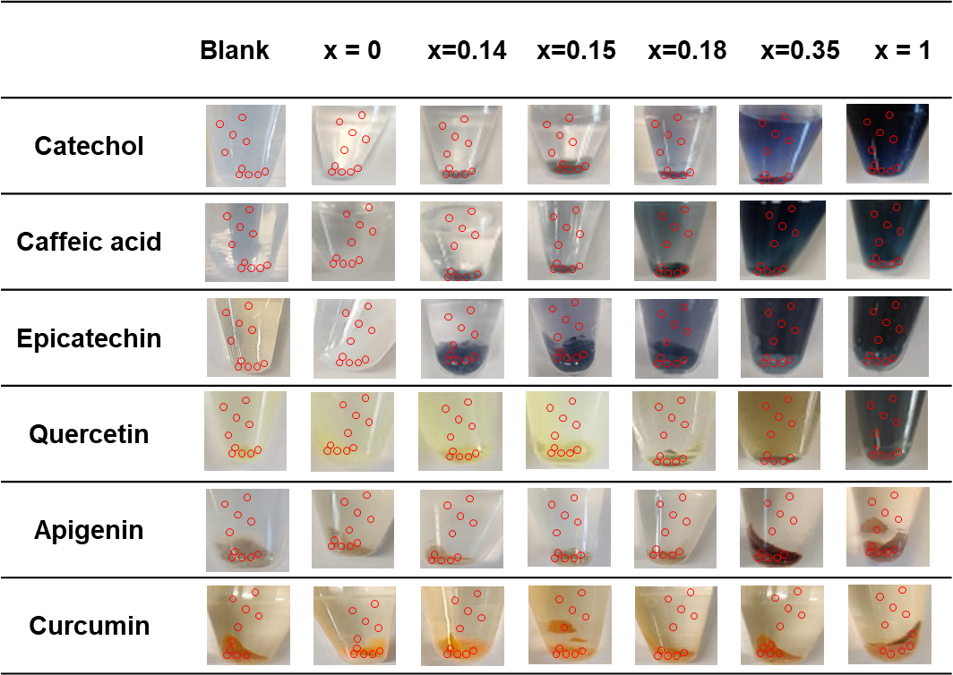
Fig. S2. Images of Eppendorfs containing phenolics in combination with CaPP (x = 0), FePP (x = 1), and mixed Ca-Fe(III) pyrophosphate salts with x = 0.14, 0.15, 0.18, and 0.35 at pH 6. The red spots indicate the positions where the L*a*b* values were extracted using a standard image analysis software (Photoshop CC2021, Adobe)

Method S2: Elution profiles reversed-phase chromatography
The following elution profile was used to measure the solubility of the phenolics at pH 3, 6, and 8: 0.00 – 1.09 min, isocratic on 1 vol.% B; 1.09 – 20.72 min, linear gradient from 1 – 55 vol.% B; 20.72 – 21.81 min linear gradient from 55 – 100 vol.% B; 21.81 – 27.26 min isocratic on 100 vol.% B; 27.26 – 28.35 min linear gradient from 100 – 1 vol.% B; 28.35 – 33.81 min isocratic on 1 vol.% B.
The following elution profile was used to monitor the oxidation of epicatechin and quercetin: 0.00 – 1.09 min, isocratic on 1 vol.% B; 1.09 – 13.45 min, linear gradient from 1 – 35 vol.% B; 13.45 – 14.54 min linear gradient from 35 – 100 vol.% B; 14.54 – 19.99 min isocratic on 100 vol.% B; 19.99 – 21.08 min linear gradient from 100 – 1 vol.% B; 21.08 – 26.54 min isocratic on 1 vol.% B.

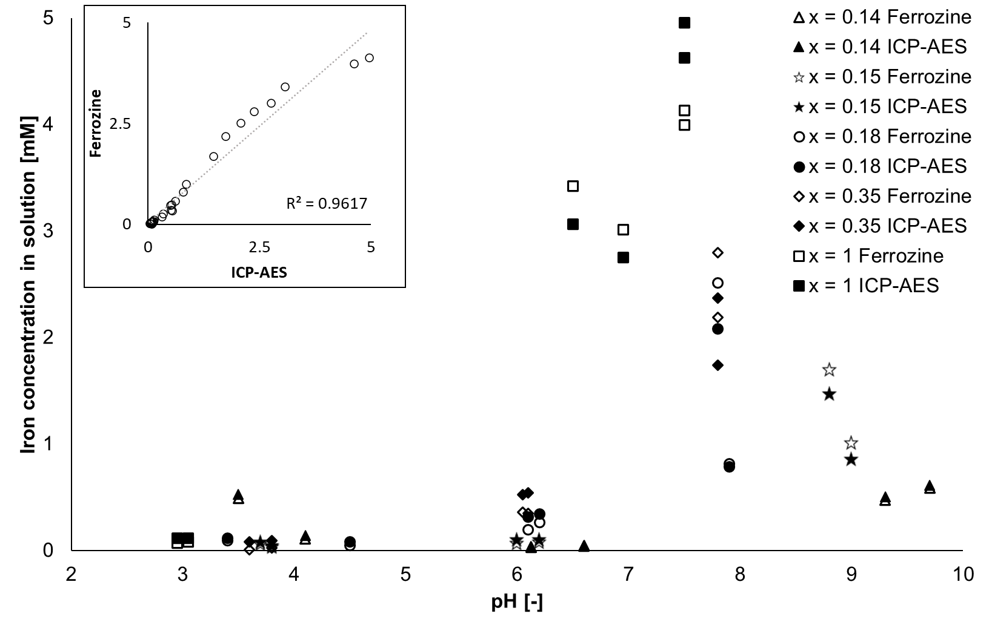
Fig. S3. Soluble iron concentration from FePP (x = 1) and mixed Ca-Fe(III) pyrophosphate salts with x = 0.14, 0.15, 0.18, and 0.35 in the presence of epicatechin as a function of pH determined by ICP-AES (filled markers) and by the ferrozine (open markers) methods. The inset depicts the correlation between the iron concentration measured using both methods. The iron concentrations in solution measured by the two different methods were found to be in good agreement (R² = 0.96).
Table S1. Iron content (%), theoretical maximum concentration (mM), and measured iron concentration (mM) from FePP (x =1) and mixed Ca-Fe(III) pyrophosphate salts with x = 0.14, 0.15, 0.18, and 0.35, based on the iron content of the salt and the amount of salt in the starting dispersion (10 mg/ml for all salts).
x-value | Iron content  (Mole %) | Theoretical maximum iron concentration (mM) | Measured iron concentration (mM)
 |  |  | pH 3 | pH 6 | pH 8
0.14 | 4.06 | 17.35 | 0.232±0.000ª | 0.006±0.000 | 0.059±0.001
0.15 | 4.29 | 17.75 | 0.365±0.017 | 0.032±0.003 | 0.307±0.014
0.18 | 4.93 | 21.03 | 0.265±0.005 | 0.147±0.002 | 0.608±0.009
0.35 | 7.78 | 32.87 | 0.080±0.004 | 1.422±0.037 | 3.148±0.037
1 | 12.90 | 53.69 | 0.028±0.001 | 0.810±0.029 | 3.198±0.016
ª standard deviation of independent duplicates

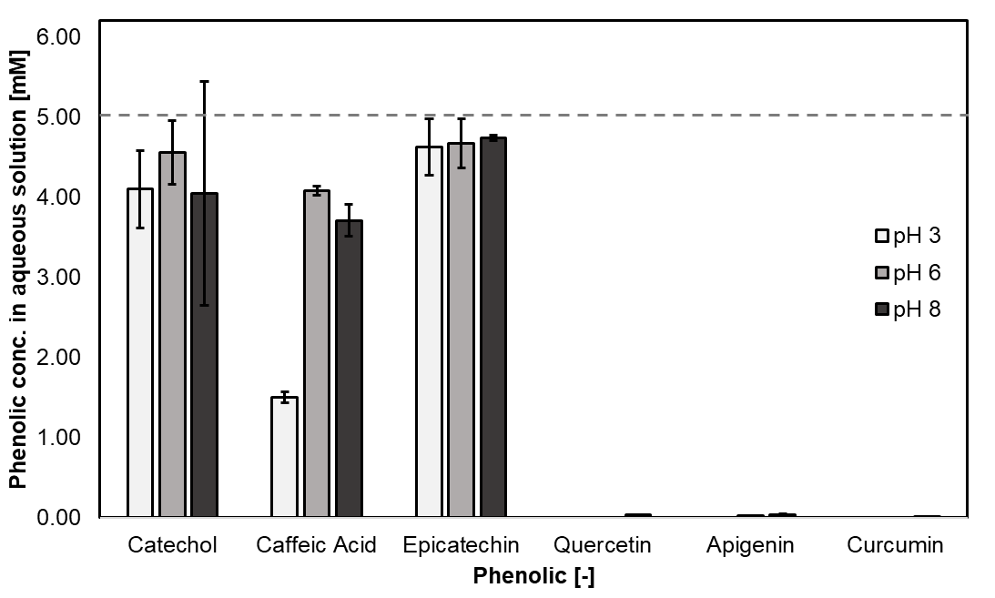
Fig. S4. Water solubility of the phenolics in absence of any iron- or calcium-containing salts at pH 3, 6, and 8 as quantified by RP-UHPLC-PDA-MS. The dashed line indicates the prepared concentration of the phenolic solution.

Table S2. Reported stability constants of Fe(III) with the phenolic compounds tested in this study.
Phenolic | Logβ | Reference
Catechol | 43.8 | (Avdeef, Sofen, Bregante, & Raymond, 1978)
Caffeic acid | 18.9 | (Hynes & O'Coinceanainn, 2004)
Catechin | 47.4 | IUPAC. (1979). IUPAC stability constants of metal–ion complexes, part B, organic ligands. Oxford, UK: Pergamon Press. (Perron & Brumaghim, 2009)
Quercetin | 44.2 | (Escandar & Sala, 1991)
Apigenin | Not reported
Curcumin | 22.1 | (Borsari, Ferrari, Grandi, & Saladini, 2002)

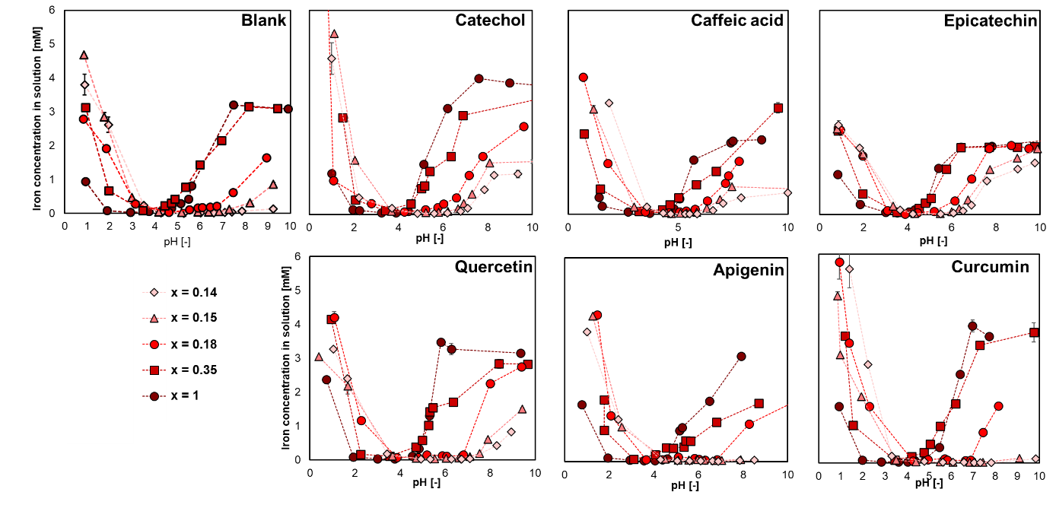
Fig. S5. Dissolution behavior of iron from FePP (x = 1) and the mixed Ca-Fe(III) pyrophosphate salts with x = 0.14, x = 0.15, x = 0.18, and x = 0.35 at pH 1-10; in the absence of phenolics (blank), and in presence of catechol, caffeic acid, epicatechin, quercetin, apigenin, and curcumin at 23 °C.

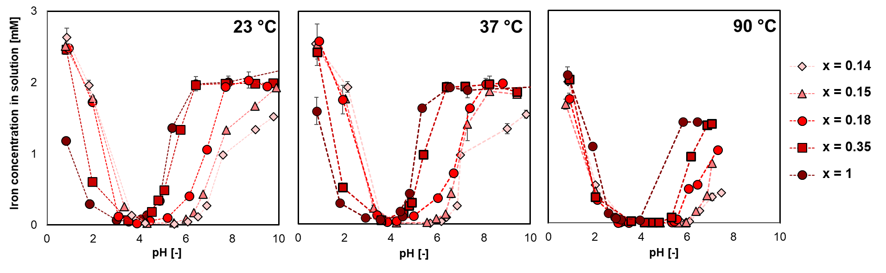
Fig. S6. Dissolution behavior of iron from FePP (x = 1) and the mixed Ca-Fe(III) pyrophosphate salts with x = 0.14, x = 0.15, x = 0.18, and x = 0.35 at pH 1-10 in the presence of epicatechin at 23, 37, and 90 °C.

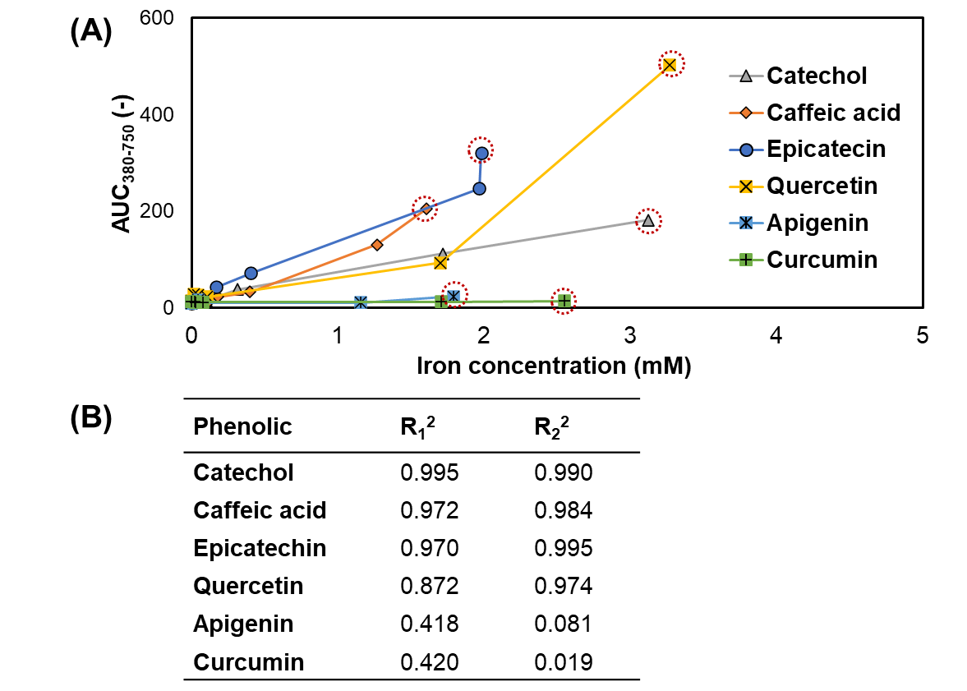
Fig. S7. (A) Relationship between the area under the curve in the visible light spectra (AUC₃₈₀₋₇₅₀) versus the iron concentration in solution and (B) R₁² the regression value from the mixed salts and FePP (including the red dashed point from A), and R₂² the regression value of the mixed salts only (excluding the red dashed point from A).

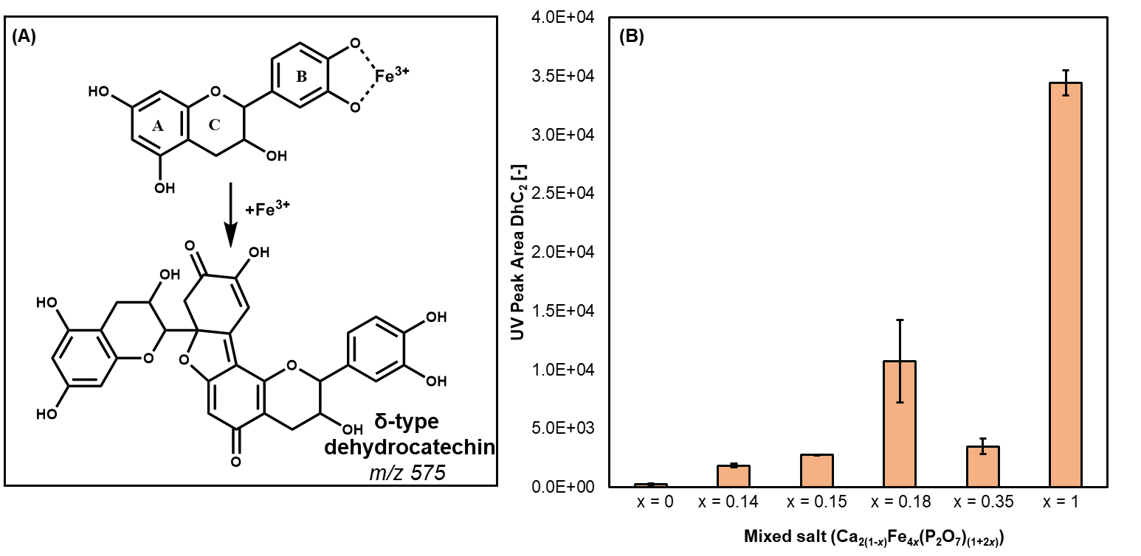
Fig. S8. (A) Proposed main oxidation compound (δ-type dehydrocatechin; δ-type DhC₂) of Fe(III)-mediated oxidation of epicatechin (Bijlsma, de Bruijn, Velikov, & Vincken, 2022; Tan, de Bruijn, van Zadelhoff, Lin, & Vincken, 2020). (B) Bar graph indicating the peak area of δ-type DhC₂ after incubation of CaPP (x =0), FePP (x = 1), and mixed Ca-Fe(III) pyrophosphate salts with epicatechin at pH 6.

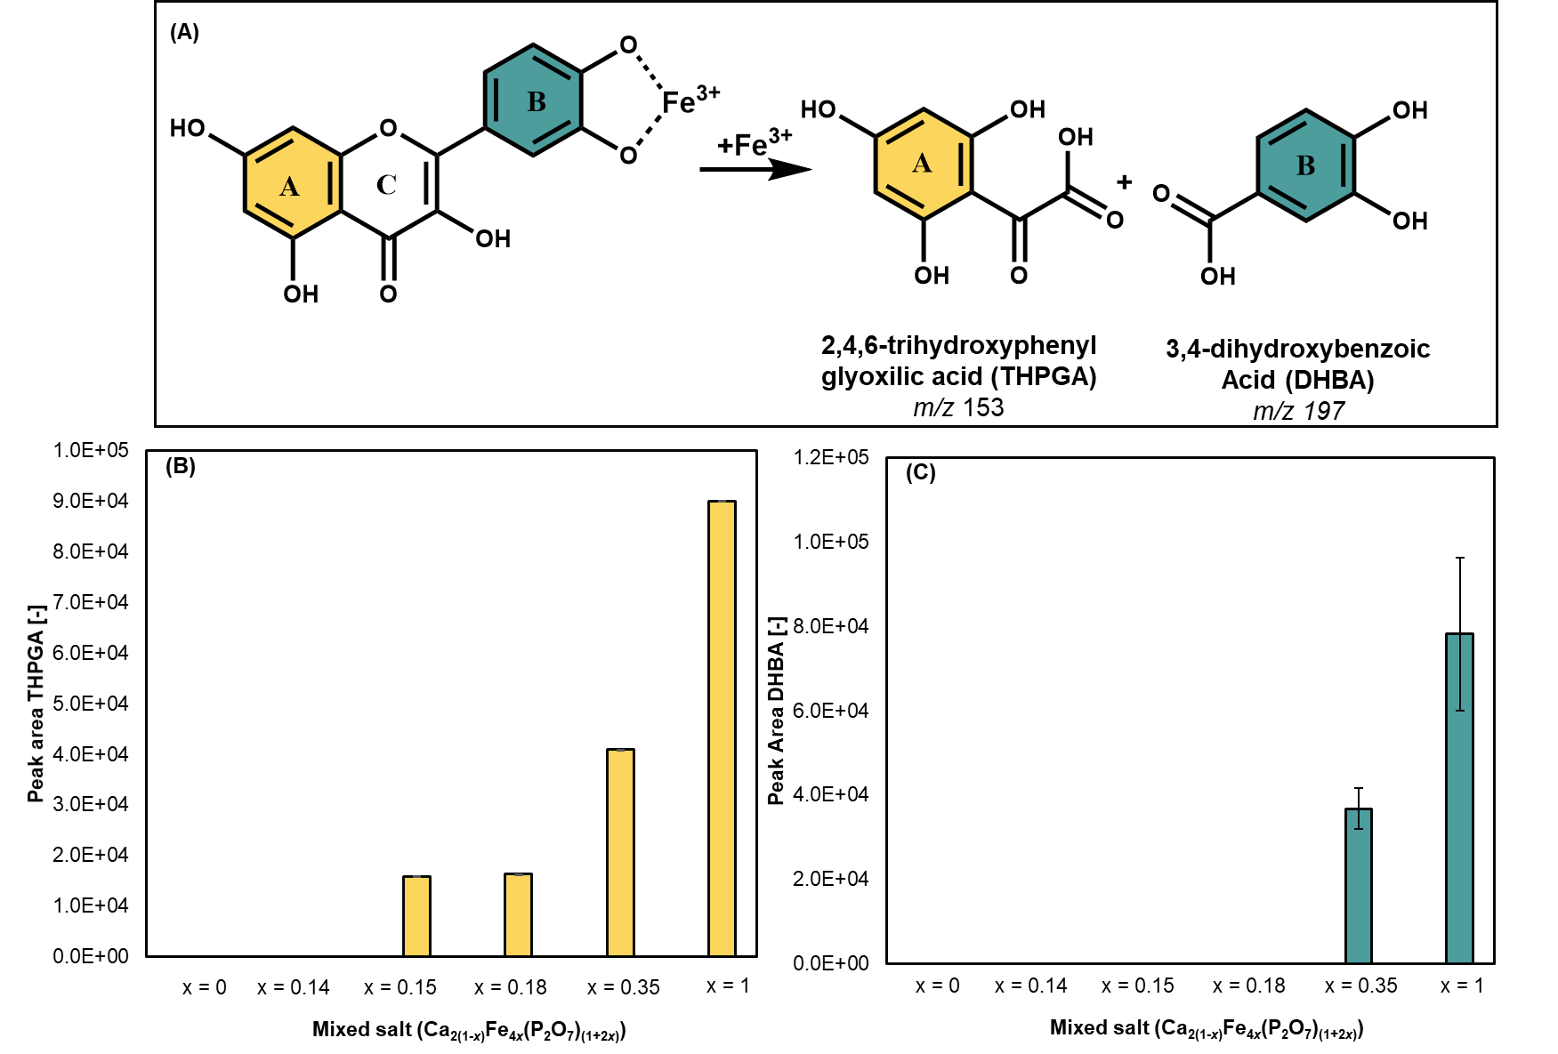
Fig. S9. (A) Main oxidation compounds of Fe(III)-mediated oxidation of quercetin (Bijlsma et al., 2022). (B) Bar graph indicating the peak area of THPGA and (C) of DHBA after incubation of CaPP (x = 0), FePP (x = 1), and mixed Ca-Fe(III) pyrophosphate salts with x = 0.14, 0.15, 0.18, and 0.35, with quercetin at pH 6.

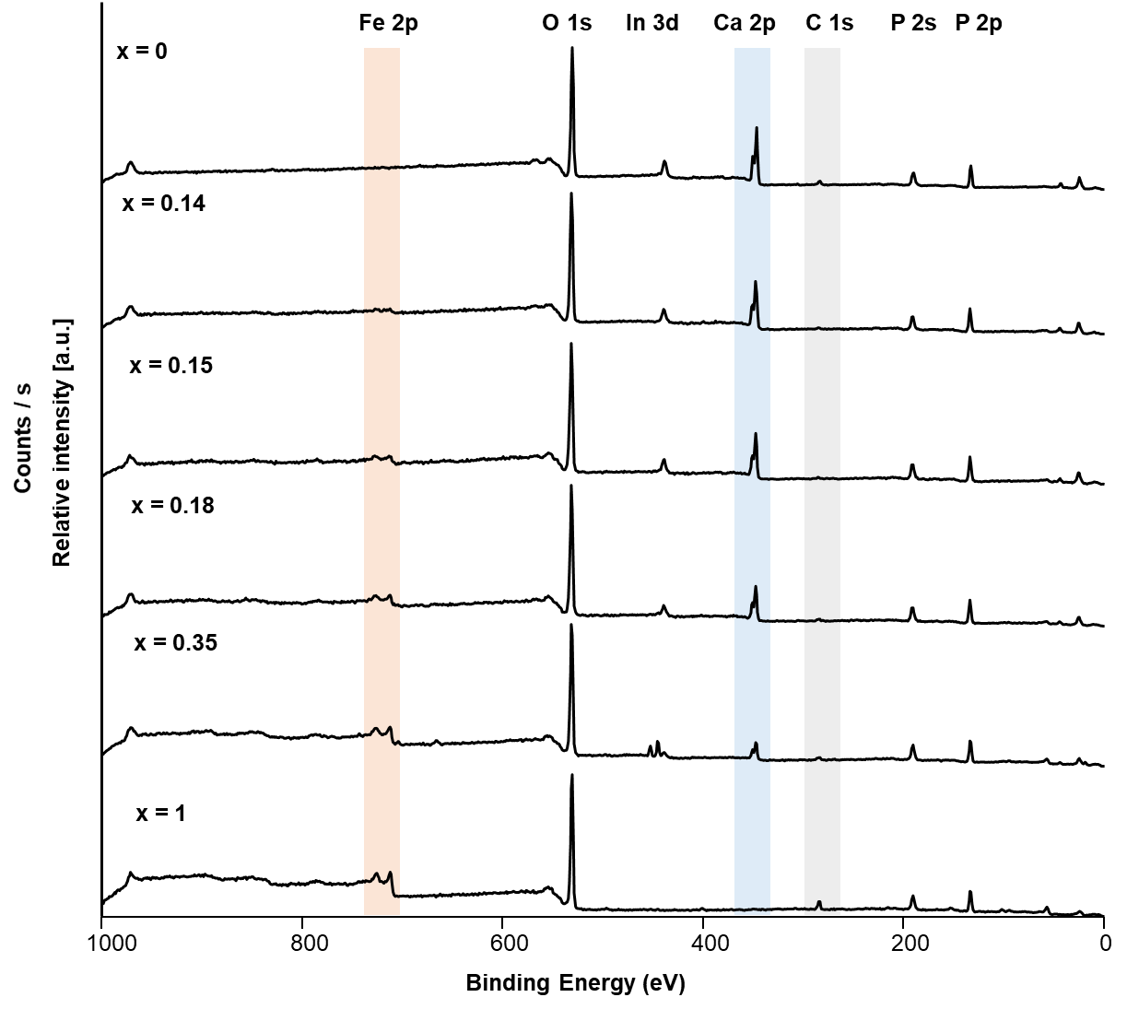
Fig. S10. XPS Wide scan spectrum of CaPP (x = 0), FePP (x =1), and mixed Ca-Fe(III) pyrophosphate salts with x = 0.14, 0.15, 0.18, and 0.35. The salts were measured on a indium (In) surface.

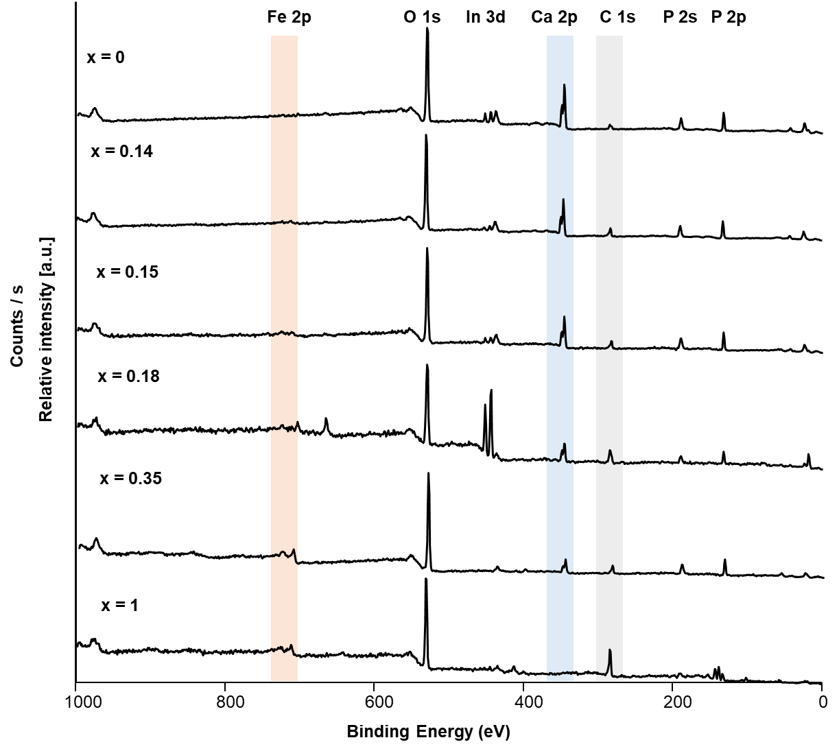
Fig. S11. XPS Wide scan spectrum of CaPP (x = 0), FePP (x =1), and mixed Ca-Fe(III) pyrophosphate salts with x = 0.14, 0.15, 0.18, and 0.35 after incubation with epicatechin (pH 6). The salts were measured on a indium (In) surface.

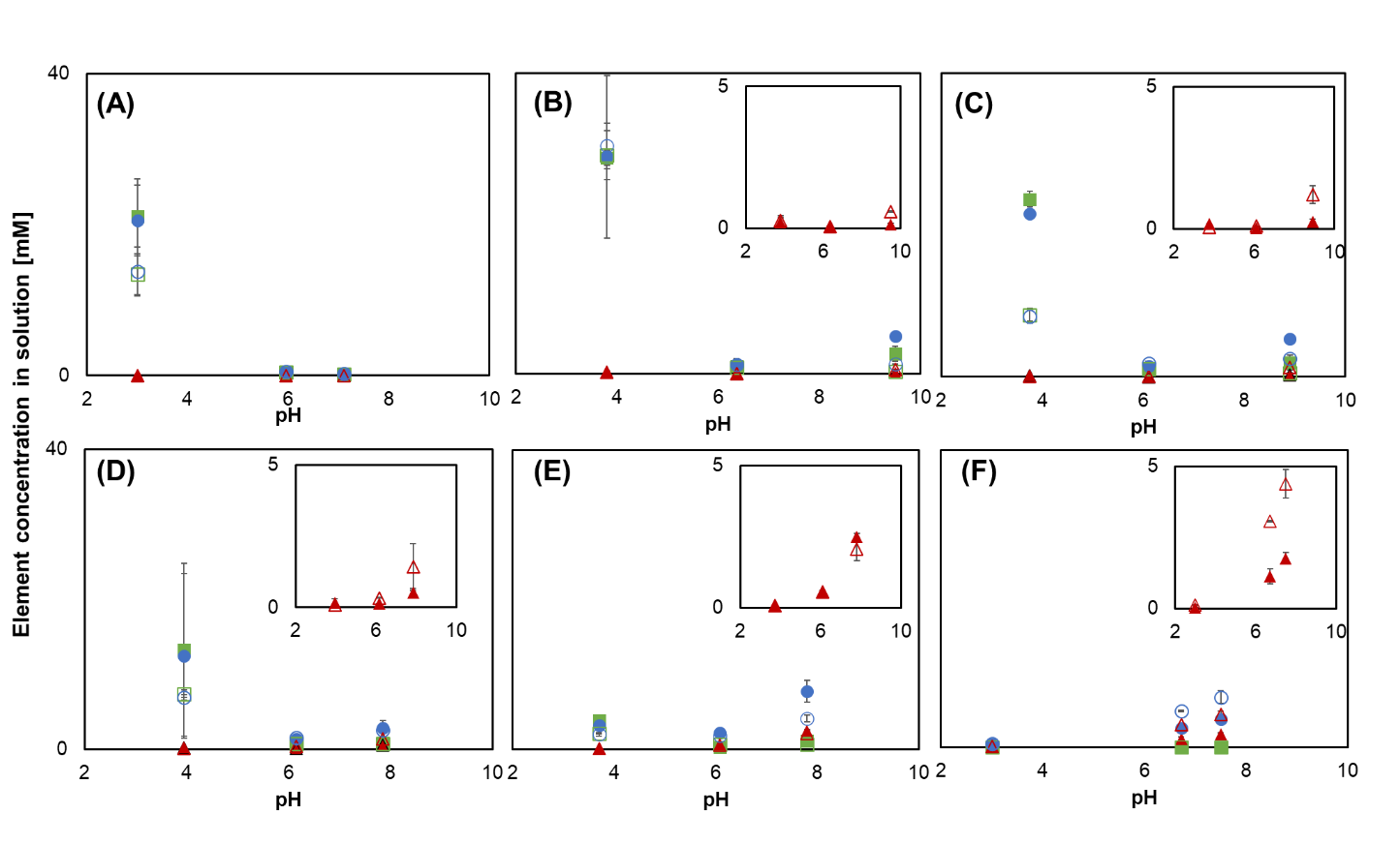
Fig. S12 Concentration of iron (red triangle), calcium (green square), and phosphorus (blue circle) quantified by ICP-AES in aqueous supernatant for (A) CaPP (x = 0) and the mixed Ca-Fe(III) pyrophosphate salts with (B) x = 0.14; (C) x = 0.15; (D) x = 0.18; (E) x = 0.35; and (F) FePP (x = 1) in the absence (filled markers) and presence (open markers) of epicatechin. The insets show the corresponding iron concentration in solution.

References
Avdeef, A., Sofen, S. R., Bregante, T. L., & Raymond, K. N. (1978). Coordination chemistry of microbial iron transport compounds. 9. Stability constants for catechol models of enterobactin. Journal of the American Chemical Society, 100(17), 5362-5370. https://doi.org/10.1021/ja00485a018.
Bijlsma, J., de Bruijn, W. J. C., Velikov, K. P., & Vincken, J.-P. (2022). Unravelling discolouration caused by iron-flavonoid interactions: Complexation, oxidation, and formation of networks. Food Chemistry, 370, 131292. https://doi.org/10.1016/j.foodchem.2021.131292.
Borsari, M., Ferrari, E., Grandi, R., & Saladini, M. (2002). Curcuminoids as potential new iron-chelating agents: Spectroscopic, polarographic and potentiometric study on their Fe(III) complexing ability. Inorganica Chimica Acta, 328(1), 61-68. https://doi.org/10.1016/S0020-1693(01)00687-9.
Escandar, G. M., & Sala, L. F. (1991). Complexing behavior of rutin and quercetin. Canadian journal of chemistry, 69(12), 1994-2001. https://doi.org/10.1139/v91-288.
Hynes, M. J., & O'Coinceanainn, M. n. (2004). The kinetics and mechanisms of reactions of iron(III) with caffeic acid, chlorogenic acid, sinapic acid, ferulic acid and naringin. Journal of Inorganic Biochemistry, 98(8), 1457-1464. https://doi.org/10.1016/j.jinorgbio.2004.05.009.
Perron, N. R., & Brumaghim, J. L. (2009). A review of the antioxidant mechanisms of polyphenol compounds related to iron binding. Cell Biochemistry and Biophysics, 53(2), 75-100. https://doi.org/10.1007/s12013-009-9043-x.
Tan, J., de Bruijn, W. J. C., van Zadelhoff, A., Lin, Z., & Vincken, J.-P. (2020). Browning of epicatechin (EC) and epigallocatechin (EGC) by auto-oxidation. Journal of Agricultural and Food Chemistry, 68(47), 13879-13887. https://doi.org/10.1021/acs.jafc.0c05716.

