Supporting Information
for
Deposition of hierarchically porous cellulose microfibril films via emulsion templating and drying at ambient temperature

Hyung-Ju Kim^{1,2}, Yan Zeng¹, Krassimir P. Velikov^{3,4,5}*, and Orlin D. Velev¹*
¹ Department of Chemical & Biomolecular Engineering, North Carolina State University
911 Partners Way, Raleigh, North Carolina, 27695-7905911 USA
² Nuclear Facility Cleanup Technology Division, Korea Atomic Energy Research Institute, 989-111 Daedeok-daero, Yuseong-gu, Daejeon, 305-353, Korea
³ Unilever Innovation Centre Wageningen, Bronland 14, 6708 WH Wageningen, The Netherlands
⁴ Institute of Physics, University of Amsterdam, Science Park 904, 1098 XH Amsterdam, The Netherlands
⁵ Soft Condensed Matter, Debye Institute for Nanomaterials, Utrecht University, Princetonplein 1, 3584 CC, Utrecht, The Netherlands
* E-mails: krassimir.velikov@unilever.com; odvelev@ncsu.edu;
Table S1. The vapor pressure, evaporation speed, initial droplet size, pore size of final dry film, film thickness, film density, and other film properties of emulsions and their corresponding dry film prepared with 0.3 wt% MFC (7.5 g) and 25 wt% hexane/octane/decane.
 | Hexane | Octane | Decane
Initial droplet size (µm) | 148 ± 95 | 138 ± 68 | 137 ± 48
Pore size (µm) | No pore | 219 ± 60 | 477 ± 196
Film thickness (µm) | 18 ± 1 | 19 ± 1 | 30 ± 1
Film density (g/m³) | 6.23×10⁻⁵ | 5.13×10⁻⁵ | 3.34×10⁻⁵
Vapor Pressure (Pa) | 17600 | 1470 | 195
Evaporation speed | Faster than water | Same order as water | Slower than water
Properties | No porous structure, ring pattern, stick to the substrate | Thin porous film | Moderate thin porous film

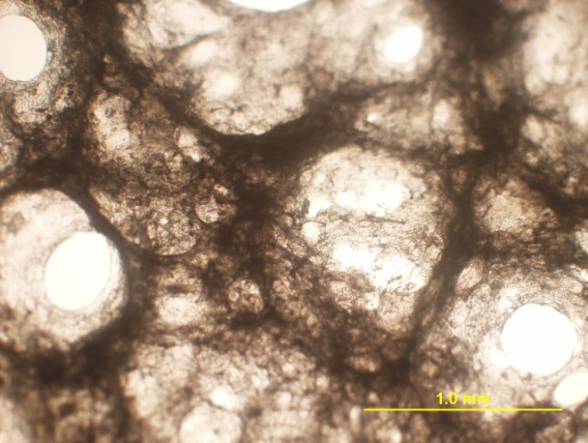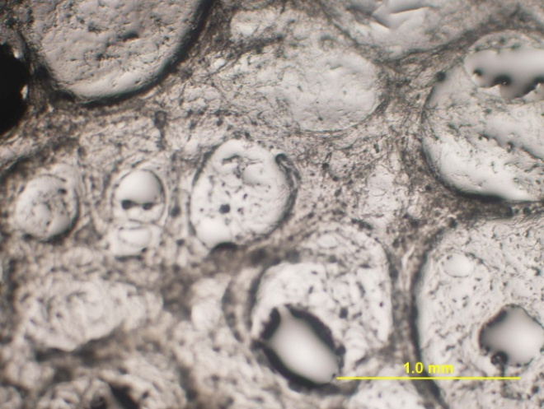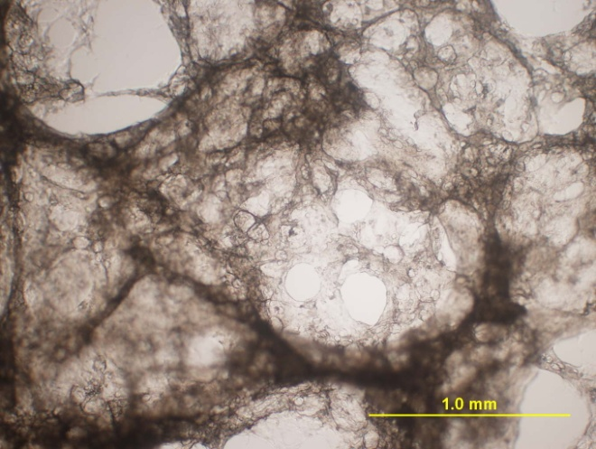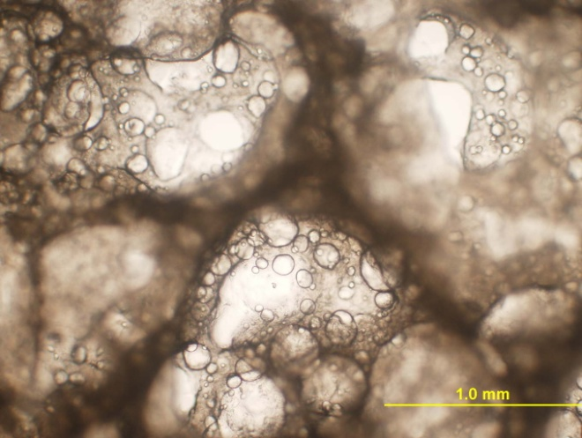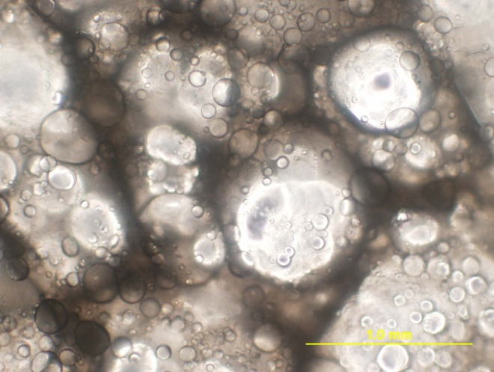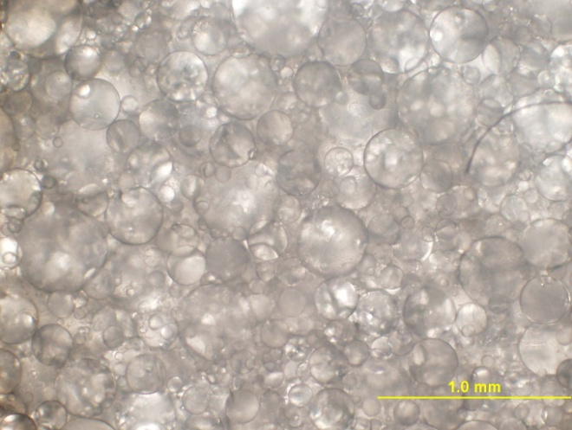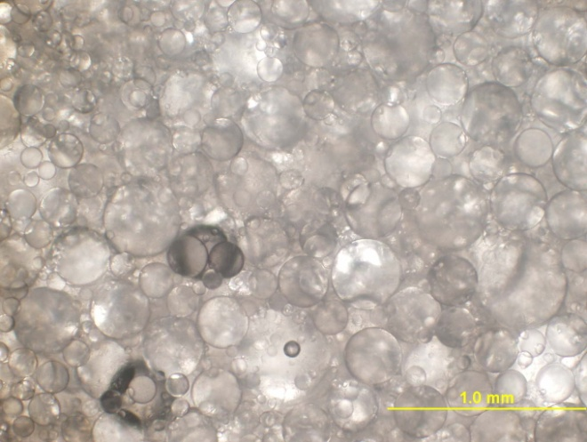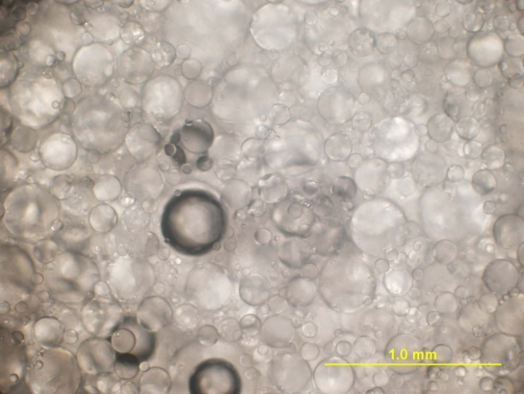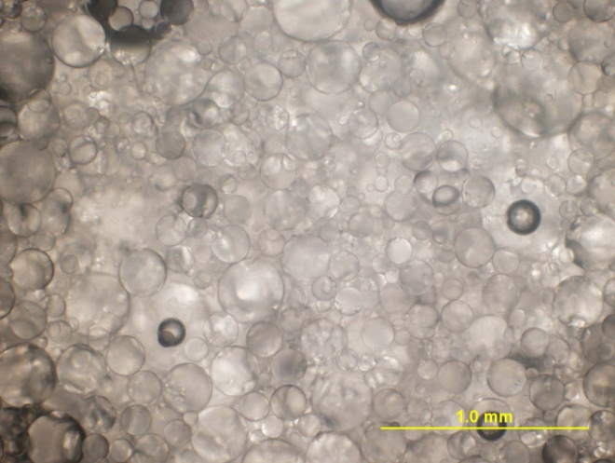
t=0
t = 2.5 h
t = 17.5 h
t=26 h
t = 40 h
t = 50 h
t=67 h
t = 93.5 h
t = 112 h
Fig. S1. Optical microscopy images showing the evolution of the emulsion droplet size during drying process. Emulsion prepared via hand-shaking 0.3 wt% MFC (7.5 g) and 25 wt% decane (2.5 g) for 1 minute.

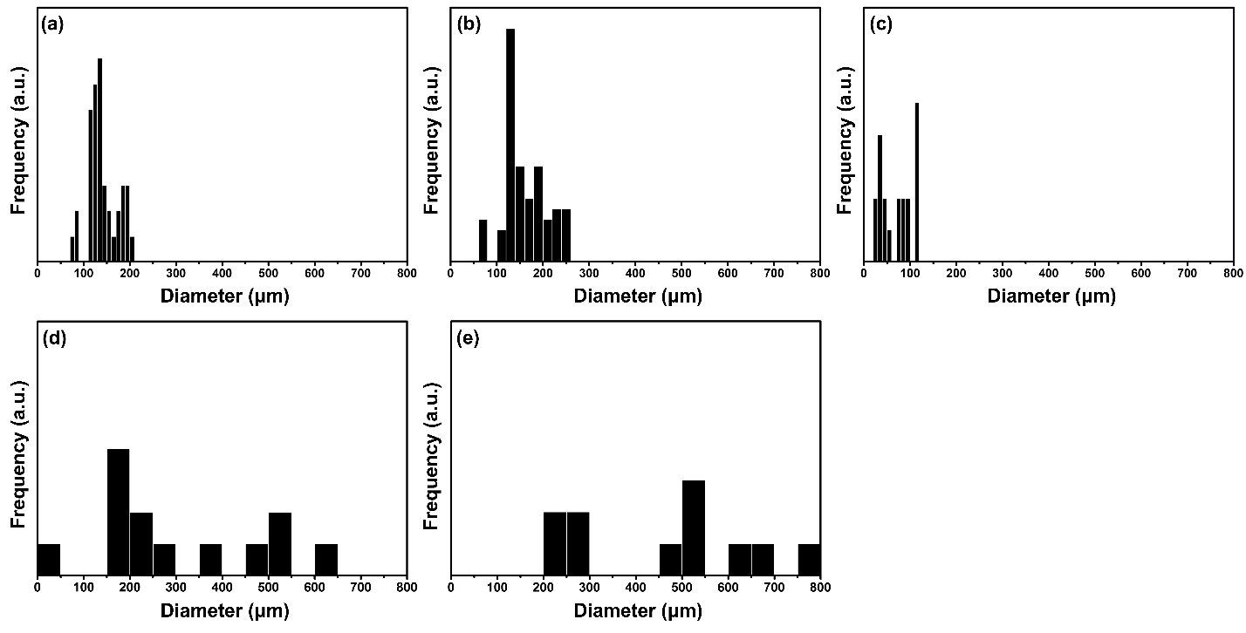
Fig. S2. Distributions of emulsion droplet size and pore size for MFC-decane gel prepared by 7.5 g of 0.3 wt% MFC dispersion and 2.5 g of decane: droplet size of decane emulsion (i.e., 25 wt% of total pre-mixed solution). (a) 0 hours, (b) 26 hours, (c) 50 hours, (d) 67 hours, and (e) 112 hours.

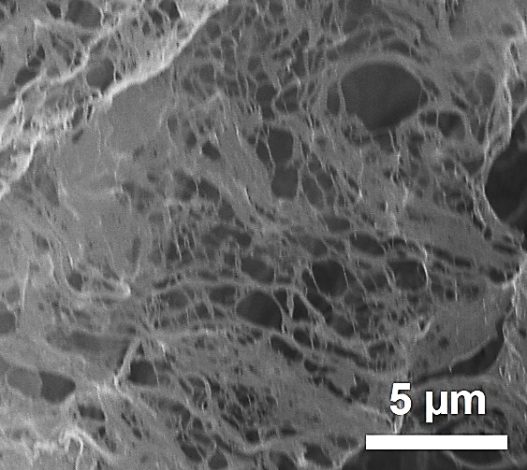
Fig. S3. SEM image of individual MFCs indicating size around several nanometers in width and several tens of microns in length.

Table S2. The initial droplet size, pore size of dry film, film thickness and film density at varying decane fraction.
 | 5 wt% | 10 wt% | 20 wt% | 25 wt% | 30 wt% | 40 wt% | 50 wt%
Droplet size (µm) | 81±37 | 86±41 | 111±57 | 137±48 | 136±65 | 139±77 | 144±78
Pore size (µm) | 175±58 | 260±85 | 377±161 | 477±198 | 469±253 | 533±424 | 556±292
Film thickness (µm) | 20 ± 1 | 20 ± 1 | 25 ± 1 | 30 ± 1 | 20 ± 1 | 20 ± 1 | 24 ± 1
Film density (g/m³) | 4.55×10⁻⁵ | 4.32×10⁻⁵ | 3.73×10⁻⁵ | 3.34×10⁻⁵ | 3.31×10⁻⁵ | 2.77×10⁻⁵ | 2.40×10⁻⁵

Table S3. The initial droplet size, pore size, film thickness and film density of emulsions and their corresponding dry films prepared at 0.3 wt% MFC, 25 wt% decane and various surfactant conditions.
 | No surfactant | Tween 20 | SDS
Initial emulsion size (µm) | 137 ± 48 | 103 ± 47 | 127 ± 48
Pore size (µm) | 477 ± 196 | 188 ± 69 | 320 ±147
Size expansion ratio | 3.5 | 1.8 | 2.5
Film thickness (µm) | 30 ± 1 | 270 ± 1 | 200 ± 1
Film density (g/m³) | 3.34×10⁻⁵ | 3.82×10⁻⁴ | 7.90×10⁻⁵

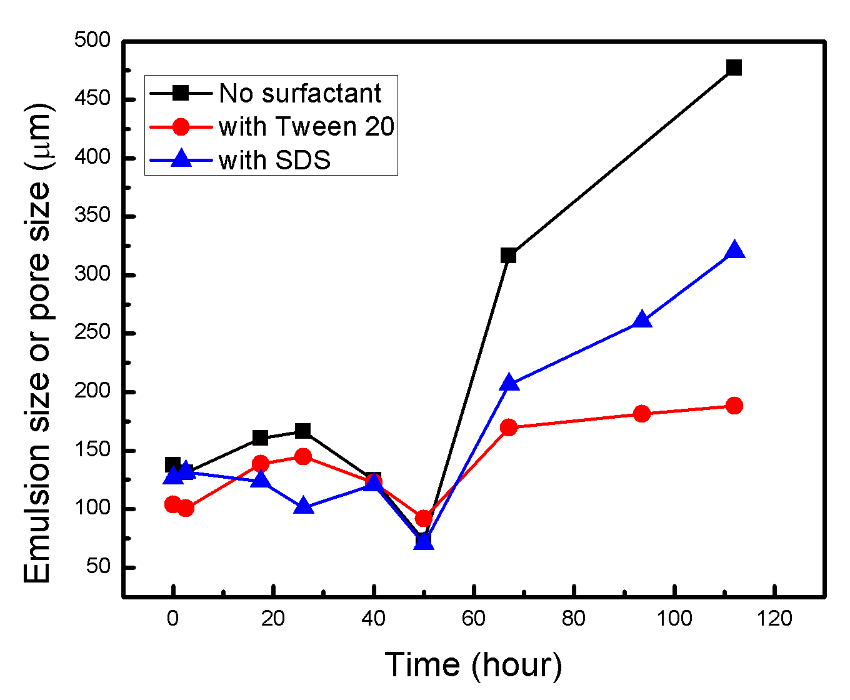
Fig. S4. Similar drying process (three step process) obtained for decan-in-water emulsions containing Tween 20 and SDS, in comparison to that of the emulsion without surfactant.

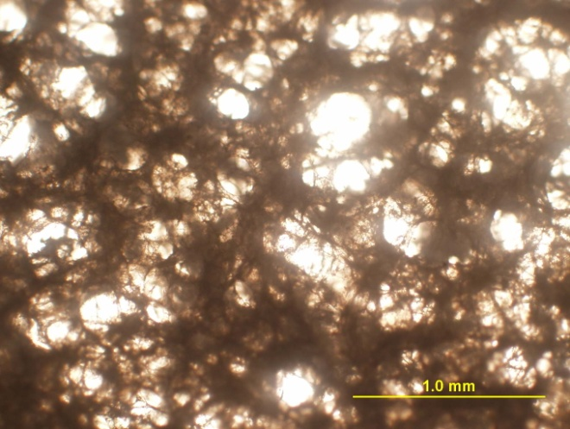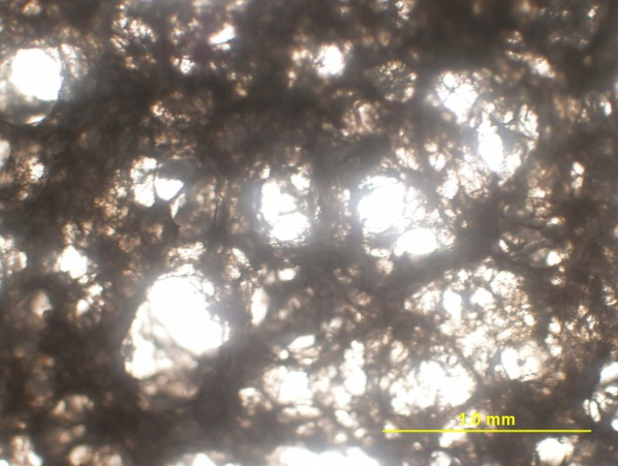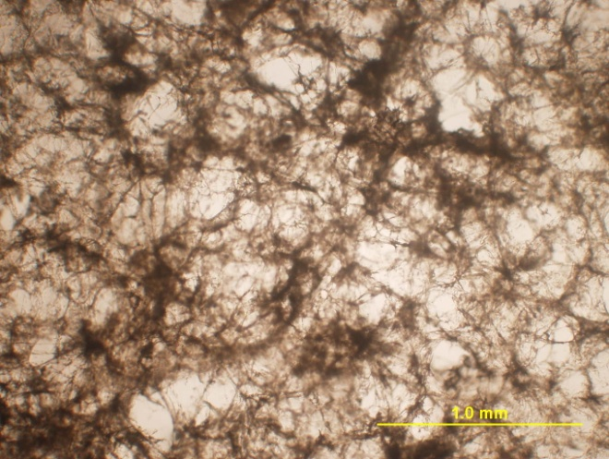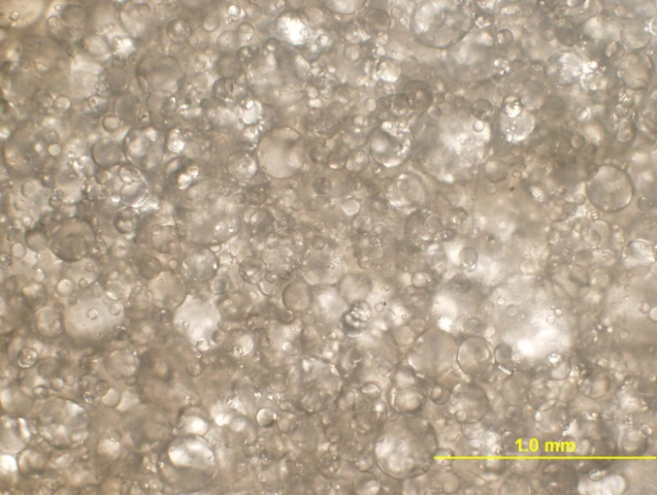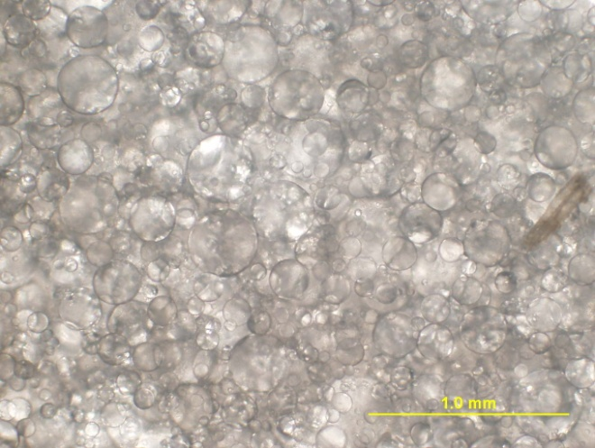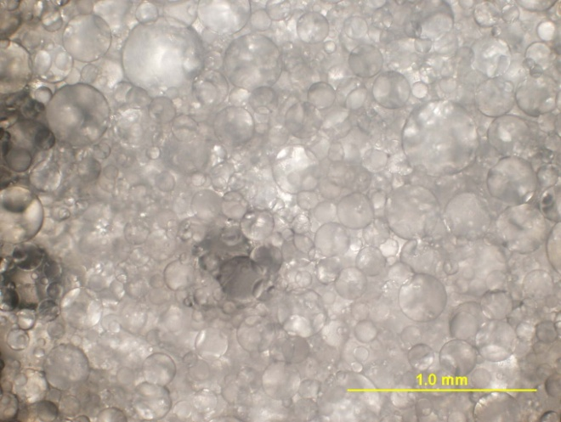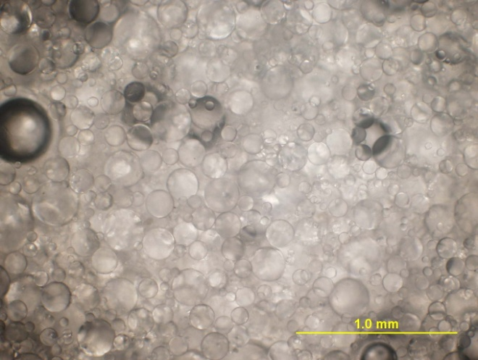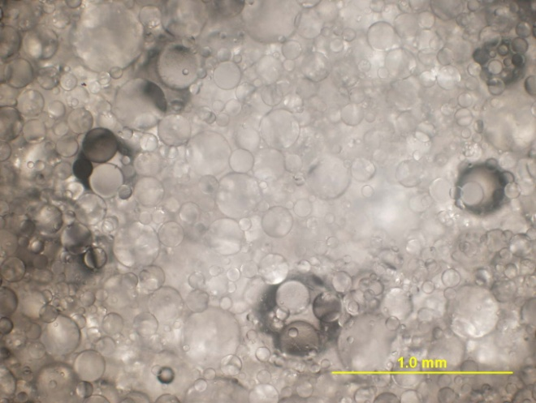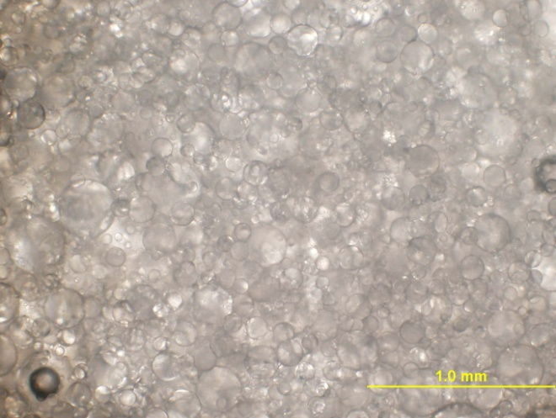
t=0
t = 2.5 h
t = 17.5 h
t=26 h
t = 40 h
t = 50 h
t=67 h
t = 93.5 h
t = 112 h
Fig. S5. Optical microscopic images evolution on the emulsion droplet size during drying process, emulsion prepared by hand-shaking 0.3 wt% MFC (7.5 g), 25 wt% decane (2.5 g) and 1 g of 0.16 wt% Tween 20.

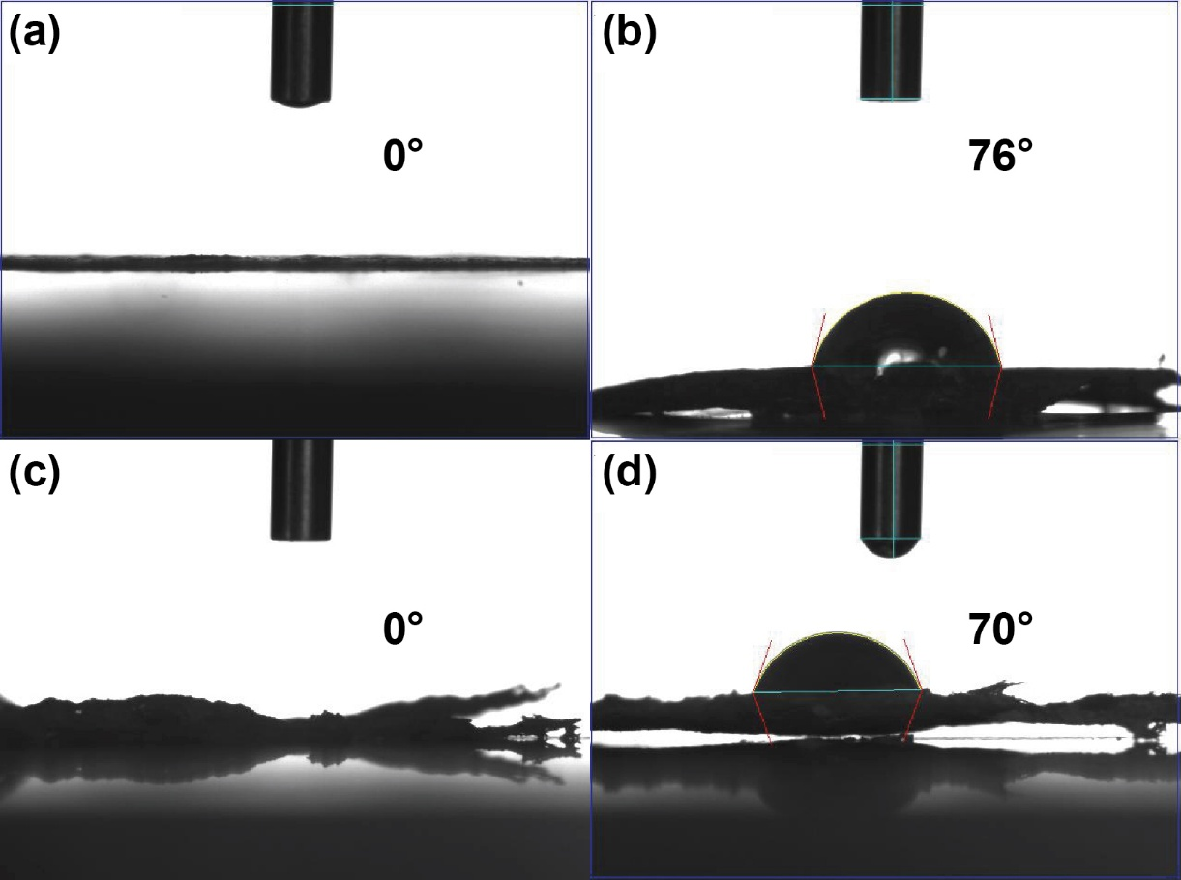
Fig. S6. WCAs of non-silylated and silylated films. (a) porous MFC film templated by 5 wt% decane, (b) silylated (a), (c) porous MFC film templated by 25 wt% decane with 0.16 wt% aqueous Tween 20 solution, and (d) silylated (c).

Table S4. Comparison of non-silylated and silylated MFC films with respect to silylation agent, porosity, and WCA.
MFC film | Silylation agent | Porosity | WCA(°) | Reference
MFC | - | None | 28 | (Andresen et al., 2006)
Silylated MFC | Chlorodimethyl isopropylsilane | None | 146 | (Andresen et al., 2006)
Cellulose nanofibrils (CNF) | - | None | 4.5 | (Kim et al., 2022)
Silylated CNF | Hexadecyltrimethoxysilane | None | 79.3 | (Kim et al., 2022)
MFC aerogel | - | Highly porous microstructures | 0 | (Zhou et al., 2016)
Silylated MFC aerogel | Methyltriethoxysilane | Highly porous microstructures | 151.8 | (Zhou et al., 2016)
MFC | - | None | 39.1 | (Poothanari & Leterrier, 2024)
Silylated MFC | Hexadecyltrimethoxysilane | None | 125.1 | (Poothanari & Leterrier, 2024)
MFC | - | None | 38.3 | (Jing et al., 2022)
Silylated MFC | 3-aminopropyltriethoxysilane | None | 108.2 | (Jing et al., 2022)
MFC-decane | - | Macroporous | 0 | This work
Silylated MFC-decane | methyltrichlorosilane | Macroporous | 116 | This work

References
Andresen, M., Johansson, L. S., Tanem, B. S., & Stenius, P. (2006). Properties and characterization of hydrophobized microfibrillated cellulose. Cellulose, 13(6), 665–677. https://doi.org/10.1007/s10570-006-9072-1
Jing, M., Zhang, L., Fan, Z., Liu, X., Wang, Y., Liu, C., & Shen, C. (2022). Markedly improved hydrophobicity of cellulose film via a simple one-step aminosilane-assisted ball milling. Carbohydrate Polymers, 275, 118701. https://doi.org/https://doi.org/10.1016/j.carbpol.2021.118701
Kim, G.-H., Kang, D.-H., Jung, B.-N., & Shim, J.-K. (2022). Fabrication and Characterization of Hydrophobic Cellulose Nanofibrils/Silica Nanocomposites with Hexadecyltrimethoxysilane. In Polymers (Vol. 14, Issue 4). https://doi.org/10.3390/polym14040833
Poothanari, M. A., & Leterrier, Y. (2024). Fluorine Free Surface Modification of Microfibrillated Cellulose-Clay Composite Films: Effect of Hydrophobicity on Gas Barrier Performance. In Surfaces (Vol. 7, Issue 2, pp. 283–295). https://doi.org/10.3390/surfaces7020019
Zhou, S., Liu, P., Wang, M., Zhao, H., Yang, J., & Xu, F. (2016). Sustainable, Reusable, and Superhydrophobic Aerogels from Microfibrillated Cellulose for Highly Effective Oil/Water Separation. ACS Sustainable Chemistry & Engineering, 4(12), 6409–6416. https://doi.org/10.1021/acssuschemeng.6b01075

