Supplementary information for:
Emulsions stabilised with cellulose microfibrils and potato protein
Ieuan Roberts-Harry ^{a b} *, Pau Marquès Duran ^{a §}, Max Molendijk ª, Daniel Bonn ^{b}, Krassimir P. Velikov ^{a b c} *.
ª Unilever Innovation Centre Wageningen, Bronland 14, 6708 WH Wageningen, The Netherlands.
^{b} Institute of Physics, University of Amsterdam, Science Park 904, 1098 XH Amsterdam, The Netherlands.
^{c} Soft Condensed Matter, Debye Institute for Nanomaterials Science, Utrecht University, Princetonplein 5, 3584 CC Utrecht, The Netherlands.
* Corresponding authors: Ieuan Roberts-Harry (ieuan.robertsharry@unilever.com), Krassimir Velikov (Krassimir.velikov@unilever.com).
§ Current address: Intersnack Netherlands B.V. Havenstraat 62, 7005 AG Doetinchem, Netherlands.
Supplementary figure 1: Cross-validation of droplet size
We use time-domain (TD) NMR to measure the droplet size of the samples of oil-in-water emulsions in the presence of protein and CMF in the continuous phase. A known limitation of this method is that only droplets with diameters in the range of 0.25 µm to 20 µm are accurately measured. In this supplementary note we cross validate our droplet size measurements. We do this by demonstrating that a very small very fraction of droplets are outside this range exist within the samples, and as such are not expected to contribute significantly to the rheology of the emulsion.
Using the cryo-SEM images generated for samples with 1 wt% potato protein, and 30 wt% oil, we are able to observe the presence some very small droplets. Such small droplets are outside the detection limits for the TD NMR. However, there is comparatively few droplets of this size– we estimated less than 1% of droplets. We consider that they do not contribute to the rheology of the emulsion.
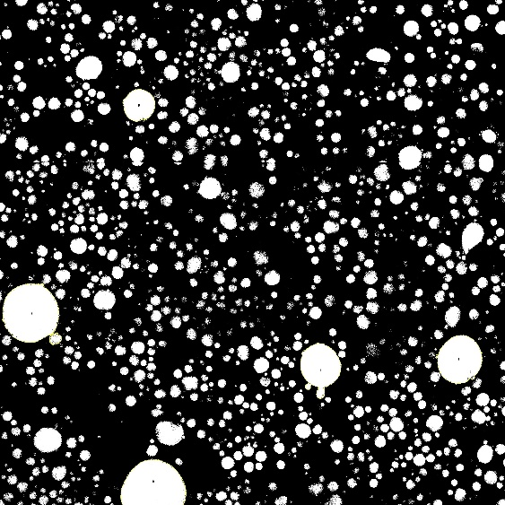
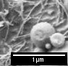
The largest droplet sizes observed throughout the paper are for emulsions of 0.2 wt% potato protein, 0.5 wt% citrus fibre, and 30 wt% oil. The tilescan confocal micrograph for this sample was thresholded. The Analyze Particles function within ImageJ was used to count the number of droplets depicted in the micrograph with a diameter larger than 20 µm. Via this method, we could conclude that there are only four droplets in the micrograph (< 0.1 % by number) with a droplet size that falls above the limitations of the TD NMR method. Given that this value is very low in comparison with droplets that are smaller than 20 µm, we assume that such large droplets are so few within the sample, that they do not drastically affect the rheology of the system. It’s worth noting these large droplets could be the product of coalescence driven by the intrusive nature of confocal laser scanning microscopy.
Figure S1: A) Cropped cryo-SEM image depicting droplet sizes smaller than 0.25 µm. Sample prepared with 0.5 wt% citrus fibre, 1 wt% potato protein, and 30 wt% oil. Sample is at pH 4. B) Thresholded confocal micrograph depicting 5 droplets greater than 20 µm in size. Sample prepared with 0.2 w% potato protein, 0.5 wt% citrus fibre, and 30 wt% soybean oil. Sample at pH 4.
Droplet diameter < 0.1 µm
A.
B.
Supplementary figure 2: Storage modulus plotted versus droplet size
Figure S2: Storage modulus plotted against the droplet size (D3,3) for emulsions prepared with 0.5 wt% citrus fibre, 0-1 wt% potato protein, 30 wt% soybean oil, at pH 4.
Supplementary figure 3: Storage modulus of the continuous phase with varying pH
Figure S3: Storage modulus of gels prepared with 0.5 wt% citrus fibre, 1 wt% potato protein, with varying pH. pH was adjusted using vinegar spirit. Rheology measurements completed as described in the main text.

Supplementary figure 4: Droplet size of emulsions with varying pH
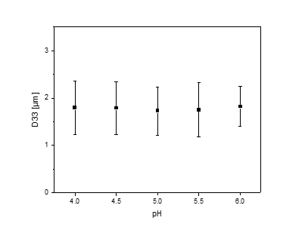
Figure S4: D_{3,3} measurements for emulsions prepared with 0.5 wt% citrus fibre, and 1 wt% potato protein in the continuous phase, and 30 wt% of dispersed soybean oil, measured using NMR for droplet size.

Supplementary figure 5: Storage modulus of emulsions stabilised with citrus fibre and protein separately
A.
B.

Figure S5: Storage modulus of 30 wt% soybean oil emulsions with A) 1 wt% of potato protein, without citrus fibre, with varying pH, and B) 0.5 wt% of citrus fibre, without potato protein, at varying pH.

Supplementary figure 6: Dispersity index of emulsions with varying pH

Figure S6: Dispersity index of emulsions prepared with 0.5 wt% citrus fibre, 1 wt% potato protein, 30 wt% soybean oil, at varying pH. Lines are to guide the eye.

Micrographs of the emulsion at varying pH were generated using Confocal Laser Scanning Microscopy (CLSM), and analysed using ImageJ, to generate an index of dispersity (IoD)(Kam et al., 2013), which has been previously used to quantify clustering of oil droplets in MFC-stabilised emulsions (Nomena et al., 2018). The images are first thresholded and then divided into quadrats, or grids, as explained in the literature (Kam et al., 2013). Then, ImageJ’s Particle Analyzer function is used to measure how much of the area within each quadrat is occupied by the emulsion droplets. Here we use area coverage rather than number of droplets, due to challenges in thresholding images where droplets are small and numerous, such that contrasting between droplets isn’t possible. A mean and standard deviation for the area occupied is then measured. The IoD is obtained using the following equation, where N is the number of quadrats, m is the mean value for the percentage of the quadrat area occupied by droplets in each quadrat, and s is the standard deviation:
$$IoD =(N-1)\frac{s^{2}}{m}$$
The IoD is a number that indicates how evenly the oil droplets are spread out. If the droplets (or objects) are spread out evenly, the IoD will be low. If the droplets are clumped together in some places and missing in others, the IoD will be high. The figure shows a peak in IoD at pH 5, Demonstrating that the degree of flocculation increases at this pH. This is due to the pH being very close to the isoelectric point of the protein, such that there is no net charge on it. Droplets, which have the protein at its interface, then have no repulsive force between them. For obtain the IoD value, we analyse 5 micrographs, 5 quadrats within each micrograph, with at least 100 droplets per quadrat.
References
Kam, K. M., Zeng, L., Zhou, Q., Tran, R., & Yang, J. (2013). On assessing spatial uniformity of particle distributions in quality control of manufacturing processes. Journal of Manufacturing Systems, 32(1), 154-166. https://doi.org/10.1016/j.jmsy.2012.07.018
Nomena, E. M., Remijn, C., Rogier, F., van der Vaart, M., Voudouris, P., & Velikov, K. P. (2018). Unravelling the Mechanism of Stabilization and Microstructure of Oil-in-Water Emulsions by Native Cellulose Microfibrils in Primary Plant Cells Dispersions. ACS Appl Bio Mater, 1(5), 1440-1447. https://doi.org/10.1021/acsabm.8b00385

