Supplementary information for:

Use of cellulose microfibrils and potato protein to form double network gels
Ieuan Roberts-Harry ^{a b} *, Braulio Macias Rodriguez ^{a, §}, Krassimir P. Velikov ^{a b c} *

ª Unilever Innovation Centre Wageningen B.V. Bronland 14, 6708 WH Wageningen, The Netherlands.
^{b} Institute of Physics, University of Amsterdam, Science Park 904, 1098 XH Amsterdam, The Netherlands.
^{c} Soft Condensed Matter, Debye Institute for Nanomaterials Science, Utrecht University, Princetonplein 5, 3584 CC Utrecht, The Netherlands.

* Corresponding authors: Ieuan Roberts-Harry (ieuan.robertsharry@unilever.com), Krassimir Velikov (Krassimir.velikov@unilever.com).
§ Current address: Food Science and Human Nutrition, University of Illinois-Urbana Champaign, 905 S. Goodwin Ave., Urbana, IL 61801, USA.

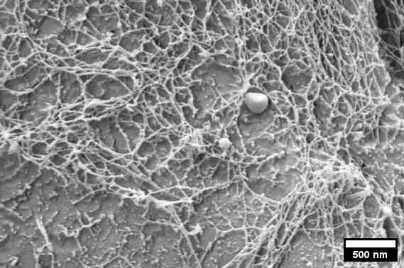
Supplementary note 1: Cryo-SEM images of cellulose microfibrils
Figure S1: Cryo-SEM image of cellulose microfibrils forming a network due to their attractive nature. Sample prepared with 0.5 wt% Citrus Fibre.
Passing dispersions of citrus fibre through the Microfluidizer, with the conditions described in the main text, leads to a network of cellulose microfibrils as depicted in the image above. A small droplet of sample was placed on a rivet and plunged into melting ethane, which flash freezes the entire sample. The sample was placed into the sample holder of a cryosystem (Gatan Alto2500, USA) and kept cool under liquid nitrogen. Next, the sample was placed into the scanning electron microscope (Zeiss Auriga, Germany) and freeze-fractured with a knife before being sublimated for 90 seconds at -90 °C. After being cooled back to -125 °C, the sample was sputter-coated with platinum for 90 seconds from a perpendicular angle, and another 30 seconds while tilting to ensure an even coating. The sample was viewed at 3 kV at 5 mm with an SE2 detector under high vacuum at -125 °C.
Supplementary note 2: Flow properties of citrus fibre dispersions before and after deagglomeration
Figure S2: Amplitude sweep for dispersions of 2 wt% Citrus Fibre in water, for samples which have, and have not been passed through the microfluidizer. Filled symbols represent G’, hollow symbols represent G”.

Supplementary note 3: µDSC profile of various samples
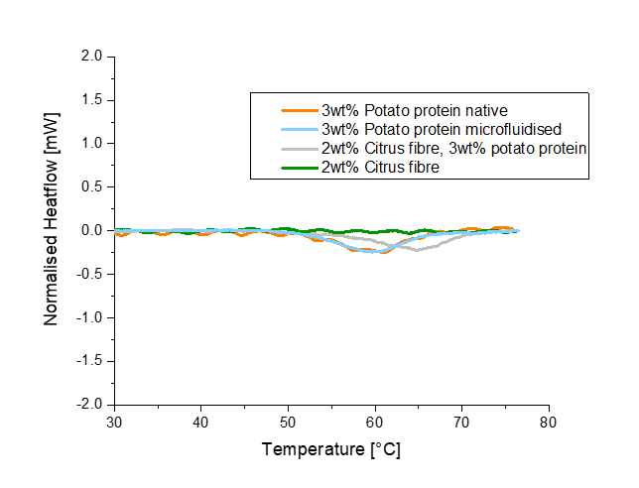
Thermal denaturation behaviour of various samples was measured using a microcalorimeter (µDSC, Setaram). Various samples were prepared and measured to assess how changes in the sample environment affects the thermal denaturation behaviour of the protein. Samples of approximately 700 mg was placed into the heating chambers, The samples were initially held at 20 °C for 10 minutes, and heated to 80°C at a rate of 1°C/min.
Figure S3: µDSC profiles for samples of potato protein, and citrus fibre, and mixed samples, all at neutral pH.
Firstly, two samples of potato protein solution (3 wt%) were measured, one having been passed through the microfluidizer at 1000 bar, and one which had not, this was to confirm whether microfluising the protein denatured it, and thus affects its gelling abilities. The thermal denaturation behaviour of both samples was similar, both showing endothermic peaks at around 60°C, suggesting that shear-induced denaturation of the protein is not taking place when the protein is passed through the Microfluidizer. Next, to better understand the influence of the citrus fibre on the denaturation of the potato protein, two gels of 2wt% citrus fibre, one with 3wt% potato protein present, and another with 0 wt% protein were studied. As expected, the pure citrus fibre gel displayed no endothermic peaks across the temperature range probed, while the gel with potato protein present displayed an endothermic peak at around 65°C. The shift in the endothermic peak between a sample of pure protein versus when citrus fibre is present along with protein is attributed to the molecular interactions between the cellulose microfibres and the potato protein which make the protein more stable against thermal denaturation and effecting the denaturation kinetics, an effect discussed previously (Sharma et al., 2010).
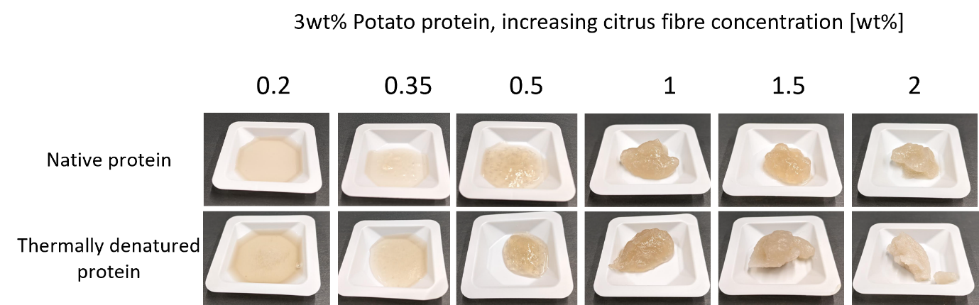
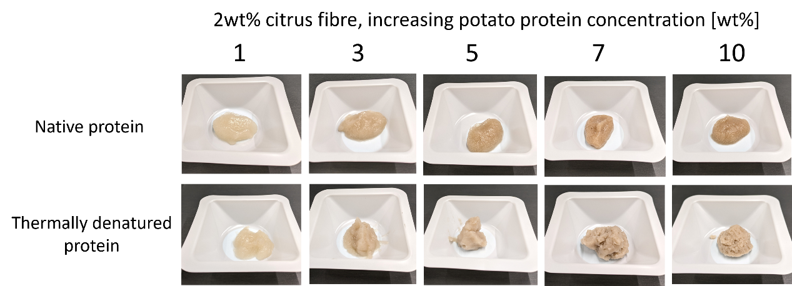
Supplementary note 4: Appearance of samples before and after heating
Figure S5: Photos of samples of increasing citrus fibre, and constant potato protein concentration, both before and after being heated in a water bath at 80°C for 30 minutes

Figure S4: Photos of samples of increasing potato protein concertation (1 – 7 wt%), and constant citrus fibre concentration (2 wt%), both before (top raw) and after being heated (bottom raw) in a water bath at 80°C for 30 minutes.

Supplementary note 5: Example amplitude sweeps demonstrating LVE regime of sample
Figure S6: Amplitude sweep completed on samples with 1 wt% citrus fibre and increasing concentrations of potato protein. The figure illustrates that an amplitude or 0.2% strain is within the linear viscoelastic regime for all samples probed.

Supplementary note 6: Amplitude sweep data for dispersions with increasing concentration of citrus fibre
Figure S7: A) Amplitude sweep data for samples with increasing concentration of Citrus Fibre, before heating of the system. Filled circles represent G’, and hollow circles represent G”. B) The loss factor, G”/G’, with increasing shear strain.
A.
B.

Supplementary note 7: Amplitude sweep data demonstrating no 2-step yielding
Figure S8: Amplitude sweep completed on samples with 1 wt% citrus fibre, and increasing concentrations of protein, after denaturation. The figure illustrates that there our samples show no 2-step yielding.

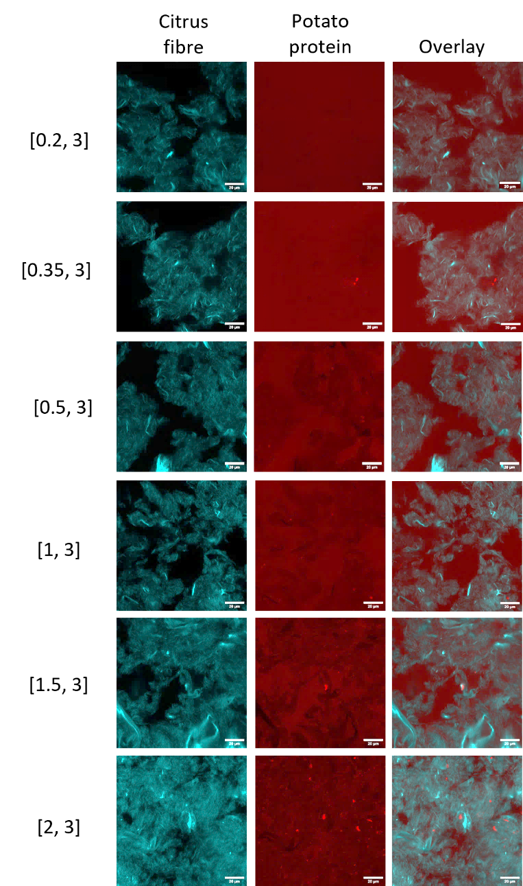
Supplementary note 8: Confocal laser scanning microscopy images of gelled and ungelled samples
Figure S9: CSLM images taken of samples of constant potato protein in native state and increasing citrus fibre concentration. Scale bar is 20µm, concentration (wt%) of each component given by [Citrus fibre, Potato protein].
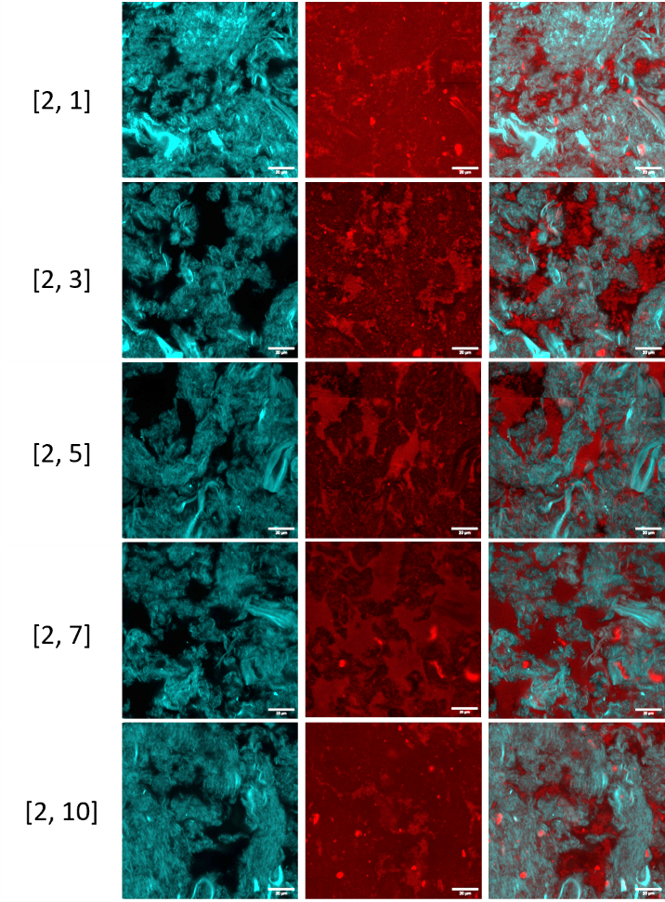

Figure S10: CSLM images taken of samples of constant citrus fibre and increasing potato protein concentration, after heating of the system. Scale bar is 20µm, concentration (wt%) of each component given by [Citrus fibre, Potato protein].

Supplementary information references
Sharma, S., Berne, B. J., & Kumar, S. K. (2010). Thermal and structural stability of adsorbed proteins. Biophys J, 99(4), 1157-1165. https://doi.org/10.1016/j.bpj.2010.05.030

