Supporting information: Quantitative 3D Real-Space Analysis of Photonic Supraparticles
J.I. Bu¨ckmann*, L.D. Hoitink, R. Yang, A. Ulug¨ol, L. Filion, A. van Blaaderen*

Soft Condensed Matter and Biophysics Group, Debye Institute for Nanomaterials Science, Utrecht University, Princetonplein 1, Utrecht, 3584 CC, Netherlands
*Email Address: J.i.buckmann@uu.nl, A.vanblaaderen@uu.nl

1 Methods

Materials
All chemicals were used as received without further purification. Krytox 157 FS(H) was purchased from Chemours. HFE-7500 3M (TM) Novec was purchased from Fluorochem. (3-aminopropyl)triethoxysilane (APTES, 98 %), ammonium hydroxide (25 wt% NH₃ in H₂O), dimethyl sulfoxide (DMSO, dried, ≤ 0.02
% water), fluorescein isothiocyanate (FITC, 90 %), glycerol (99.5 %), L-arginine (98 %), sodium dodecyl sulfate (SDS, 99 %), and tetraethyl orthosilicate (TEOS, 98 %) were purchased from Sigma-Aldrich. Ultrapure (type 1) H₂O (Direct-Q3 Milli-Q, from Merck Millipore) with a resistivity of 18.2 mΩ was used in all experiments. All the glassware was cleaned in a standard isopropanol/KOH base bath overnight, rinsed with water, and dried in an oven at 100 ◦C prior to use.
Scanning electron microscopy (SEM) images were acquired using Zeiss EVO 15 with an accelerating voltage of 5 kV used in figures. For quantitative analysis SEM images were acquired using the FEI Helios with an accelerating voltage of 3 kV.

Seed Synthesis
Initial silica seeds were prepared in an amino acid stabilized solution. This procedure is based on the method reported by Shahabi & Rezwan et al. [1]. The silica seeds that are obtained from this synthesis have a typical size between 10 to 30 nm, with the final size depending on the reaction temperature. To obtain larger seeds this synthesis can be repeated, with a small amount of seeds from a previous amino acid stabilized synthesis. This was used to grow the seeds to approximately 60 nm, from which point onwards the particles were grown larger via the Sto¨ber synthesis.
For the initial seed synthesis an aqueous solution of 182 mg (1.04 mmol) L-arginine in 169.0 g MQ H₂O was prepared. This solution was heated to 70 ◦C in a heating mantle while it was stirred at 200 rpm.
After 1 h, 10.45 g (50.2 mmol) TEOS was gently added, forming a 2-layer system. The flask was closed with a stopper and left for 48 h before cooling it down. To get larger seeds an aqueous solution of 163 mg (0.94 mmol) L-arginine in 152.0 g MQ H₂O was prepared. This was heated to 65 ◦C in a heating mantle while it was stirred at 200 rpm. After 45 min, 25.00 mL of seeds from the previous synthesis were added. After 15 min, 9.33 g (44.8 mmol) TEOS was gently added, forming a 2-layer system. The flask was closed with a stopper and left for 48 h before cooling it down.

Fluorescently Doped Shell
To be able to determine the positions of the silica particles with confocal microscopy, a fluorescent molecule was incorporated in the structure of the silica particles. Here, this was done by growing a fluorescently doped silica shell around particles with a diameter of 63 nm ± 4.5 %. In this case, fluorescein isothiocyanate (FITC) was used as dye, which was incorporated in the Sto¨ber silica shell through the silane coupling agent (3-aminopropyl)triethoxysilane (APTES) [2, 3]. The St¨ober solution consisted of 57.6
g (73.0 mL) absolute ethanol, 10 mL 63 nm ± 4.5 % amino-acid seeds with a weight of 13.7 mg/mL, and 2.0 mL (26.7 mmol NH₃) ammonium hydroxide solution. These seeds are in an aqueous solution

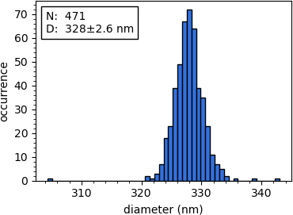
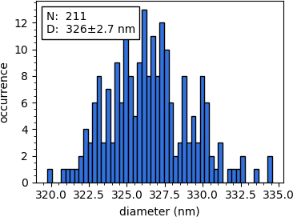
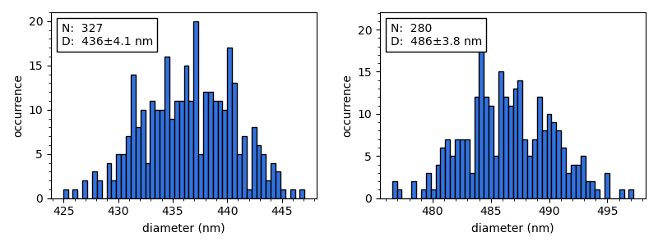
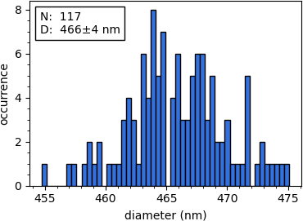
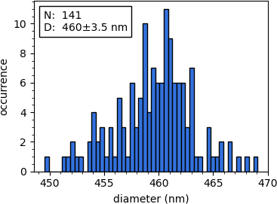
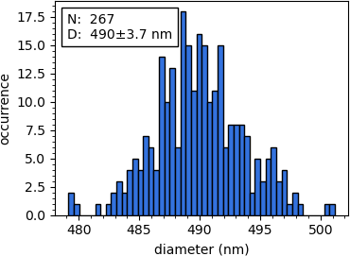
Table S1: Parameters for the growth to larger silica sizes, including the polydispersities determined from TEM (see also Figure S1) and the final particle sizes, determined from xy planes in confocal microscopy.
1
3
5
2
4
6
7

Initial particle size | Weight (x) | Addition rate | 1:2 TEOS:ethanol | Final size
(w) (nm) | (mg/mL) | (y) (mL/h) | (z) (mL) | (nm)
93 | 14 | 0.70 | 19.69 | 328 ± 0.8 %
123 | 11 | 0.70 | 15.00 | 326 ± 0.8 %
326 | 13 | 0.25 | 1.50 | 442 ± 0.9 %
328 | 14 | 0.25 | 1.96 | 457 ± 0.9 %
326 | 13 | 0.25 | 1.96 | 462 ± 0.8 %
328 | 16 | 0.25 | 2.15 | 450 ± 0.8 %
326 | 13 | 0.25 | 2.15 | 478 ± 0.8 %

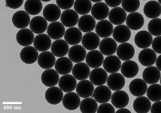
Figure S1: Overview of the particle sizes measured via TEM to give an indication of the polydispersity. The TEM image shows an example of the silica nanoparticles measured in the histogram (7) above it.

and provide enough water for the St¨ober reaction. Next, the solution was heated to 35 ◦C in a heating mantle, and stirred at 350 rpm. A solution of 19.1 mg (49.1 µmol) FITC, 12.00 mL ethanol, and 30.6 µL (0.13 mmol) APTES was prepared and loaded into a 20.0 mL syringe. A second 20.0 mL syringe was filled with 4 mL (17.9 mmol) TEOS and 8 mL ethanol. The syringes were equipped with precision tips to which BOLA tubing (PTFE, inner diameter: 0.8 mm, outer diameter: 1.58 mm) was attached. These tubes ended approximately 1 cm above the reaction mixture and were used to add the solvents with a syringe pump. The pump rate was 0.7 mL/h with a target volume of 11.67 mL for a syringe diameter
of 20.00 mm. This yielded particles with a diameter of 123 nm, whereas a target volume of 3.95 mL resulted in cores 93 nm.

Further Seeded Silica Growth
After growing the fluorescent shell, the particles were subsequently grown to larger sizes to provide sufficient separation between the fluorescent cores for analysis. The synthesis to the desired dimensions was split into two parts to minimize the number of dumbbells and secondary nucleation in the final mixtures. The particles were first grown to around 330 nm, and from there to the final sizes. As the St¨ober method is a self-sharpening mechanism, the polydispersity of the samples typically decrease as the particles become bigger [4, 5].
To grow the seeds from w nm to the desired size, 60.5 g (76.6 mL) ethanol, 7.50 mL MQ H₂O, 7.00 mL fluorescent silica seeds with a weight of x mg/mL, and 2.20 mL (29.4 mmol NH₃) ammonium hydroxide solution were added to a 250 mL 3-neck RBF. Next, the St¨ober mixture was heated to 35 ◦C and stirred at 350 rpm. Using a syringe pump at a rate of y mL/h a volume of z mL 1:2 TEOS: ethanol was added. After 48 h the reaction was stopped and the particles stored in a 100 mL glass jar. The added parameters are shown in Table S1, as well as the final sizes of the obtained particles.
After obtaining the desired particle sizes, the particles were centrifuged at 500 relative centrifugal force (rcf) for 30 min to remove excess liquid. The particles were then redispersed in 2.0 mL ethanol and sonicated for 15 min. To ensure that the refractive index of the particles remains fixed the ammonia must

be removed from the pores [6]. This was done by rotary evaporation for 30 min at 100 mbar, 40 ◦C, and 150 rpm, resulting in a dried sample. Afterwards, the particles were redispersed in water.

Self-assembly
Once the fluorescent core-shell silica particles were synthesized, they were treated by rotary evaporation to remove the ammonia from the inner pore structure. By doing so, the refractive index of the particles becomes stable, even when they are dispersed in water [6]. Afterwards, they could be used for the assembly into supraparticles and still reliably be index matched. The self-assembly method used here, is based on the simplified double-emulsion method reported by Wang et al., [7]. This specific method was chosen as the water-in-oil-in-water (w/o/w) emulsion offers more control over the drying speed, as was already shown in several previous works [8, 9]. This is achieved through varying the osmotic pressure in the bulk of the solution in order to control the flux of water through the oil layer around each disper- sion droplet. A concentration of 2 vol% particles in MQ H₂O was used to make the dispersion droplets. Of this solution, 250 µL was added to a 15 mL centrifuge tube (VWR SuperClear) containing 1.50 mL 1 wt% krytox in HFE 7500. This mixture was vortexed at 3000 rpm for 1 min, after which it was left for 1 min to cream. The top layer of emulsion droplets were then removed with a pipette tip in which
the solution was creamed for an additional 30 s. After this creaming step, the excess liquid was removed and around 200 µL particles were transferred to a 15 mL centrifuge tube (VWR SuperClear) containing
1.00 mL 4 wt% (0.14 mmol) SDS in MQ H₂O. This mixture was vortexed at 3000 rpm for 1 min, before the sample was transferred to a 4 mL vial which was left on a table shaker (IKA KS 260 basic) at 300 rpm for 2 days. Note that by changing the surfactant concentrations in the oil and water phases the osmotic pressure can be changed. Under the conditions described here, near-equilibrium structures were obtained. However, if one was to increase the surfactant concentration in the outer (water) phase, much faster self-assembly times could be achieved, resulting in less ordered structures.
Next, the particles were centrifuged several times at 10-20 rcf for 10 min, in 4 mL glass vials. The particles were redispersed in THF after the first washing step, in a mixture of 50/50 vol% THF/HFE 7500 solution after the second and third washing step to remove the Krytox surfactant from the supraparticles. At this point the particles could either be stored in HFE 7500 for later use, or the washing procedure could be continued to prepare the supraparticles for further analysis. The latter was done by redispersing them in THF once and two more times in pure water after the subsequent washing steps. The final particle solution was used for the sample preparation of the confocal/STED samples.

Supraparticle with Spherical Inclusion
The SP with the spherical inclusion was made using a modified self-assembly procedure. In the self-assembly process, both the inner and outer water phases were replaced by dimethylsulfoxide (DMSO). To ensure proper index matching during confocal imaging, the SP was afterwards immersed in DMSO. The DMSO tends to enter the pores of the silica, resulting in only a minor refractive index mismatch.

Additional data
In this section we will briefly outline the additional data. In Figure S3, the different clusters classified in UMAP are shown, together with an inset of a SP that shows what each class represents. Note, the classifier was originally trained to classify 20 classes, and via entropy-based merging the number of classes has been reduced to 12. This number was chosen to have a balance between seeing the finer details of the supraparticle structure, while not being overwhelmed by small details caused by noise or experimental imperfections.
In Figure S2, we show an example from both the scanning electron microscopy dataset and a cross-sectional slice (out of around 20 slices per z-scan) from the confocal microscopy dataset. These images are annotated to indicate how the supraparticles were quantitatively characterized. Here, anti-Mackay (AM) and

icosahedral (Icos) supraparticles were grouped together as crystalline, off-center and partially icosahedral (PI) as partially crystalline, and disordered (D) as the disordered/onion-shell class, respectively.

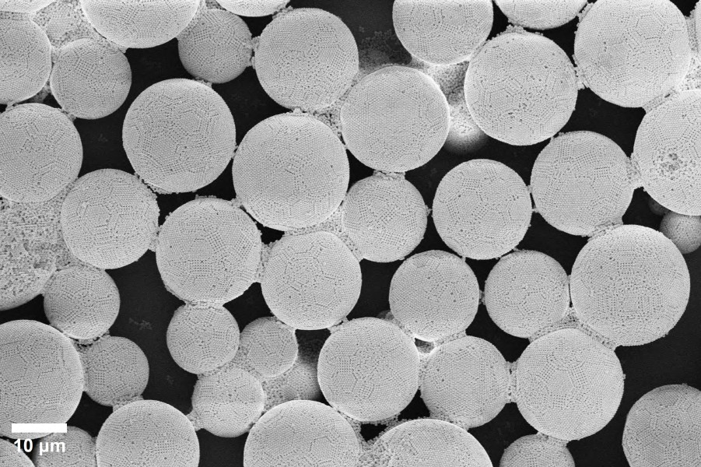
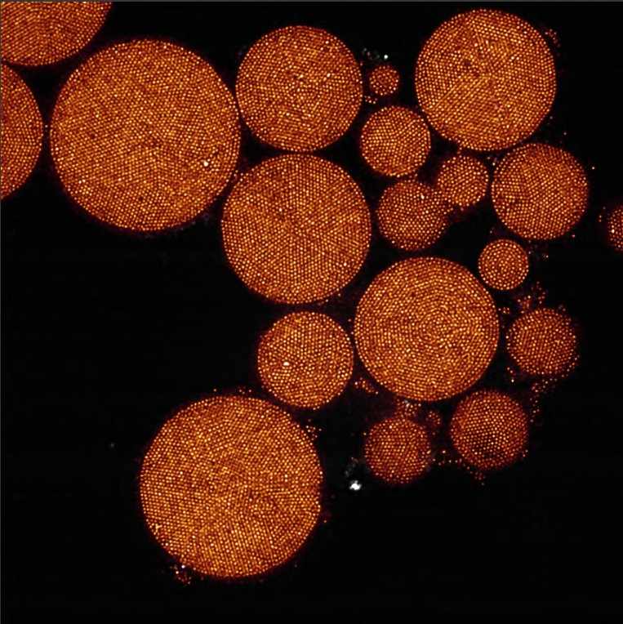
AM
PI
AM
PI
AM
AM
PI
Icos
PI
PI
OS
AM
PI
AM
AM
AM
AM
OS
AM
PI
AM
PI
AM
AM
Icos
AM
OS
Off center
AM
PI
OS
PI
OS
AM
Icos
PI
AM AM
AM
AM
PI
AM
PI
PI
AM
AM
AM
10 μm
Figure S2: Examples of datasets used for the quantitative analysis of the supraparticles with scanning electron microscopy and confocal microscopy. The annotation is as follows: Anti-Mackay (AM), partially icosahedral (PI), disordered (D), non- surface reconstructed icosahedral (Icos), and off center. All supraparticles that were not characterized were either not fully in the image, or consist of some different crystal class, where the one in the SEM image for example shows two five-fold symmetry points that are almost overlapping.

In Table S2 an overview is given of the type of supraparticle, how many particles it contains and its packing fraction. All the experimental supraparticles are listed first, followed by cookie cut FCC crystals of different sizes, clusters of 13 particles, and finally simulated magic number clusters from [10].

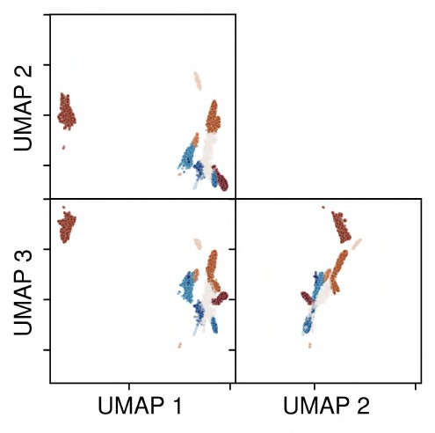
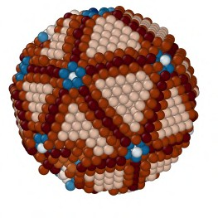
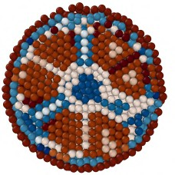


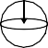
σ
Figure S3: Projection and clustering after entropy-based merging into 12 clusters together with a visual representation of what each cluster represents within the SPs [11].

Table S2: Overview of packing fractions for the fully analyzed SPs, the naming convention given here is also maintained throughout supraparticle visualization files.

SP ID | Number of particles | Packing fraction (%)
(Mostly) anti-Mackay 1 | 6590 | 64.18
(Mostly) anti-Mackay 2 | 8047 | 62.73
(Mostly) anti-Mackay 3 | 17971 | 62.79
(Mostly) anti-Mackay 4 | 8210 | 62.24
(Mostly) anti-Mackay 5 | 11953 | 63.42
(Mostly) anti-Mackay 6 | 10286 | 66.99
Decahedral 1 | 7847 | 63.84
Disordered 1 | 44019 | 61.98
Disordered 2 | 151016 | 51.65
Disordered 3 | 16651 | 47.74
Disordered 4 | 23188 | 50.49
Off-center 1 | 39442 | 64.91
Off-center 2 | 44109 | 66.81
Onion-shell 1 | 60982 | 64.00
Onion-shell 2 | 61972 | 57.93
Partial decahedral 1 | 18644 | 65.27
Partial decahedral 2 | 41266 | 65.71
Partial decahedral 3 | 82151 | 62.26
Partial FCC 1 | 56759 | 67.59
Partial onion-shell 1 | 11199 | 67.78
Partial onion-shell 2 | 5854 | 64.58
Spherical inclusion 1 | 1870 | 57.59
FCC 1 | 7107 | 67.83
FCC 2 | 55940 | 70.58
FCC 3 | 192698 | 71.58
FCC 4 | 1000000 | 73.32
FCC 5 | 5000000 | 73.34
FCC 13 | 13 | 64.98
HCP 13 | 13 | 64.96
Icos 13 | 13 | 63.47
Magic number icosahedral 1 | 6861 | 64.99
Magic number icosahedral 2 | 10515 | 65.35
Magic number decahedral 1 | 7838 | 67.70

References
- Shakiba Shahabi, Laura Treccani, and Kurosch Rezwan. “Amino acid-catalyzed seed regrowth synthesis of photo- stable high fluorescent silica nanoparticles with tunable sizes for intracellular studies”. In: Journal of Nanoparticle Research 17 (June 2015), pp. 1–15. doi: 10.1007/s11051-015-3072-8.
- Alfons van Blaaderen and A Vrij. “Synthesis and characterization of colloidal dispersions of fluorescent, monodisperse silica spheres”. In: Langmuir 8.12 (Dec. 1992), pp. 2921–2931. doi: 10.1021/la00048a013.
- Nynke AM Verhaegh and Alfons van Blaaderen. “Dispersions of rhodamine-labeled silica spheres: synthesis, charac- terization, and fluorescence confocal scanning laser microscopy”. In: Langmuir 10.5 (July 1994), pp. 1427–1438. doi: 10.1021/la00017a019.
- Gregory H Bogush and Charles F Zukoski Iv. “Uniform silica particle precipitation: An aggregative growth model”. In: Journal of colloid and interface science 142.1 (Mar. 1991), pp. 19–34. doi: 10.1016/0021-9797(91)90030-C.
- A van Blaaderen, J van Geest, and A Vrij. “Monodisperse colloidal silica spheres from tetraalkoxysilanes: particle formation and growth mechanism”. In: Journal of colloid and interface science 154.2 (Dec. 1992), pp. 481–501. doi: 10.1016/0021-9797(92)90163-G.
- Qingsong Fan et al. “Unveiling Enhanced Electrostatic Repulsion in Silica Nanosphere Assembly: Formation Dynam- ics of Body-Centered-Cubic Colloidal Crystals”. In: Journal of the American Chemical Society 145.51 (Dec. 2023),
pp. 28191–28203. doi: 10.1021/jacs.3c10817.
- Junwei Wang et al. “Tailored double emulsions made simple”. In: Advanced materials 34.5 (Feb. 2022), p. 2107338.
doi: 10.1002/adma.202107338.
- Kathryn Shirk et al. “Assembly of colloidal silica crystals inside double emulsion drops”. In: Langmuir 29.38 (Aug. 2013), pp. 11849–11857. doi: 10.1021/la4019986.
- Shin-Hyun Kim et al. “Osmotic-pressure-controlled concentration of colloidal particles in thin-shelled capsules”. In:
Nature communications 5.1 (Jan. 2014), p. 3068. doi: 10.1038/ncomms4068.
- Junwei Wang et al. “Magic number colloidal clusters as minimum free energy structures”. In: Nature communications
9.1 (Dec. 2018), p. 5259. doi: 10.1038/s41467-018-07600-4.
- Alptu˘g Ulug¨ol et al. “Comparing unsupervised learning methods for local structural identification in colloidal sys- tems”. In: arXiv preprint arXiv:2509.07186 (2025). doi: 10.48550/arXiv.2509.07186.

