Supplementary Information

Ultrafast Electric Switching of Brookite TiO₂ Nanorods with a Permanent Dipole Moment at High Concentrations

Seyed Naveed Hosseini¹, Anna G. Nikolaenkova¹, Ivan Dozov², Patrick Davidson², Patrick J. Baesjou¹, Alfons van Blaaderen¹, Arnout Imhof^{1,*}

S. N. Hosseini, A. G. Nikolaenkova, P. J. Baesjou, A. van Blaaderen, A. Imhof
Soft Condensed Matter, Debye Institute for Nanomaterials Science, Utrecht University, Princetonplein 1, 3584 CC Utrecht, The Netherlands
E-mail: a.imhof@uu.nl

I. Dozov, P. Davidson
Laboratoire de Physique des Solides, Université Paris-Saclay, CNRS, 91405 Orsay, France
E-mail: patrick.davidson@universite-paris-saclay.fr

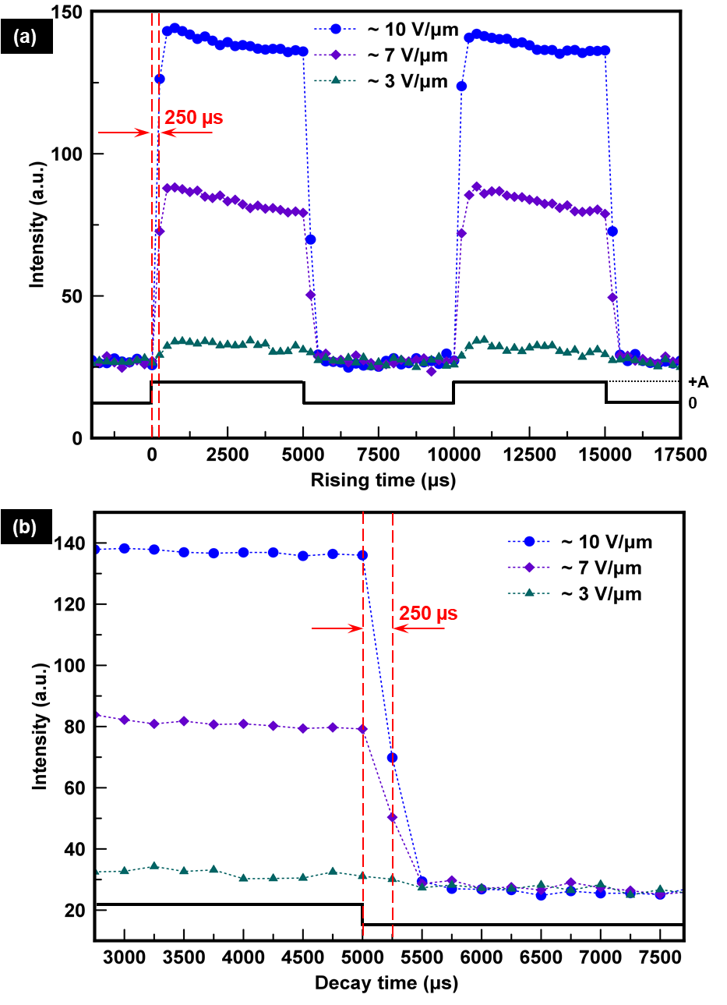
Supplementary Figure 1. (a) Transmitted light intensity versus time measured on in-plane switching cells between crossed polarizers containing a brookite TiO₂ nanorod dispersion when square d.c. pulses with a pulse width of 5000 $μs$ and a duty cycle of $50\%$ are applied at 3, 7, and 10 V/μm field strengths. (b) The same, but zoomed-in around a time when the field is switched off. The dashed vertical lines in red depict the time interval between the two consecutive data points corresponding to the camera’s frame rate of 4000 fps.

Supplementary Figure 2. X-ray diffraction pattern of the titania nanorods compared with the Brookite titania reference (JCPDS No.029-1360). The inset shows an HR TEM image of one nanorod.

