Supporting information
Particle Size Effects in Au/TiO₂ Catalysts for the Oxidation of
5-hydroxymethylfurfural
H.L. Noltenª, M.A. van Huis^{b}, P.E. de Jonghª
ªMaterials Chemistry and Catalysis, Debye Institute for Nanomaterials Science, Utrecht University, Universiteitsweg 99, 3584CG Utrecht, the Netherlands
^{b} Soft Condensed Matter & Biophysics, Debye Institute for Nanomaterials Science, Utrecht University, Princetonplein 1, 3584CC Utrecht, the Netherlands

Contents
S1. Additional characterization data 3
Figure S1 – X-ray diffractograms of selected catalysts. 3
Table S1 – Comparison of particle sizes of Au/TiO₂ catalysts using XRD and TEM 3
Figure S2 – Deconvolution of Au XRD peaks from TiO₂ support 4
Table S2 – Crystallite sizes before and after deconvolution 5
S2. Additional characterization data after catalysis 6
Table S3 – Particle size before and after 6 hours of HMF oxidation 6
Figure S3 – X-Ray Diffractograms after catalysis 8
Figure S4 – HAADF-STEM image of Au_2.8 after heat-up in autoclave under N₂ 10
Figure S5 – HAADF-STEM images of Au_2.0b at reaction conditions without additional organic components 11
Table S4 – ICP-OES of catalysis samples 12
S3. Additional catalysis data 13
Figure S6 – Concentration of HMF as a function of time 13
Figure S7 - Reference Catalyst XRD before and after and catalytic performance 14
Table S5 – Two-tailed paired student t-test results for statistical relevance 16
Figure S9 – HMFCA oxidation rate 17
Table S6 – Characterization overview of tested catalysts in HMFCA oxidation 18
S4. Extrapolated surface site distribution model and experimental data fits 19
Figure S10 – Extrapolated surface site distribution model 19
Figure S11 – Surface site distribution model fits in HMF oxidation rate trend 20
Figure S12 – High-resolution HAADF-STEM images of Au_2.0 and Au_4.0 21

S1. Additional characterization data

Figure S1 – X-ray diffractograms of selected catalysts.
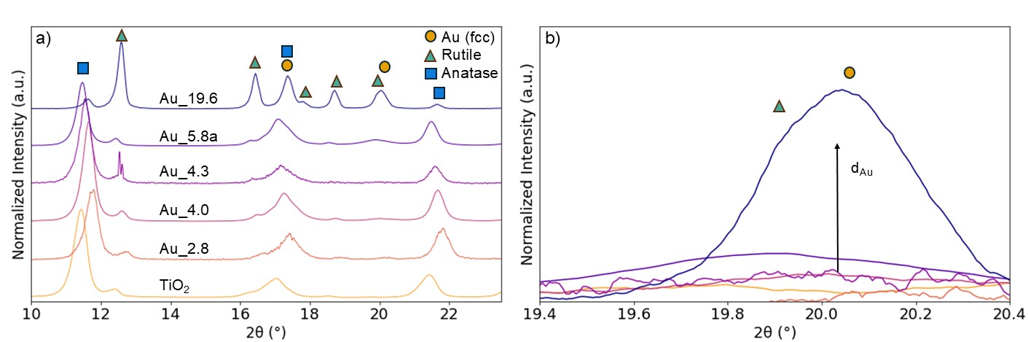
Figure S1. X-Ray diffractograms between 10-23.5° (a) of selected Au/TiO₂ catalysts with y-offset. The diffractograms are normalized to the minximum. In the top row theoretical reference X-Ray signals are shown. (b) displays a zoom-in of the 19.4-20.4° region with increasing intensity and sharper appearance of the Au(200) signal with increasing gold particle size
X-ray diffractograms of selected Au/TiO₂ catalysts were left out of Figure 2 and are presented in Figure S1 for improved visibility. Figure S1a shows an increasing Au(200) signal at 20˚ with increasing d_{TEM}. This is visualized even clearer in Figure S1b that shows the increasing intensity with increasing TEM size, but more importantly narrower FWHM, indicating increased crystallite size. The resulting crystallite size, as derived from the Scherrer equation, is displayed in Table S1.

Table S1 – Comparison of particle sizes of Au/TiO₂ catalysts using XRD and TEM
Catalyst | d_{TEM, s.a}. (nm) | d_{TEM, v.a.} (nm) | d_{XRD} (nm)
Au_2.0 | 2.0 ± 0.6 | 2.2 | 0
Au_2.8 | 2.8 ± 0.7 | 2.9 | 0
Au_3.8 | 3.8 ± 1.1 | 4 | 0
Au_4.0 | 4.0 ± 1.1 | 4.2 | 0
Au_4.3 | 4.3 ± 0.9 | 4.5 | 0
Au_5.8a | 5.8 ± 1.3 | 6.1 | 5.2
Au_5.8b | 5.8 ± 1.3 | 6 | 5.6
Au_12.5 | 12.5 ± 2.8 | 13 | 8.3
Au_18.6 | 18.6 ± 6.2 | 19.6 | 11.3ª
Au_19.6 | 19.6 ± 5.4 | 20.6 | 11.1ª
Table S1. Overview of measured particle sizes from XRD and HAADF-STEM using surface- and volume-averaging. ª after deconvolution from support signal.
To validate the particle sizes manually measured with HAADF-STEM, XRD was done as more bulk-oriented technique. From the XRD peaks in Figure S1, the Full Width at Half Maximum (FWHM) was used in the Scherrer equation and yielded crystallite sizes, listed in Table S1. The increasing particle sizes found with TEM increase in crystallite size to a lesser extent, likely due to polycrystallinity. For the catalysts with small particle size (<5 nm), no crystallite sizes are shown, as there was too little signal to obtain a valid crystallite size. Note that these catalysts also had a lower Au weight loading (Table 1). The crystallite size of Au_18.6 and Au_19.6 is derived from a deconvolution of the XRD signal. This is further explained in Figure S2 and Table S2.

Figure S2 – Deconvolution of Au XRD peaks from TiO₂ support
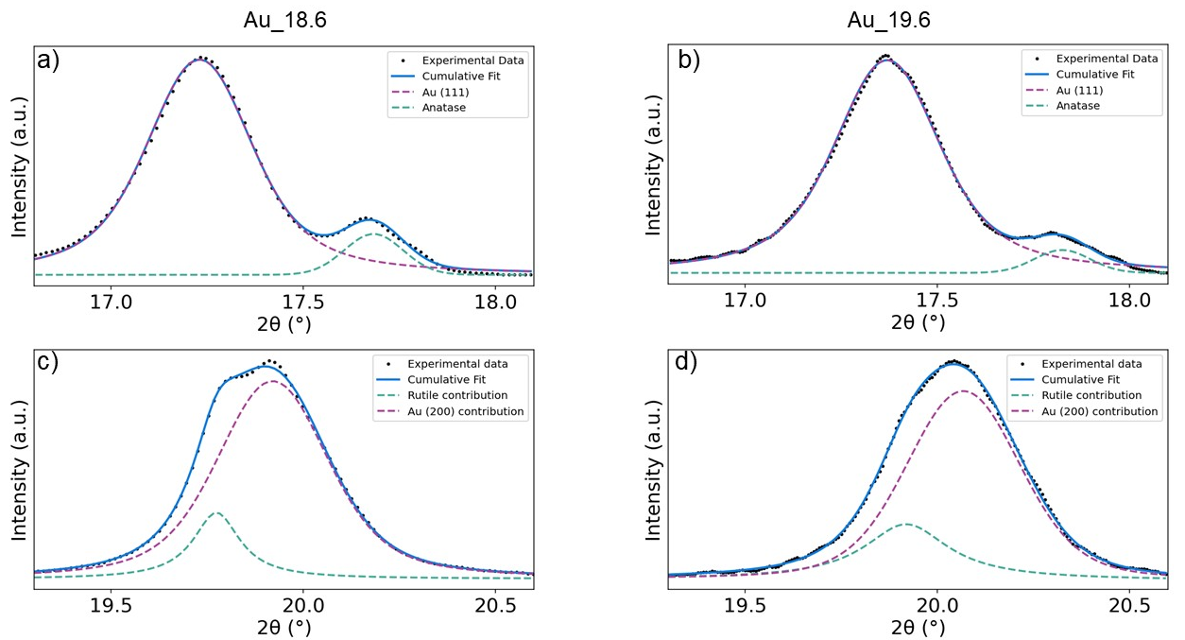
Figure S2. Zoom-in of X-ray diffractogram ranges between 16.8-18.1° and 19.2-20.6° of Au 18_6 and Au_19.6 with deconvoluted signals for Au and TiO₂. (a) and (c) show the deconvoluted signals of Au_18.6 and (b) and (d) that of Au_19.6.
Some diffraction signals required deconvolution from support signal, which is shown in Figure S2. The effect of signal deconvolution on the resulting crystallite size is listed in Table S2. Figure S2a and S2b contain the peak deconvolution of the Au(111) peak at 17.2° with that of anatase at 17.7°. Figure S2c and S2d contain the peak deconvolution of the Au(200) peak at 19.9° with that of rutile at 19.7°.

Table S2 – Crystallite sizes before and after deconvolution
Catalyst | d_{XRD} from 20° | d_{XRD} from 17° deconvoluted | d_{XRD} from 20° deconvoluted
Au_18.6 | 9.2 | 11.9 | 11.3
Au_19.6 | 10.8 | 11.8 | 11.1
Table S2. Resulting crystallite sizes for Au_18.6 and Au_19.6 after signal deconvolution at 17° and 20°.
At 2θ values of 17° and 20°, gold shows diffraction signals in the X-ray diffractograms. Several diffractograms required deconvolution from the signal of the support, which is shown in Figure S2. The effect on the resulting crystallite size is listed in Table S2. The deconvoluted signals provide a slightly larger crystallite size than the convoluted signal.

S2. Additional characterization data after catalysis

Table S3 – Particle size before and after 6 hours of HMF oxidation
Catalyst | d_{TEM,s.a.} pre-cat (nm) | d_{TEM, s.a.} post-cat (nm) | d_{XRD} post-cat (nm)
Au_2.0 | 2.0 ± 0.6 | 5.8 ± 1.8 | 10
Au_2.8 | 2.8 ± 0.7 | 8.2 ± 4.2 | 9.2
Au_3.8 | 3.8 ± 1.1 | 4.8 ± 1.2 | 6.4
Au_4.0 | 4.0 ± 1.1 | 4.9 ± 1.4 | 7.9
Au_4.3 | 4.3 ± 0.9 | 4.4 ± 1.0 | 8.7
Au_5.8a | 5.8 ± 1.3 | 6.6 ± 2.0 | 5.5
Au_5.8b | 5.8 ± 1.3 | 5.9 ± 1.2 | 6
Au_12.5 | 12.5 ± 2.8 | 12.5 ± 3.9 | 11.3ª
Au_18.6 | 18.6 ± 6.2 | 16.7 ± 9.2 | 12.3ª
Au_19.6 | 19.6 ± 5.4 | 19.0 ± 9.1 | 10.9ª
Table S3. Particle and crystallite size of Au/TiO₂ catalysts before and after 6 hours of HMF oxidation at 80°C, 900 rpm and 10 bar O₂. ª deconvoluted signal at 20°.
Catalysts tested in this work were characterized before and after a catalysis run, lasting 6 hours. An overview of after catalysis characterization results can be found in Table S3. Particle sizes and crystallite sizes after catalysis are shown. The particle size of most catalysts remained stable throughout the catalysis run. Only Au_2.0 and Au_2.8 showed significant particle growth. This is confirmed by XRD after catalysis. XRD after catalysis is expected to overestimate the crystallite size for most samples, as large crystallites influence the measured peak width heavily.

Figure S3 – X-Ray Diffractograms after catalysis
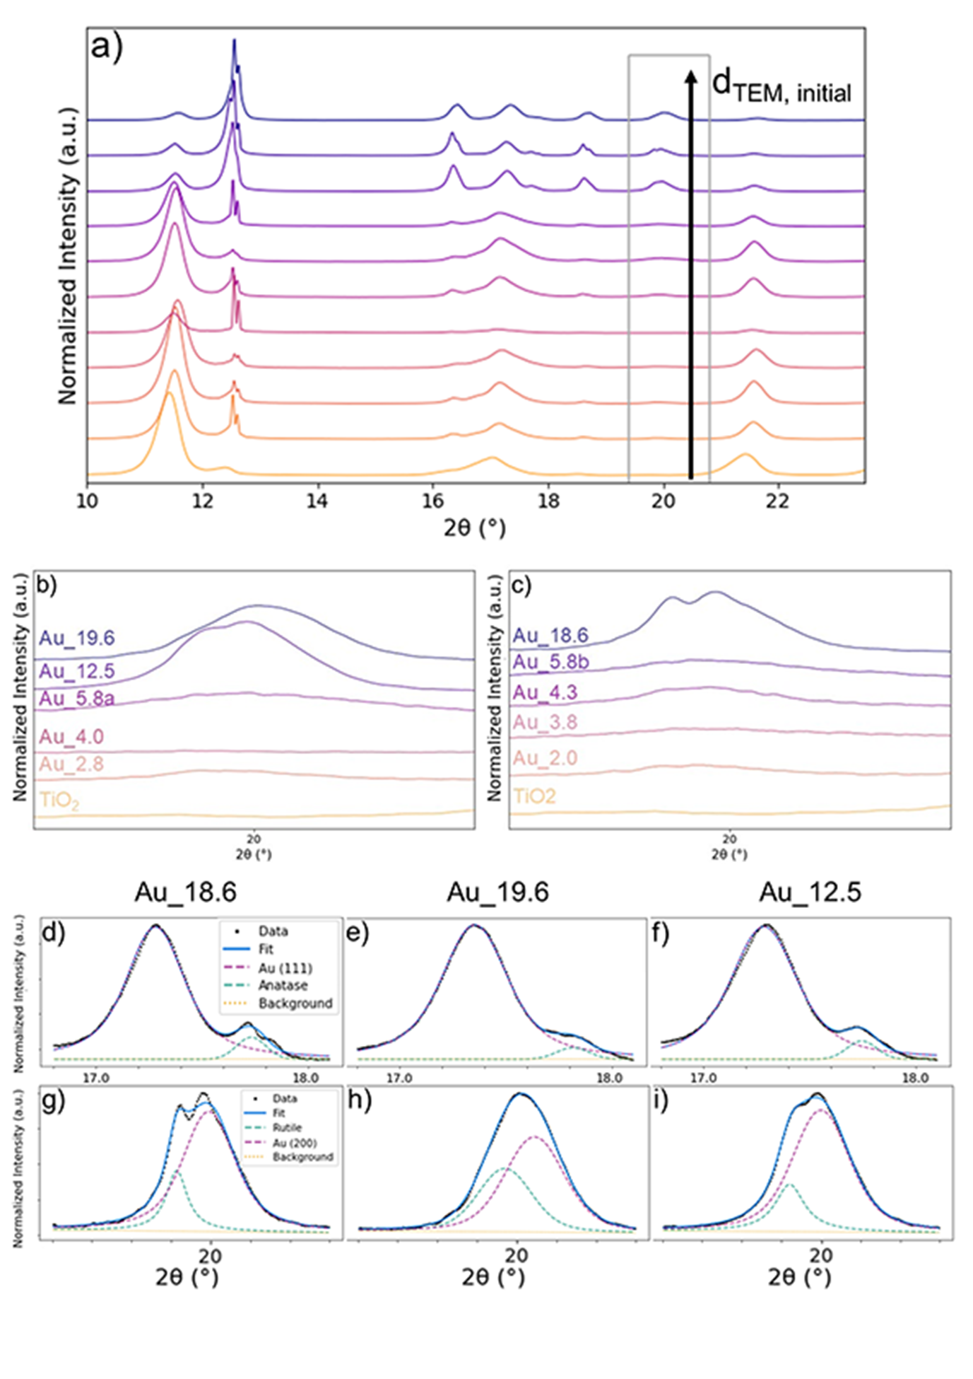
Figure S3. X-Ray Diffraction of all catalysts after 6 hours of HMF oxidation. a) An overview of all X-ray diffractograms in the entire 10-23° range in order of increasing initial particle size from bottom to top. b and c) A zoom-in of the 19-21° region, containing the signal of interest, Au (200). d), e) and f) a Zoom-in of 16.8-18.1° containing deconvolution of the anatase signal (green) from Au(111) (purple) of Au_18.6, Au_19.6 and Au_12.5 respectively. g), h) and i) a Zoom-in of 19.2-20.6° containing deconvolution of the rutile signal (green) from Au(200) (purple) of Au_18.6, Au_19.6 and Au_12.5 respectively.
The crystallite sizes after catalysis are retrieved from X-ray diffractograms, shown in Figure S3. The catalysts are displayed with increasing particle size, determined by TEM, from bottom to top. A more intense and narrower signal at 20° is the result of an increasing crystallite size. In some cases, deconvolutions were required to isolate the Au signal from the support signal, which is shown Figure S3d-i. As, XRD is often dominated by large crystallites in polydisperse samples, the d_{TEM} after catalysis was further used, as this should give a more representative size after catalysis.

Figure S4 – HAADF-STEM image of Au_2.8 after heat-up in autoclave under N₂
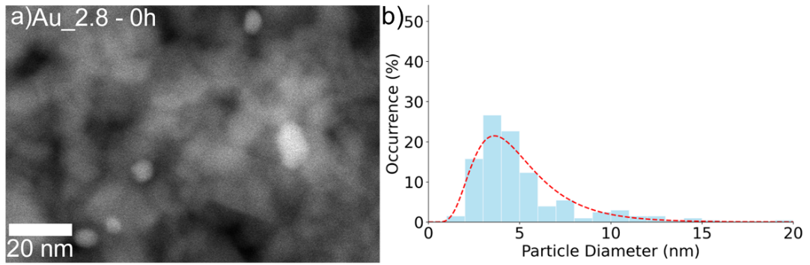
Figure S4. HAADF-STEM image (a) of Au_2.8 after heat-up to 80°C in autoclave under N₂ and (b) corresponding particle size distribution.
Figure S4 shows a HAADF-STEM image and corresponding particle size distribution of Au_2.8 after heat-up procedure to 80°C in the reaction media in the reactor under N₂. Severe particle growth compared to the pre-catalyst was observed, marked by the amount of particles larger than 5 nm in the histogram shown in Figure S4b.

Figure S5 – HAADF-STEM images of Au_2.0b at reaction conditions without additional organic components
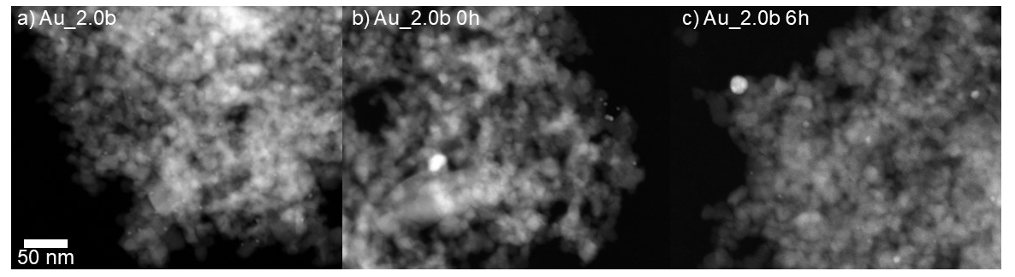
Figure S5. HAADF-STEM images of Au_2.0b at different time intervals during a run mimicking reaction conditions of HMF oxidation, but without organic species present. Conditions: 0.05 M NaHCO₃ in 12 mL H₂O, 100.8 mg Au_2.0b, O₂ (10 bar) at 80 °C, 900 rpm stirring. (a) shows the catalyst as-made, (b) after heat-up under N₂ in autoclave reactor and finally (c) shows the catalyst after 6 hours in the autoclave reactor. The scale bar for all images is displayed in the very left bottom.
In Figure S5, HAADF-STEM images of Au_2.0b during a catalysis run without organics is shown to demonstrate the anomalous growth of small Au nanoparticles during catalysis and that this effect is not solely induced by adsorbed organic components. This run without additional organic components was executed to see whether these organic components play a large role in the observed particle growth, as organic intermediates are reported to enhance metal nanoparticle growth. The particle growth of Au_2.0b was present without additional organic components, showing that only the alkaline aqueous media already allows such particle growth. This shows that Au/TiO₂ catalysts with sub-3 nm particles are expected to have poor stability in any liquid phase reaction with water as solvent.

Table S4 – ICP-OES of catalysis samples
Catalyst | ICP-OES of Au in filtered product (ppm) | Theoretically maximal amount of Au in filtered product (ppm) | Percentage Au in solution (%)
Au_2.8 | 1.3 | 39.9 | 3.3
Au_18.6 | 2.3 | 283.2 | 0.8
Table S4. ICP-OES elemental quantification of catalysis samples after 6 hours of catalysis and after filtering through 0.45 μm PTFE filter
Table S4 lists concentrations of Au found in samples after catalysis by ICP-OES. It illustrates the increased leaching occurrence of catalysts with <3 nm Au particles compared to catalysts with larger Au particles. The experimentally found ppm amounts were compared to the calculated maximal amount of Au. The resulting percentages show how much gold has leached into the reaction solution after 6 hours of catalysis.

S3. Additional catalysis data

Figure S6 – Order in HMF concentration
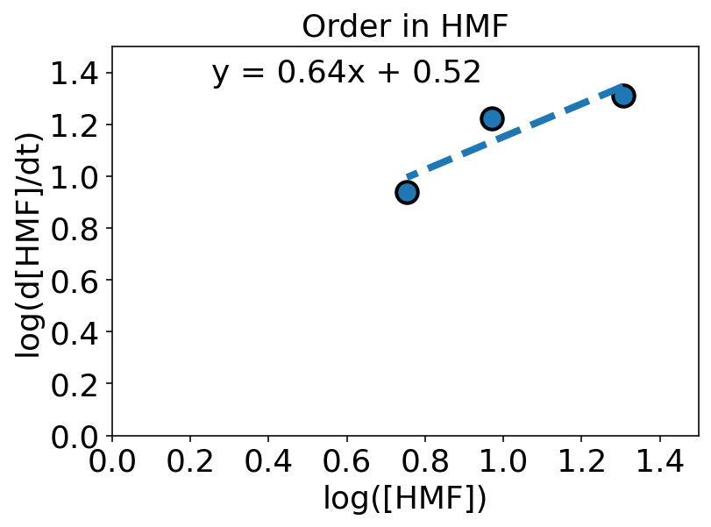
Figure S6. The logarithm of the HMF conversion as a function of the logarithm of the HMF starting concentration. The correlation between the two describes the order in HMF under the applied conditions. The formula describes the y-intercept and slope of the trend line through the three experiments with different HMF concentrations.
The order in HMF was determined by experiments with different HMF starting concentrations. The resulting activities are shown in Figure S6. The activity increases with the starting concentration of HMF, so more HMF molecules are converted in the same amount of time when the starting concentration is increased. This indicates an apparent first order in the HMF concentration. For a first order a slope of 1 between the logarithm of the activity and the starting concentration is expected. In Figure S6 a slope of 0.64 was found. Competitive adsorption of formed intermediates is likely slowing down the HMF conversion rate, as the activity is not completely linear to the HMF concentration.

Figure S7 – Impact on HMF oxidation rate by competitive adsorption of intermediates
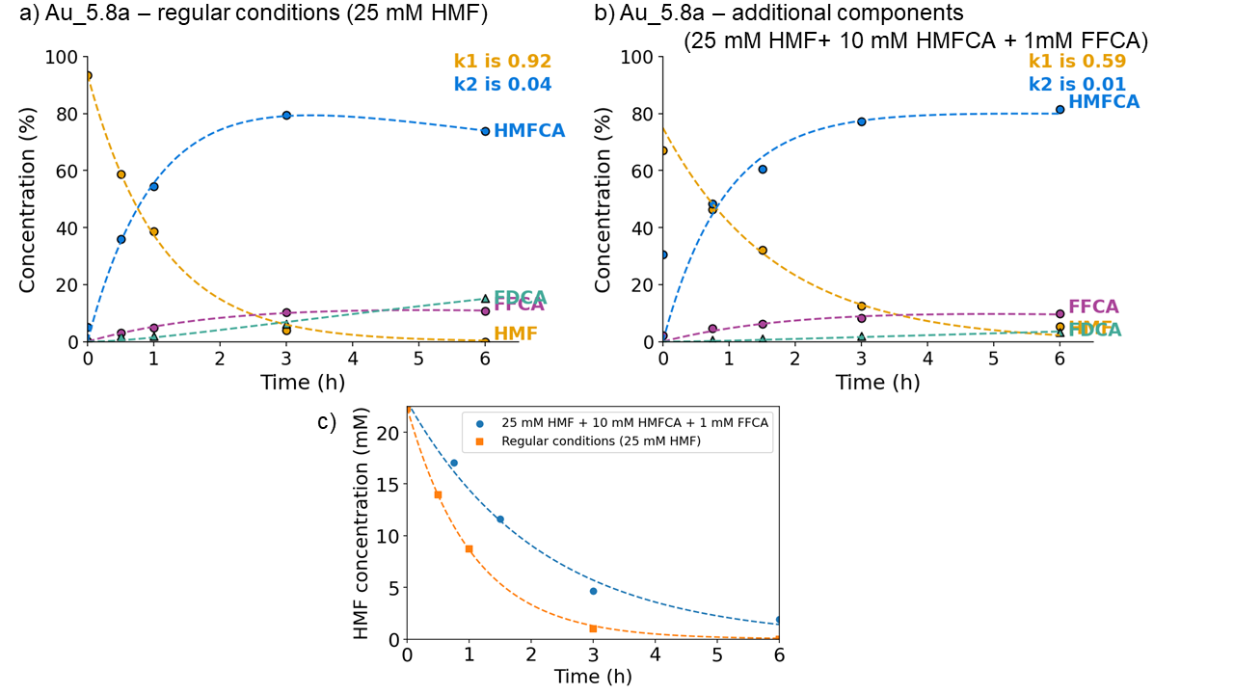
Figure S7. Reaction profiles as a function of time for Au_5.8a. a) shows the reaction profile under regular applied conditions. b) shows the reaction profile if 10 mM HMFCA and 1 mM FFCA are added at the start of the test. c) shows a comparison of the decay in HMF concentration over the measured 6 hours with the regular conditions in orange and the run with additional components in blue.
To verify the influence of competitive adsorption on the HMF conversion rate, an experiment with additional organic components at the start was conducted. Besides the regular amount of HMF (25 mM), 10 mM of HMFCA and 1mM FFCA was added, as these are common concentrations for our conditions that can be found during catalysis. The concentration profiles of catalysis under regular conditions and under competitive adsorption conditions are displayed in Figure S7. The HMF concentration decay in Figure S7c is a lot faster without these organic species that most likely inhibit active sites for HMF oxidation. The k₁ found for the experiment with additional organics is 64% (0.59 to 0.92 h⁻¹), comparable to the abundance of HMF, which is 69% (compared to the usual 100%).

Figure S8 - Reference Catalyst XRD before and after and catalytic performance
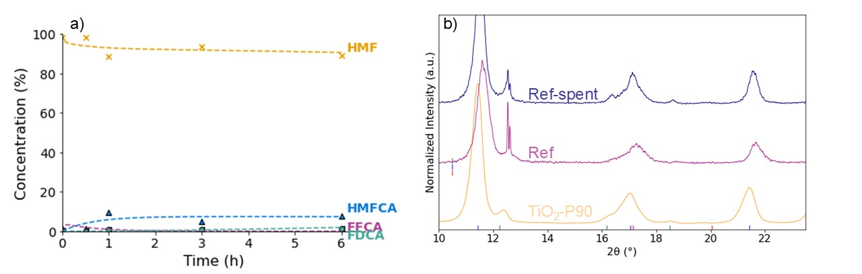
Figure S8. HMF oxidation performance (a) and XRD characterization (b) of reference sample (TiO₂ P90 treated at 550°C for 6h)
To confirm catalytic activity was really originating from the gold particles, a catalysis run was done with a TiO₂ support that was subjected to the same synthesis conditions. Figure S8a shows the results of this catalysis run. Without Au nanoparticles present no activity was found in HMF oxidation, which clearly proves the Au nanoparticles play a huge role in other shown catalysis data. Figure S8b provides additional XRD characterization of the synthesized reference material.

Figure S9 – Hot-filtration tests
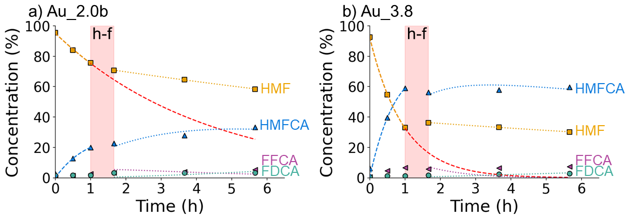
Figure S9. HMF oxidation profiles before and after hot filtration for a) Au2.0b and b) Au_3.8. The red zone marks the hot-filtration time. The data points before and after hot-filtration were fitted separately. The HMF concentration fit before hot-filtration was elongated and shown in red to display the scenario without hot-filtration as comparison to the data points after.
Hot-filtration tests were performed to exclude catalysis by species in solution. The reaction mixture is filtered after one hour of catalysis, after which the filtered solution was allowed to run for 4 more hours under the same conditions. Therefore, significant conversion observed after hot-filtration is probably not caused by the filtered solid catalyst. In Figure S9 the reaction profiles of Au_2.0b and Au_3.8 before and after hot-filtration are shown. The red line from t=1 to t=6 shows the scenario of HMF conversion without hot-filtration. In both cases, hardly any conversion is observed after hot-filtration. This shows that the HMF oxidation by Au/TiO₂ catalysts under our applied conditions is heterogeneously catalyzed.

Table S5 – Two-tailed paired student t-test results for statistical relevance
Mean difference | 0.0157
Standard deviation in difference | 0.0315
t(9) | 1.575
Probability | 0.1497
95% Confidence Interval | [−0.033,0.0071]
Table S5. Outcome of two-tailed paired student t-test of HMF oxidation TOFs obtained.
A paired two-tailed t-test was performed to verify the robustness our catalysis findings. This t-test is an indication of the average error in the TOF_{HMF} measurements, shown in Figure 6. The result of a paired t-test is shown in Table S5. The results indicate the error does not invalidate the observed trends, as the probability is higher than 0.05 and the 95% confidence interval suggests a standard error of ±0.03, which is smaller than the observed differences, caused by the particle size.

Figure S10 – HMFCA oxidation rate
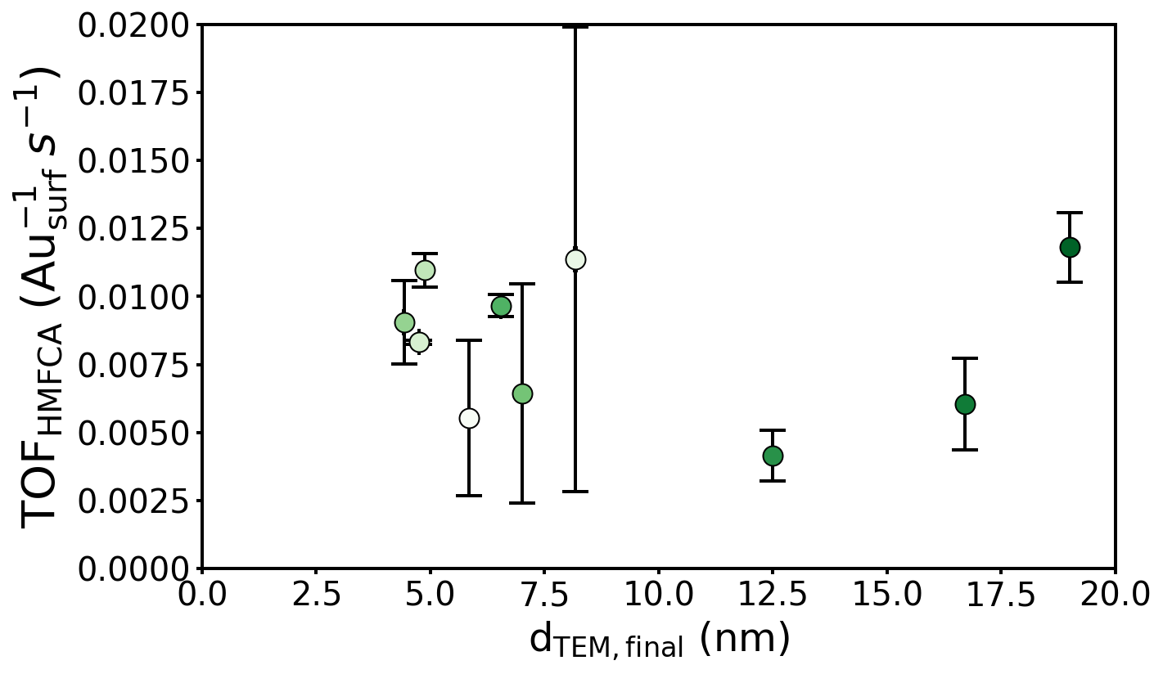
Figure S10. HMFCA oxidation performance derived from HMFCA concentration fits of HMF oxidation experiments as a function of the surface-averaged particle size after catalysis. a) the TOFHMFCA and b) the selectivity defined by a comparison of the respective HMF and HMFCA conversion rates. Conditions: HMF (0.025 M, 1 eq.), NaHCO₃ (0.05 M, 2 eq) in H₂O, 47.3 mg Au_4.3, O₂ (10 bar) at 80°C, 900 rpm stirring.
Figure S10 shows the TOF_{HMFCA} retrieved from the same catalytic runs of shown data in Figure 6. For a lot of samples, large error bars indicate the fitting error in the determination of the HMFCA oxidation rate. If HMF oxidation proceeds too slow, too few data points are present to compute a valid HMFCA oxidation rate constant. It is well known from literature that HMFCA oxidation often only takes place at HMF conversions above 80%²⁴. Therefore, we chose to investigate the particle size effect in HMFCA oxidation rate separately, which is shown in Figure 7 (in the main text).

Table S6 – Characterization overview of tested catalysts in HMFCA oxidation

Catalyst | Synthesis technique | Heat treatment T (°C); and time (h)ª | Au weight loading (wt.%)^{b} | TEM diameter  d_{,TEM, s.a.} (nm)^{c} | XRD crystallite size d_{XRD} (nm)^{d} | TEM diameter  d_{,TEM, s.a.} after 6h of catalysis (nm)
Au_2.0b | DP NaOH | 300; 4 | 0.3 | 2.0 ± 0.4 | n.a. | 6.8 ± 2.6
Au_3.8 | DPU | 200; 4 | 1.65 | 3.8 ± 1.1 | n.a. | 5.0 ± 1.3
Au_4.0 | DPU | 300; 4 | 1.49 | 4.0 ± 1.1 | n.a. | 5.2 ± 1.4
Au_5.8a | DPU | 550; 4 | 3.41 | 5.8 ± 1.3 | 5.2 | 6.9 ± 1.4
Au_5.8b | DPU | 525; 6 | 3.99 | 5.8 ± 1.3 | 5.6 | 6.0 ± 1.6
Au_12.5 | DPU | 540; 6 | 3.75 | 12.5 ± 2.8 | 8.3 | 11.8 ± 2.4
Au_18.6 | DPU | 550; 6 | 3.60 | 18.6 ± 6.2 | 9.2 | 19.1 ± 9.0
Table S6. Overview and structural characterization of Au/TiO₂ catalysts tested in direct HMFCA oxidation. ª All heat treatments were done in synthetic air (20 vol% O₂ in N₂) mixture with a flow rate of 100 mLmin⁻¹gcat⁻¹. ^{b} determined from ICP-OES measurements. ^{c} surface-averaged particle diameter and standard deviation from STEM measurements as described in experimental section. ^{d} derived from Scherrer equation on the Au (200) peak.
We chose to investigate the particle size effect in HMFCA oxidation rate separately, which is shown in Figure 7 in the main text. The catalysts used for HMFCA oxidation experiments are shown with their respective properties in Table S6. Note that Au_2.0b was remade to replace the emptied original Au_2.0. The new catalyst was fully characterized as-made. This series of Au/TiO₂ catalysts was selected based on a range of 2-20 nm Au particles, in which the most particle size effects are expected.

S4. Extrapolated surface site distribution model and experimental data fits

Figure S11 – Extrapolated surface site distribution model
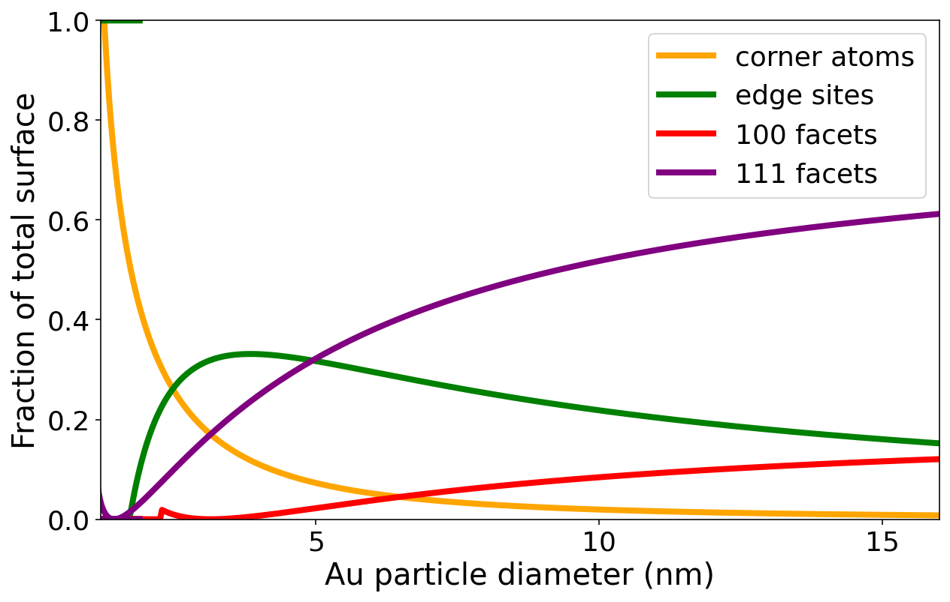
Figure S11. Extrapolated surface site distribution model for a fcc cubo-octahedron
In order to fit our experimentally retrieved catalysis data with the relative abundance of different surface sites, we extrapolated surface site distribution models, composed by van Hardeveld and Hertog³⁵. A selection of these are shown in Figure S11. This shows the abundance of corner, edge and facet atoms as a function of the Au particle size for fcc cubo-octahedra.

Figure S12 – Surface site distribution model fits in HMF oxidation rate trend
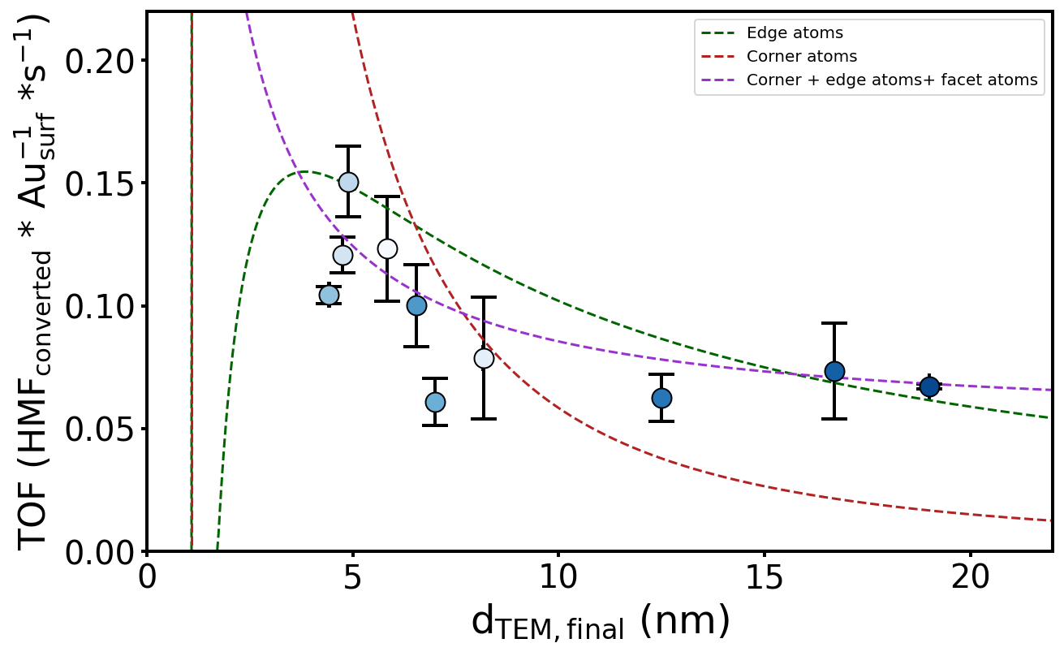
Figure S12. Fits of the distribution of edge and corner surface sites and the TOF_{HMF} as measured in this work. The models are indicative for the relative presence of surface sites at that particle diameter.
The surface site distribution models were used to fit our experimentally retrieved data in Figure S12. It becomes clear that if corner atoms were responsible for the observed activity a steeper increase in the catalytic activity, or stronger particle size effect, for small Au nanoparticles was expected. Moreover, edge sites correlate a bit better with our experimental data, but in this case more activity was expected from the 6-12 nm samples, as the abundance of edge sites is clearly higher than the observed activity trend. Lastly, a combination of edge, corner and facet sites seems to correlate the best. However, it is also the easiest to obtain a good fit, as more sites lead to more fitting parameters that can be adjusted.

Figure S13 – High-resolution HAADF-STEM images of Au_2.0 and Au_4.0
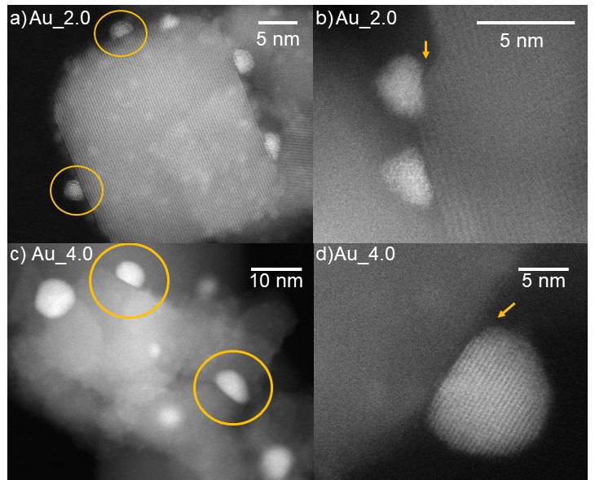
Figure S13. High-resolution HAADF-STEM Images of Au_2.0 (a and b) and Au_4.0 (c and d) as synthesized (before catalysis) with the scale shown in the top right of each panel.
Figure S13 shows high-resolution HAADF-STEM images of Au_2.0 and Au_4.0 that highlight the shape of Au particles and their contact angle and interface with the titania carrier. Overall, there is a variety of particles in terms of size and shape. The contact angle with the titania support mostly is <90°. The shape of the titania support can impact the Au particle shape (Figure S13b).

